PROJECT-4

Jenkins Master-Slave configuration

### ****Jenkins Master-Slave Concept****

Jenkins uses the **Master-Slave architecture** to distribute the workload of building, testing, and deploying projects across multiple machines. This architecture ensures scalability and efficient resource utilization.

#### **1. Jenkins Master**

The **Master node** is the central controller of Jenkins. It manages and schedules jobs, distributes tasks to slaves, and monitors their execution.

**Responsibilities of the Master:**

* Stores the configuration of all jobs and pipelines.
* Schedules builds and assigns them to available slave nodes.
* Provides the user interface (UI) for job configuration, execution, and monitoring.
* Acts as a build executor when no slaves are available.

#### **2. Jenkins Slave**

The **Slave nodes** are the worker machines that perform the build, test, or deployment tasks assigned by the master. Slaves are usually configured on separate servers to offload tasks from the master.

**Key Features of Slaves:**

* A slave node runs on any platform where Jenkins can run (e.g., Linux, Windows, MacOS).
* Slaves are configured to run specific or all types of jobs based on labels assigned to them.
* A slave must have Java installed to communicate with the master.

#### **3. Master-Slave Communication**

* Communication happens via **SSH**, **JNLP (Java Network Launch Protocol)**, or **WebSocket**.
* The master sends tasks to the slaves, which execute them and report the results back to the master.

#### **Benefits of Master-Slave Architecture**

* **Scalability**: Additional slave nodes can be added to handle more jobs.
* **Load Balancing**: Workload is distributed among multiple nodes.
* **Platform Diversity**: Jobs can run on different operating systems or environments, depending on the slave configurations.
* **Fault Tolerance**: Failure of one slave node does not disrupt other jobs running on other slaves or the master.

**Example Use Case:**

* A Jenkins Master runs on a central server to coordinate tasks.
* One slave is used for building Java applications, another for testing Python scripts, and a third for deploying code to a production server.

This setup improves efficiency and ensures faster execution of CI/CD pipelines.

Slave-1:Installation Of Ngnix

### ****Step-by-Step Guide****

#### **1. Create Master Node and Slave-1 Instance**

* Launch **one Master node** and **one Slave node** on AWS (or any cloud platform).
* Ensure both instances are up and running.

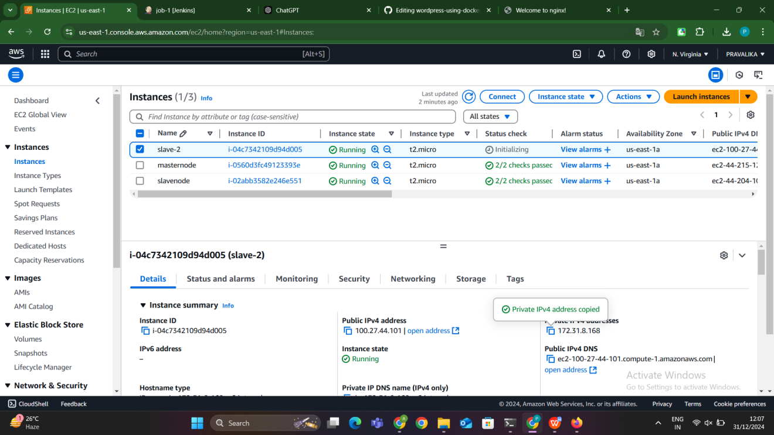

#### **2. Connect Master and Slave in Terminal**

Log in to the **Master node** via SSH.

Generate an SSH key pair on the Master: ssh-keygen

Navigate to the .ssh directory:cd .ssh

- Here we get the id_rsa.pub address go inside it by using vim id_rsa.pub then copy that address

- Next go to the slave node move to the cd .ssh directory in side that go to vim authorized key then paste the copied public address of the master in size the authorized keys

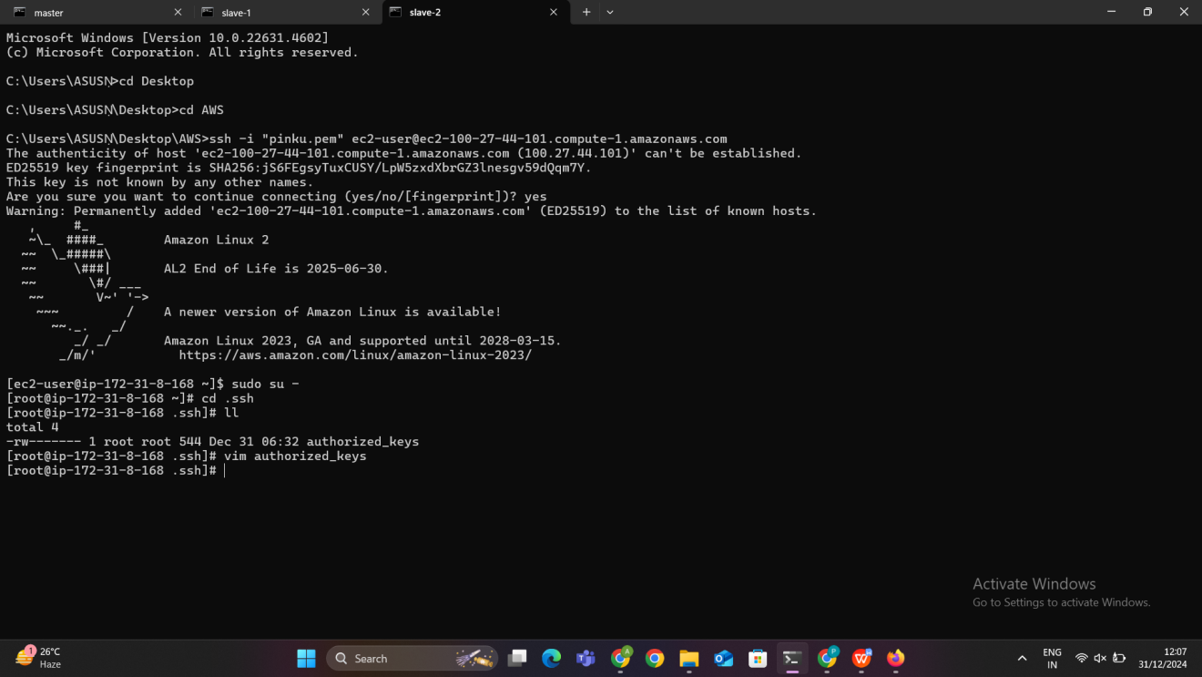

**Installation of jenkins :**

Jenkins is an open-source automation server used for continuous integration (CI) and continuous delivery (CD). To install Jenkins, certain prerequisites must be met, and the process involves setting up dependencies, configuring the system, and enabling the service.

### ****1. Prerequisites****

Before installing Jenkins, the following requirements must be fulfilled:

* **Operating System**: Jenkins runs on most platforms, including Linux (Ubuntu, CentOS, etc.), Windows, and macOS.
* **Java Installation**: Jenkins is written in Java, so a supported version of Java (JDK 11 or later) must be installed. For modern setups, Java 17 is recommended.

### ****2. Adding Jenkins Repository****

Jenkins packages are not included in the default system repositories. To install the latest stable version:

* Add the Jenkins **GPG key** to verify package integrity.
* Add the Jenkins repository URL to the system’s package manager.
* Update the system's package list to include Jenkins.

### ****3. Installing Jenkins****

Once the repository is configured:

* Use the system package manager (e.g., apt for Ubuntu, yum for CentOS) to install Jenkins.
* During the installation, required dependencies (like Java) are resolved automatically if not already installed.

### ****4. Starting and Enabling Jenkins****

* After installation, Jenkins runs as a **systemd service**.
* The service is started to allow Jenkins to function, and it is enabled to start automatically whenever the system reboots.

### ****5. Accessing Jenkins****

* Jenkins operates on **port 8080** by default.
* After installation, the web interface is accessed via a browser using the server's IP address or hostname.
* To unlock Jenkins for the first time, an **initial admin password** is required. This is generated during installation and stored in a secure file on the server.

### ****6. Key Components of Jenkins Installation****

* **Dependencies**: Ensuring Java is properly installed and configured.
* **Repository Management**: Adding the official Jenkins repository for stable and secure updates.
* **Service Management**: Running Jenkins as a service to ensure high availability and proper functioning.

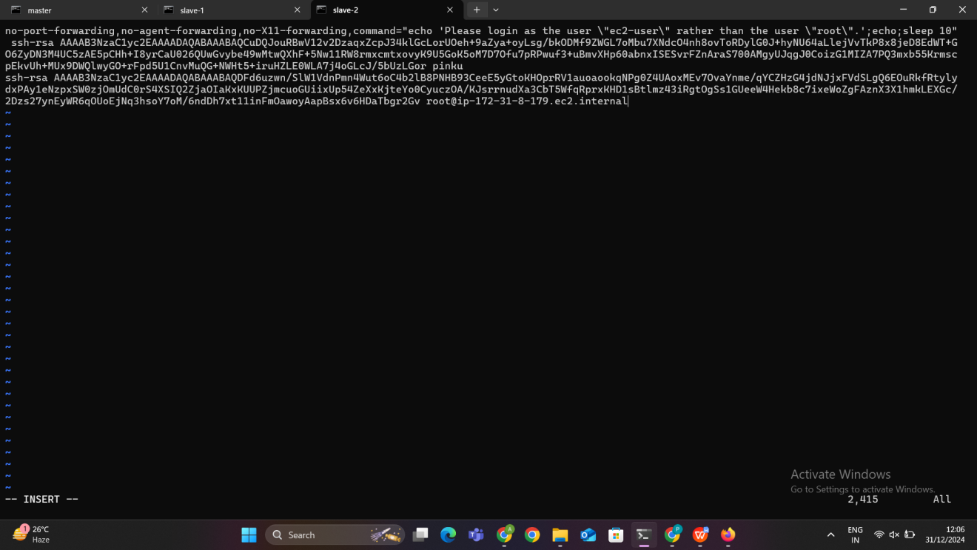

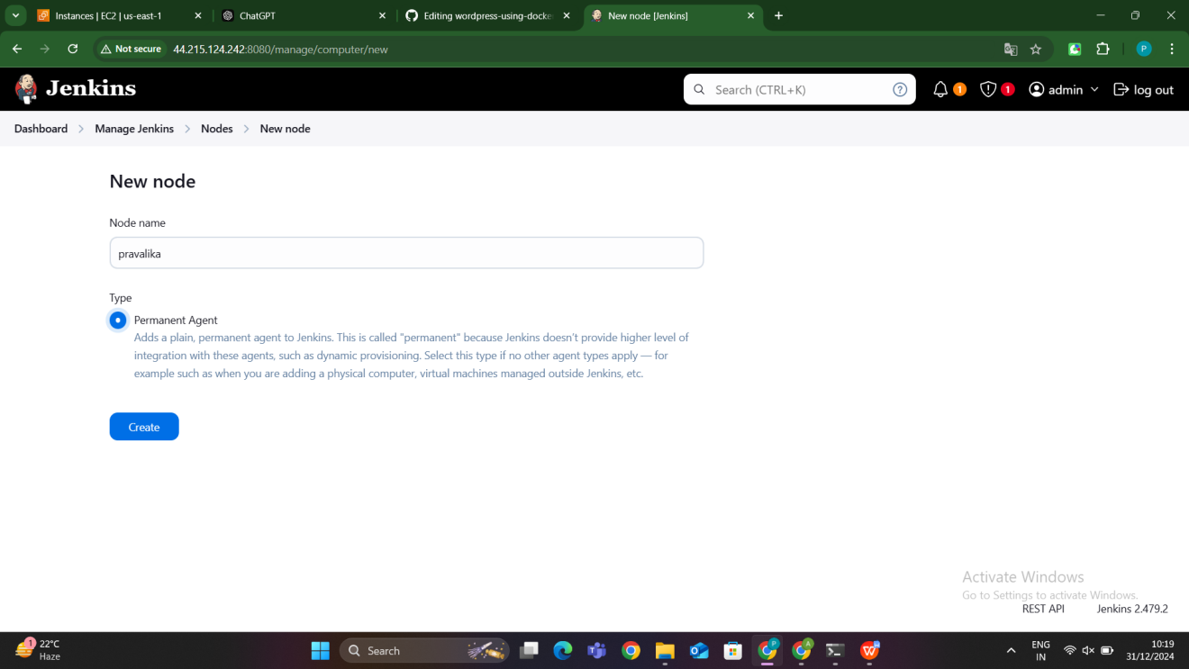

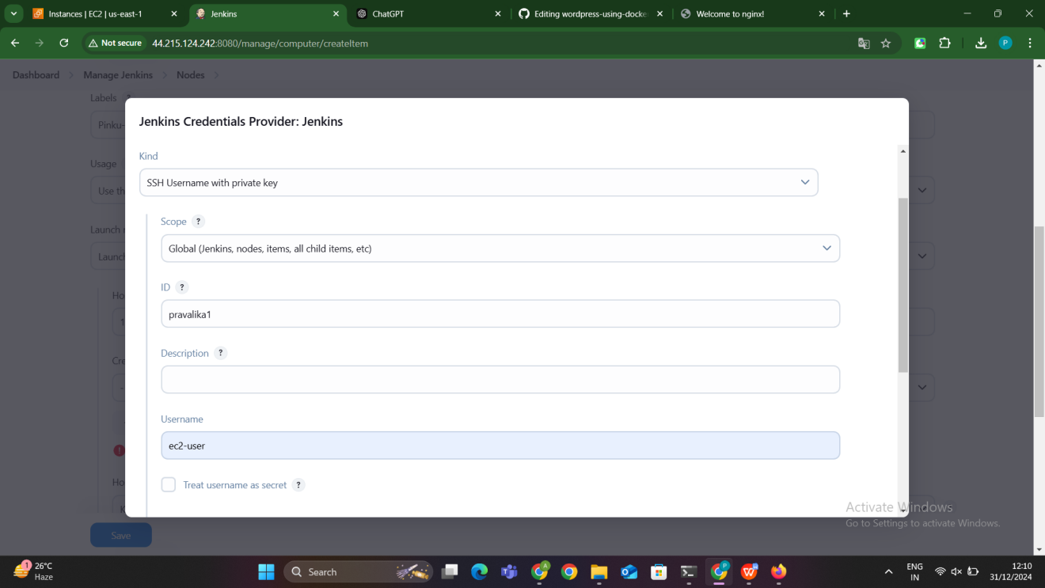

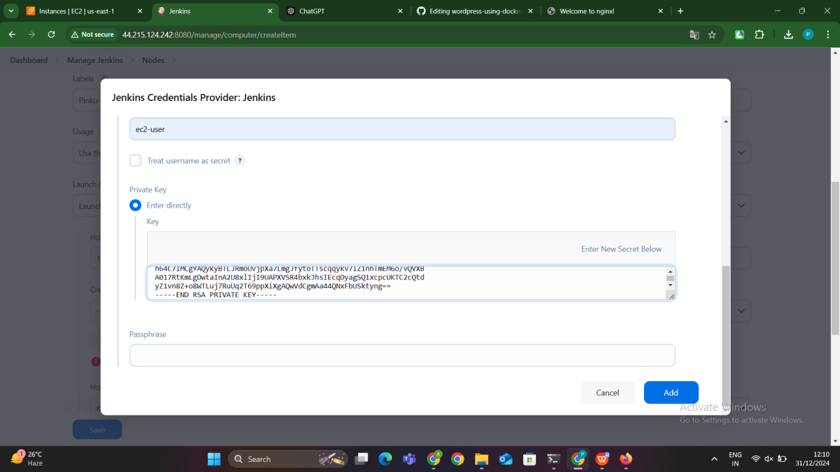

#### **5. Configure the Slave Node in Jenkins**

1. Open Jenkins Dashboard → **Manage Jenkins** → **Manage Nodes and Clouds** → **New Node**.
2. Provide a **Node Name** (e.g., Slave-1) and click **Permanent Agent** → OK.
3. Configure the following:
   1. **Remote Root Directory**: /home/ec2-user
   2. **Number of Executors**: Set to 1 (for now).
   3. **Labels**: Add a meaningful label (e.g., nginx).
   4. **Usage**: Select "Use this node as much as possible."
4. Configure the **Launch Method**:
   1. Select **Launch agents via SSH**.
   2. Host: Add the **Private IP** of the Slave node.
   3. Credentials: Add the **SSH key** credentials.
      1. **ID**: Any unique name.
      2. **Username**: Instance username (e.g., ec2-user or ubuntu).
      3. **Private Key**: Use the private key generated on the Master.
   4. Host Key Verification Strategy: Choose **Manually trusted key verification**.
5. Save the configuration and test the connection.

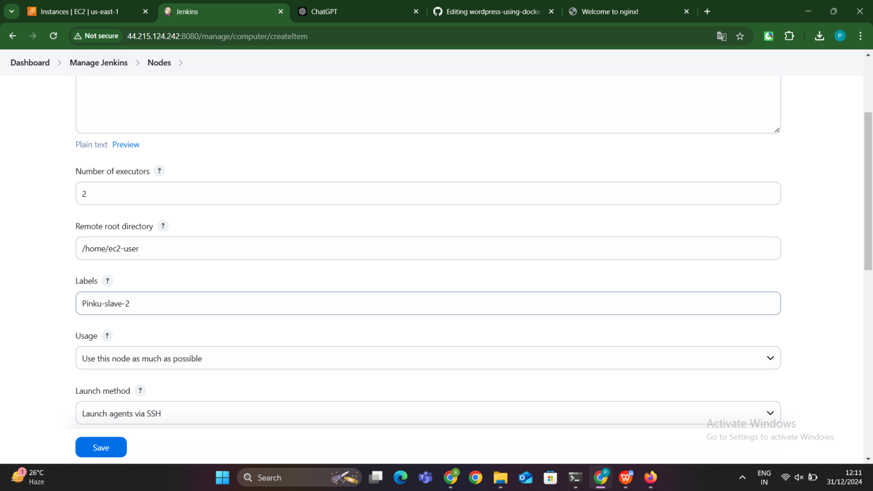

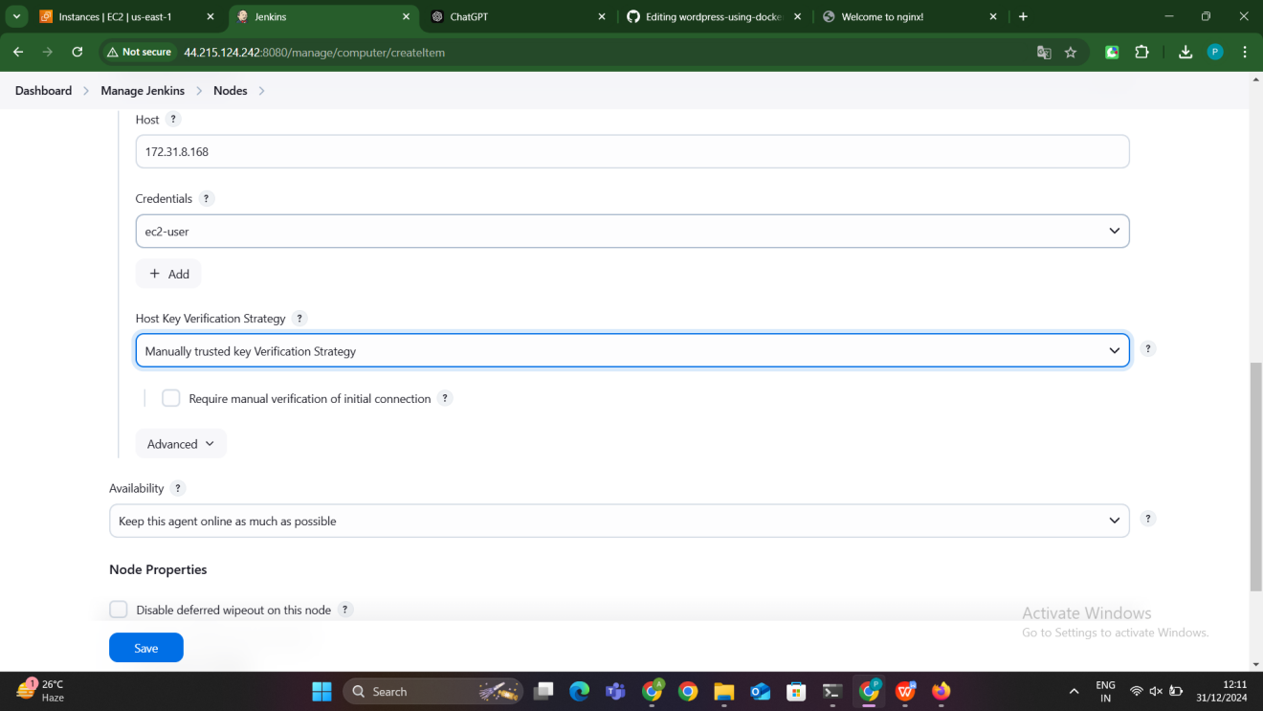

#### **6. Create a Jenkins Freestyle Job**

1. Go to Jenkins Dashboard → **New Item** → **Freestyle Project**.
2. Name the job (e.g., Install-Nginx) and click OK.
3. Under **General**, check **Restrict where this project can be run** and enter the Slave node's label (e.g., nginx).
4. Under **Build** → **Add build step** → **Execute shell**, add the Nginx installation commands

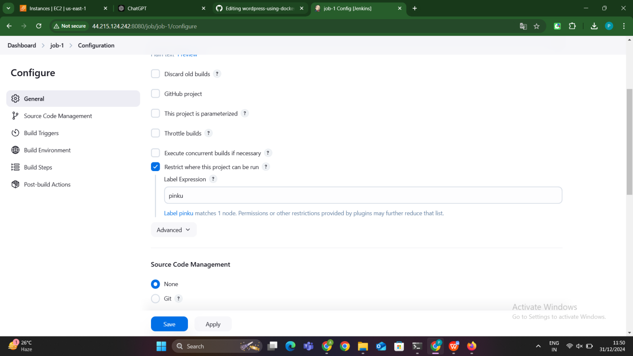

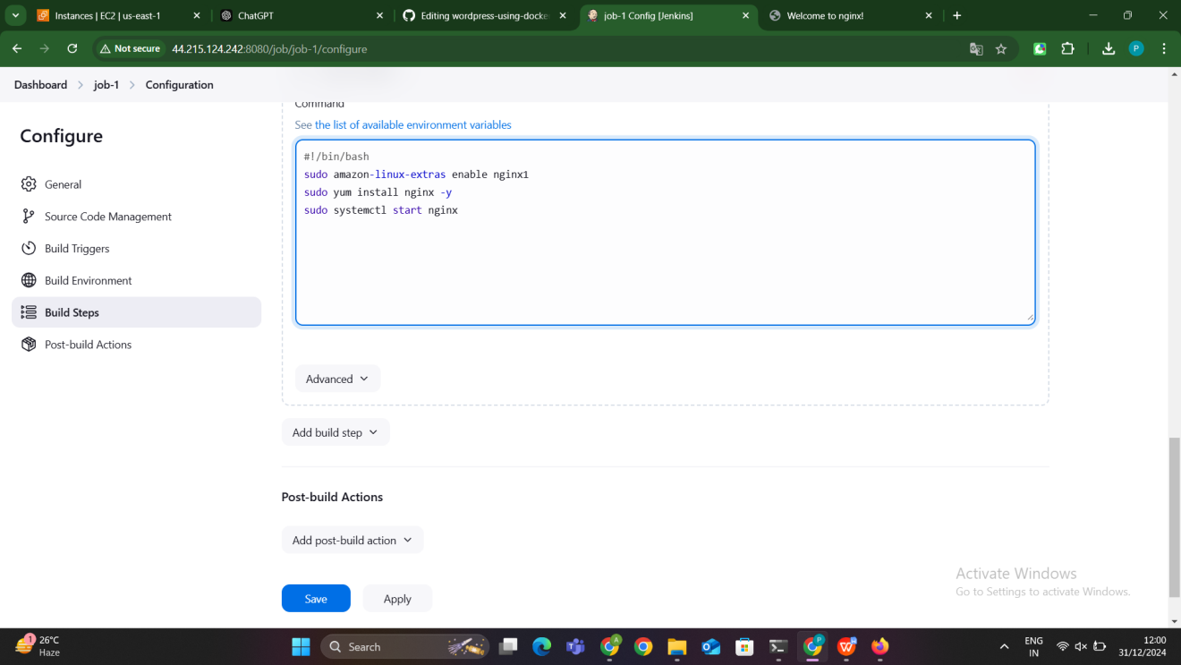

#### **7. Build the Job**

* Click **Build Now** to execute the job.
* Once the build is successful, verify the Nginx installation:
  + Access the Slave node's public IP in a browser (http://<Slave-Instance-Public-IP>).
  + You should see the default Nginx welcome page.

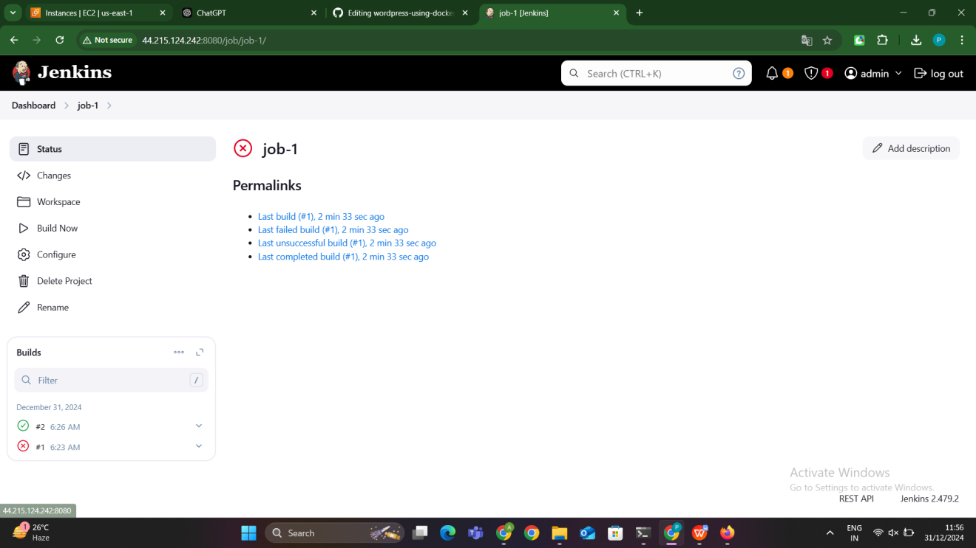

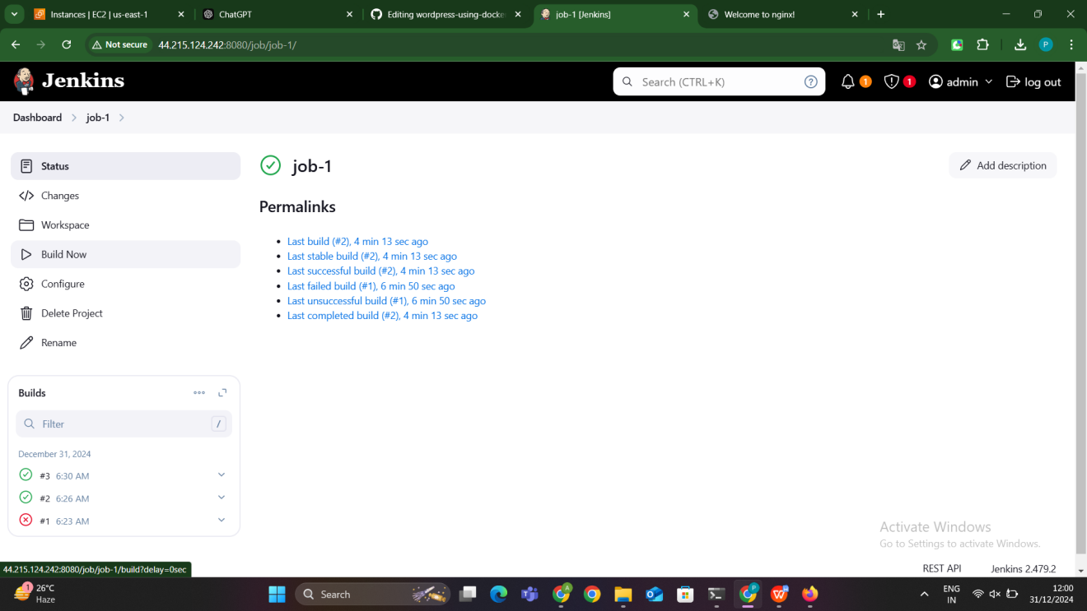

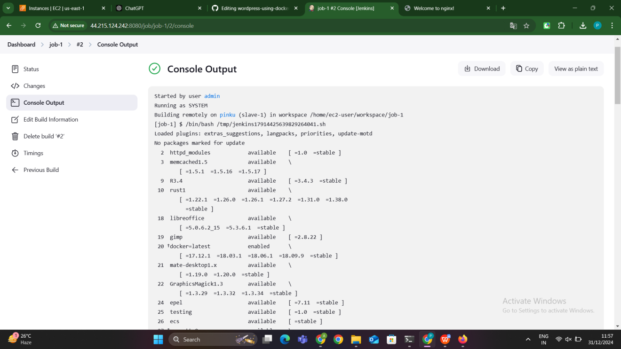

### ****Summary****

You have successfully:

* Configured Jenkins Master-Slave setup.
* Installed Nginx on Slave-1 using a Jenkins job.
* Verfied the Nginx setup through the Slave node’s public IP.

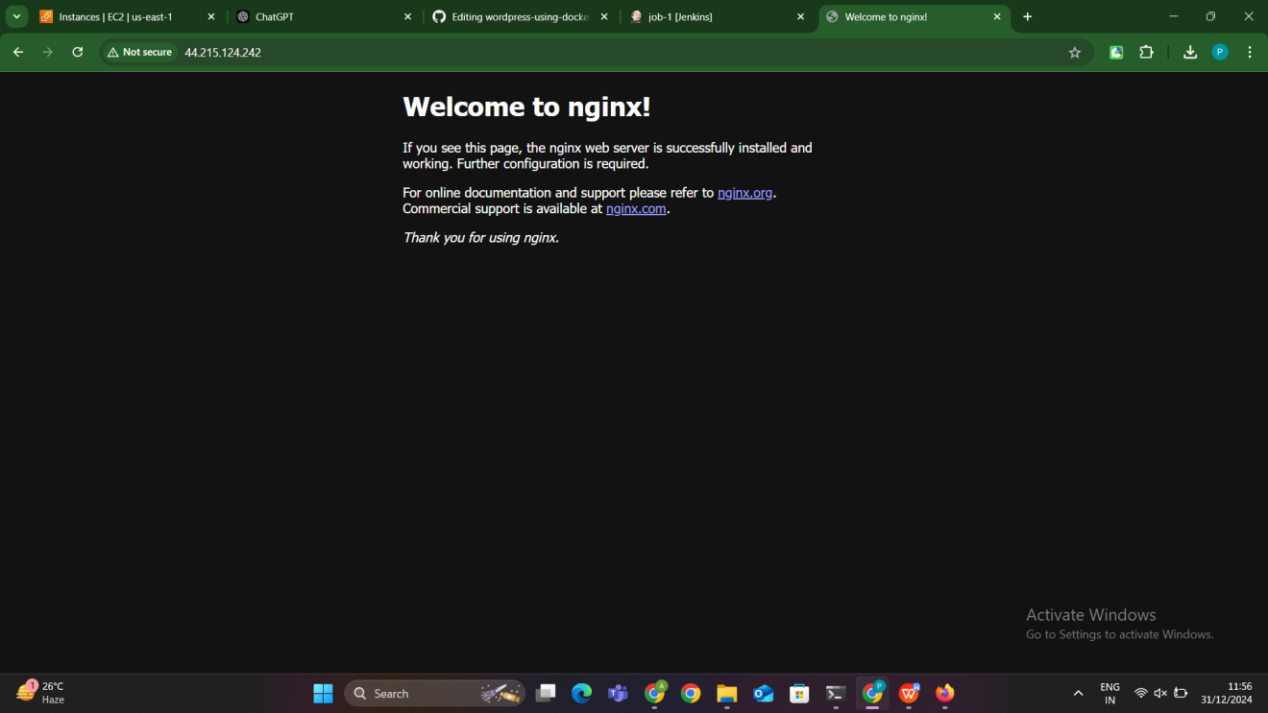

**Slave-2: Master-Slave Configuration and HTTPD Installation Using Jenkins Job**

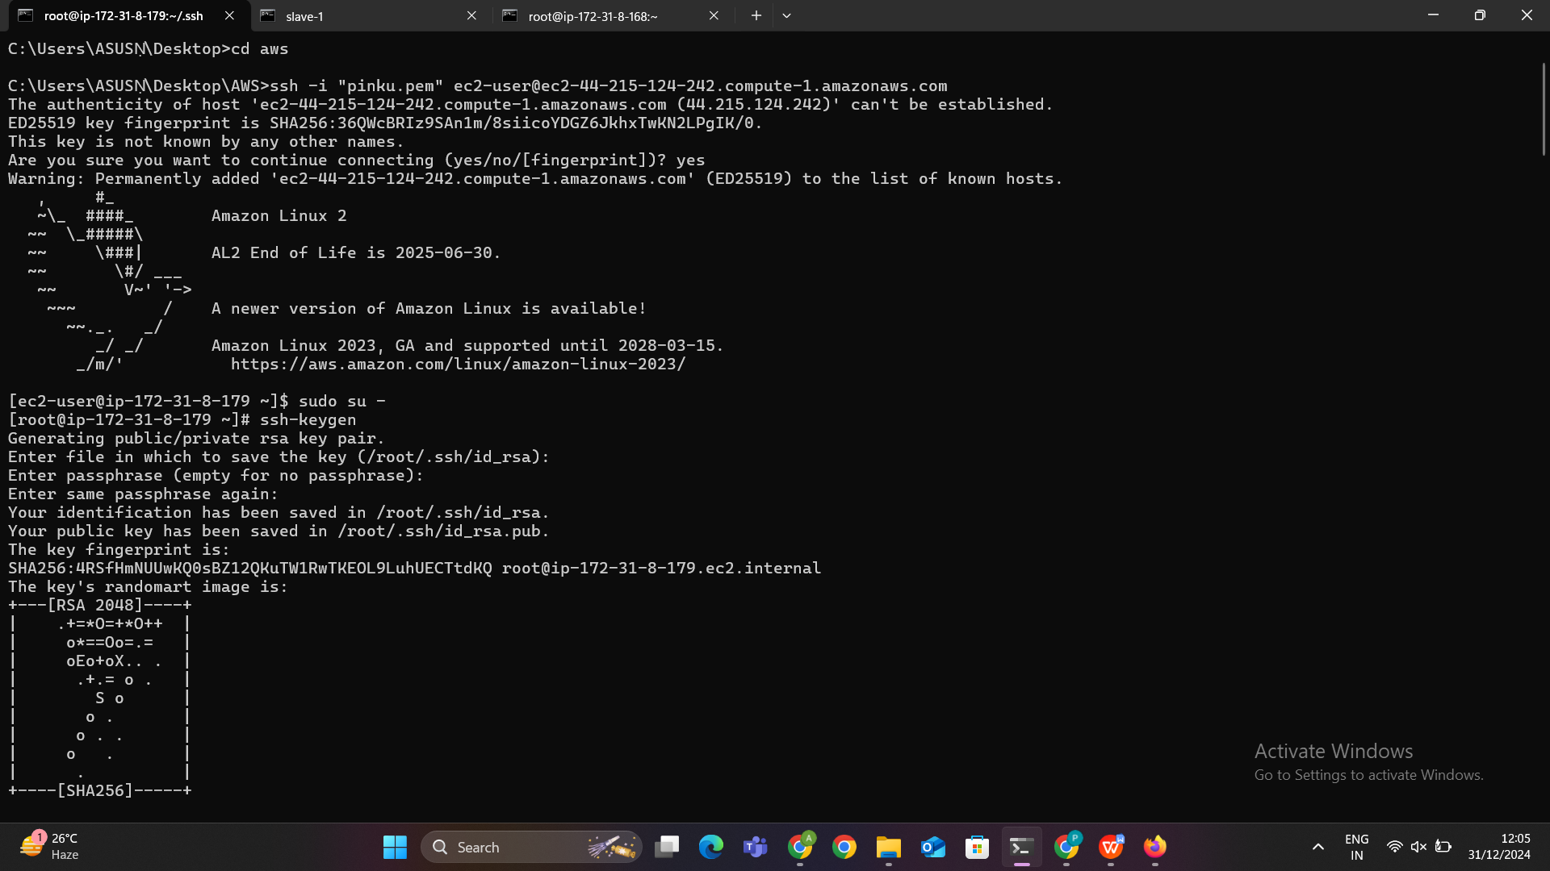



#### **Step 1: Set Up Master-Slave Nodes**

Log in to the **Master node** via SSH.

Generate an SSH key pair on the Master: ssh-keygen

Navigate to the .ssh directory:cd .ssh

- Here we get the id_rsa.pub address go inside it by using vim id_rsa.pub then copy that address

- Next go to the slave node move to the cd .ssh directory in side that go to vim authorized key then paste the copied public address of the master in size the authorized keys

**Install Jenkins on the Master Node**:

* 1. Install Jenkins on the master node and ensure it is up and running.
  2. Access Jenkins through http://<master-ip>:8080.

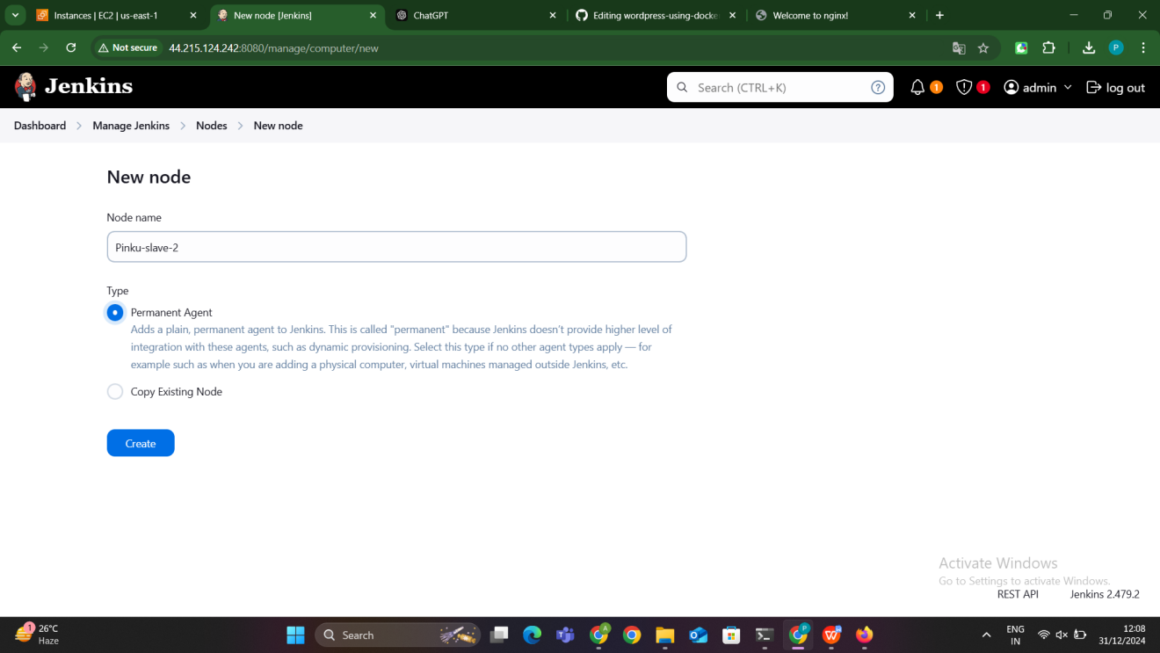

**Set Up Slave Nodes**:

* Launch a new EC2 instance (slave) or use an existing server.
* Ensure Java is installed on both the master and slave:

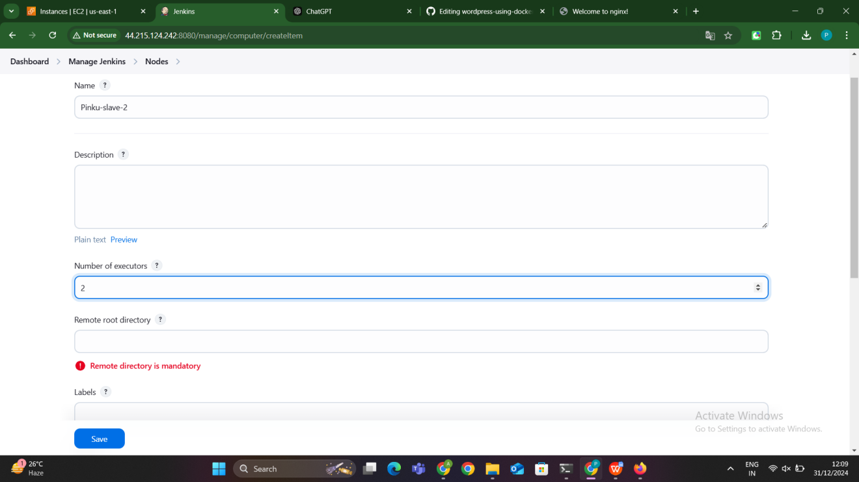

**Add the Slave Node in Jenkins**:

* Go to **Manage Jenkins > Manage Nodes and Clouds > New Node**.
* Provide the node name (e.g., slave-1) and configure:
  + **Number of Executors**: Set the number of parallel jobs this node can run.
  + **Remote Root Directory**: /home/<slave-user> (e.g., /home/ec2-user).
  + **Labels**: Add a label (e.g., slave-httpd) to identify the node.
  + **Launch Method**: Select **Launch agents via SSH**.
  + Add credentials:
    - Username: Slave instance user (e.g., ec2-user or ubuntu).
    - Private Key: Paste the master node's private key (~/.ssh/id_rsa).
* Save the configuration and connect the node. The status should show **Online**.









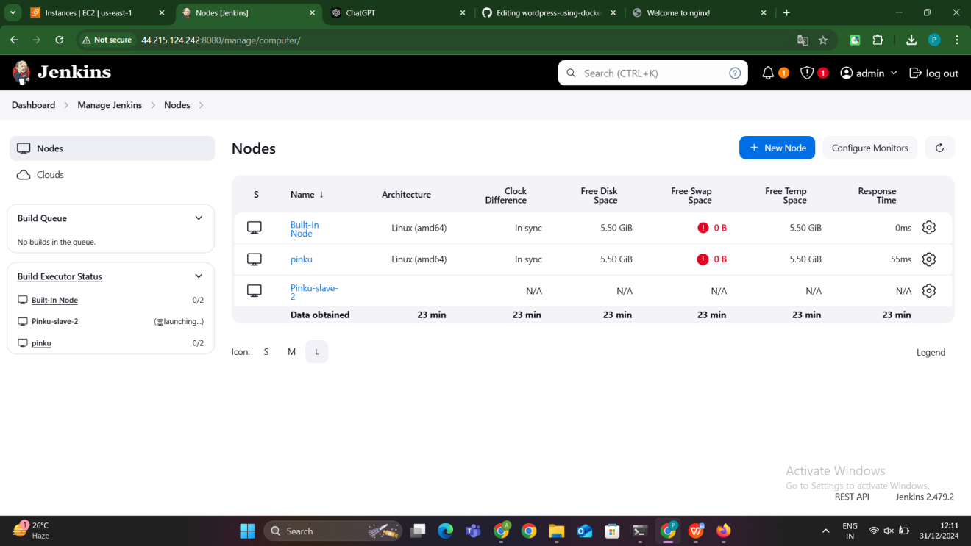

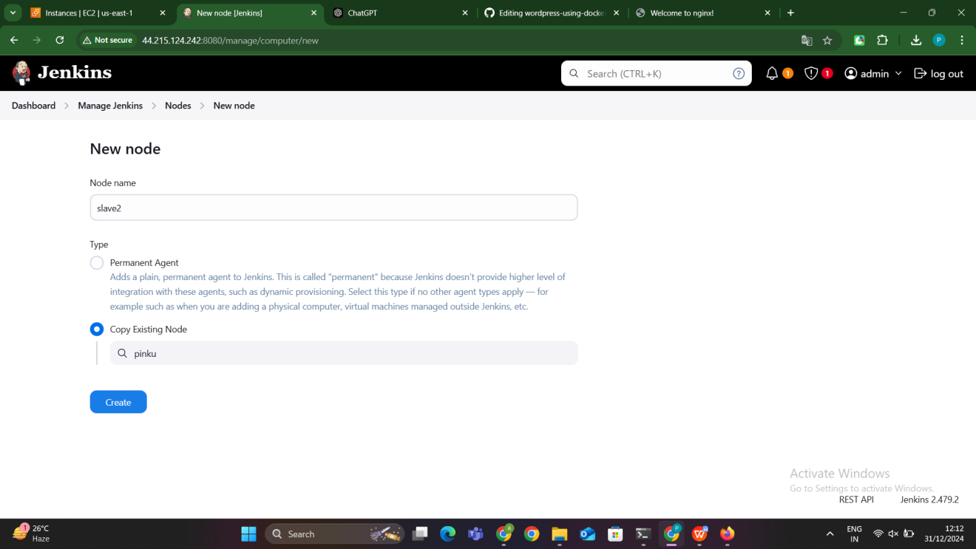

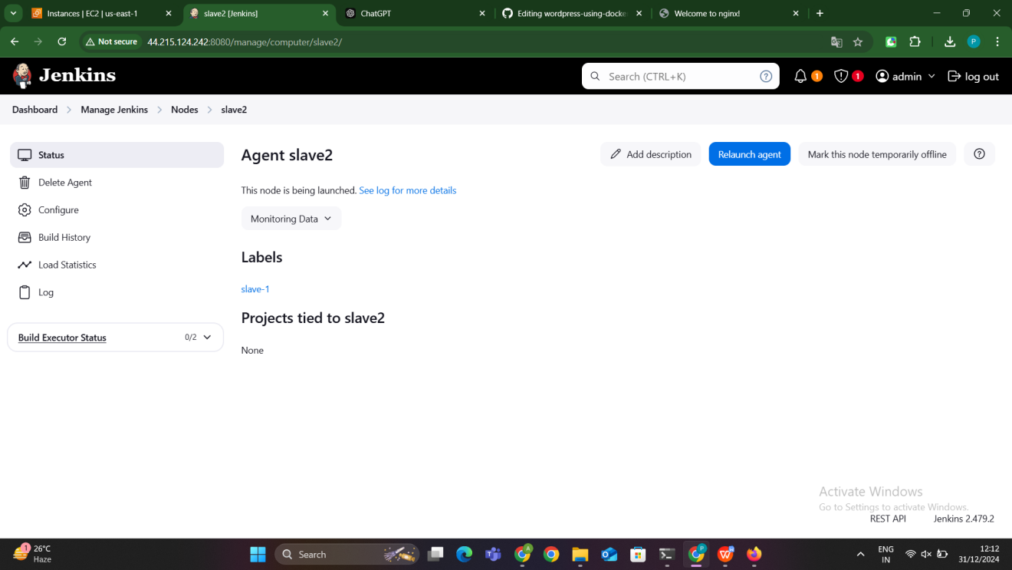

#### **Step 2: Create a Jenkins Freestyle Job**

**Create a New Job**:

* 1. Go to Jenkins Dashboard > New Item > Freestyle Project.
  2. Name the job (e.g., Install-HTTPD-Slave) and click **OK**.

**Restrict Job to Slave Node**:

* 1. In the **General** tab, check **Restrict where this project can be run**.
  2. Add the label of the slave node (e.g., slave-httpd).

**Add Build Steps**:

Under **Build**, click **Add build step > Execute shell**.

Add the following commands to install and start HTTPD on the slave node:

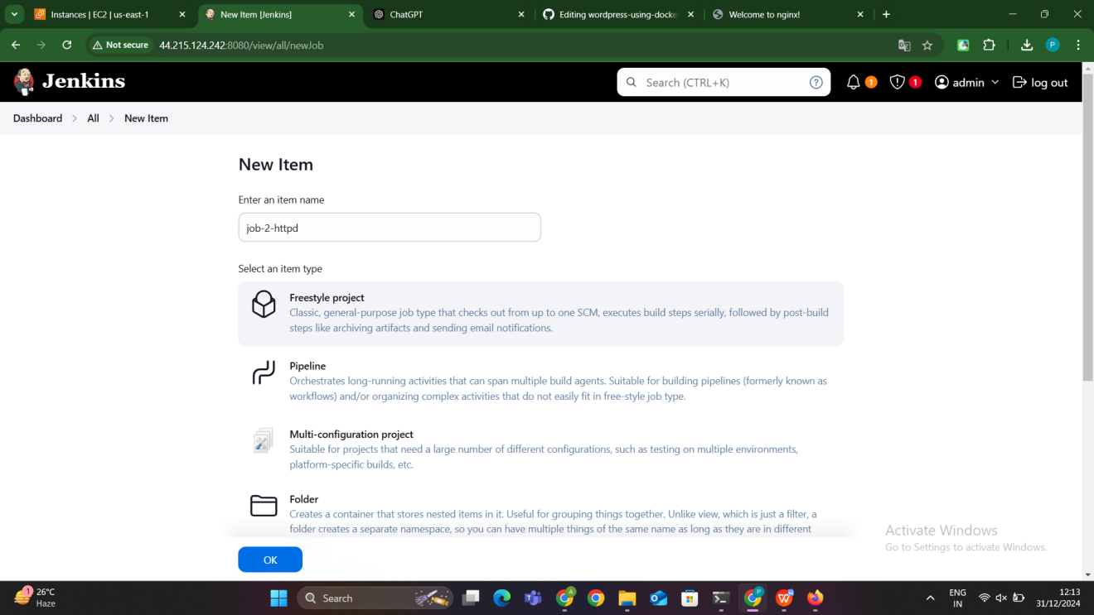

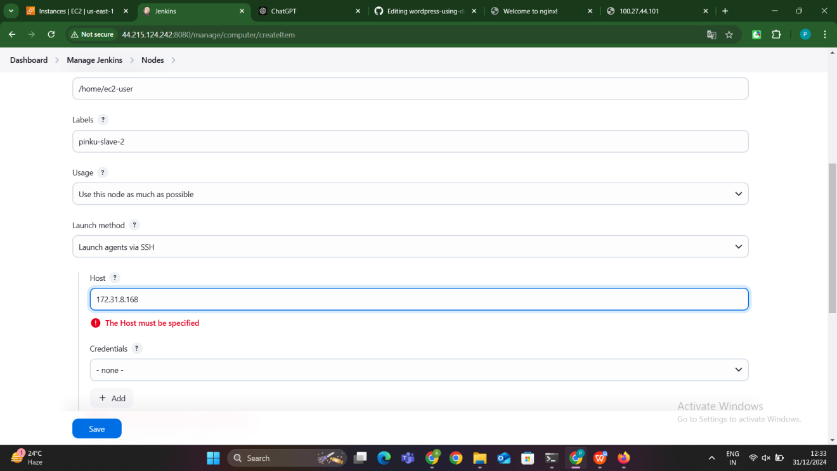

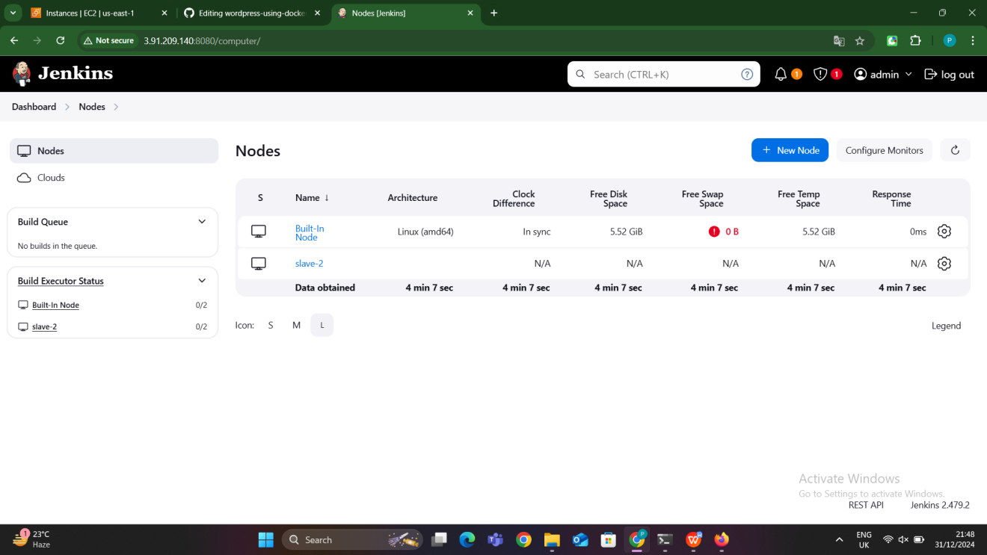

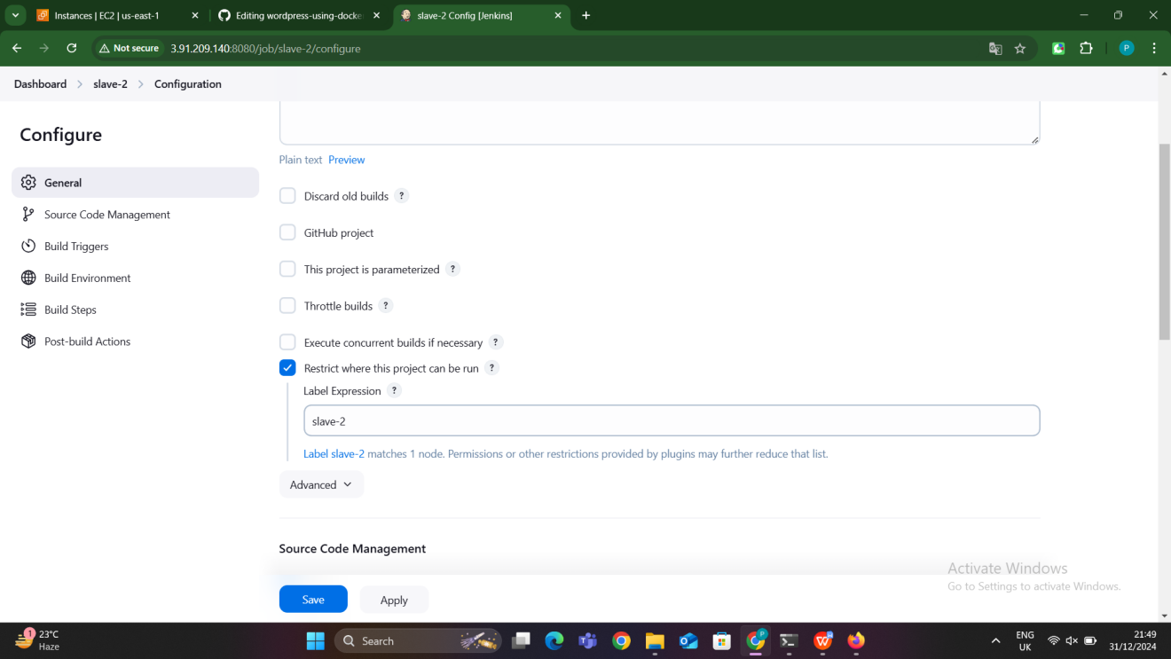

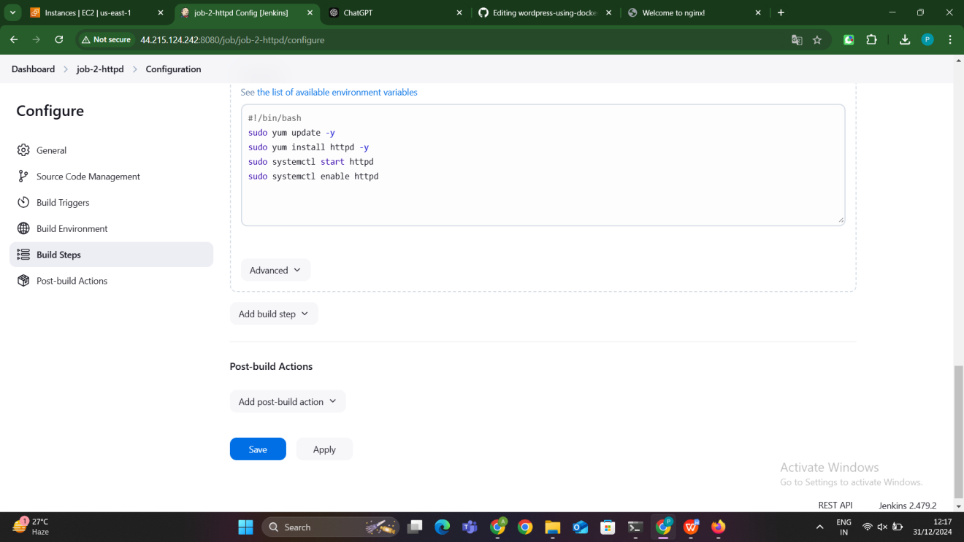

#### **Step 3: Build the Job**

1. Save the configuration and click **Build Now**.
2. Monitor the job output in the **Console Output** section. It will show the commands being executed on the slave node.
3. Verify the installation of the httpd then access the httpd page by using public ip address of the slave node

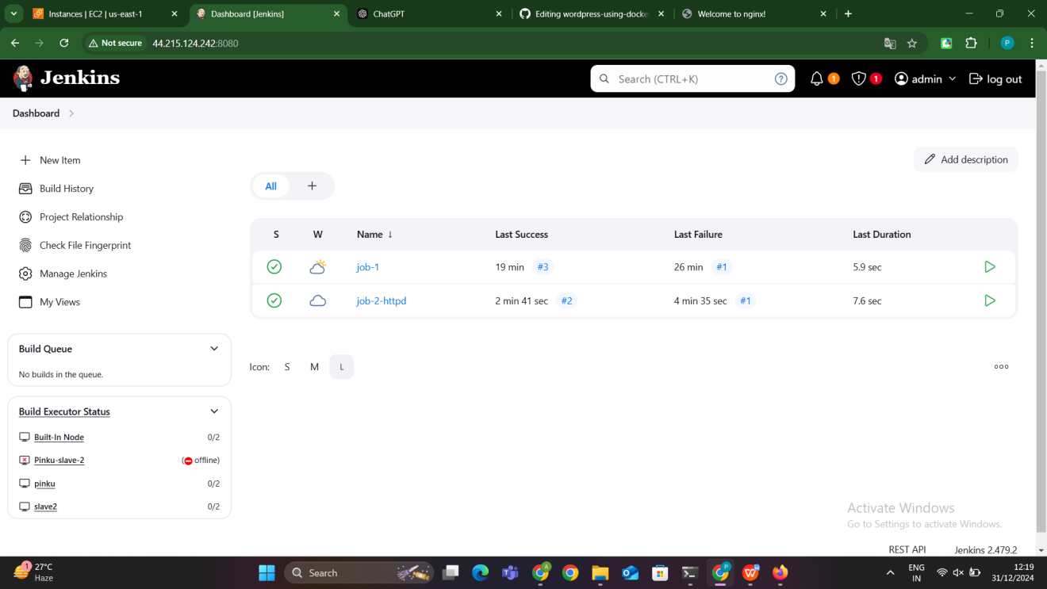

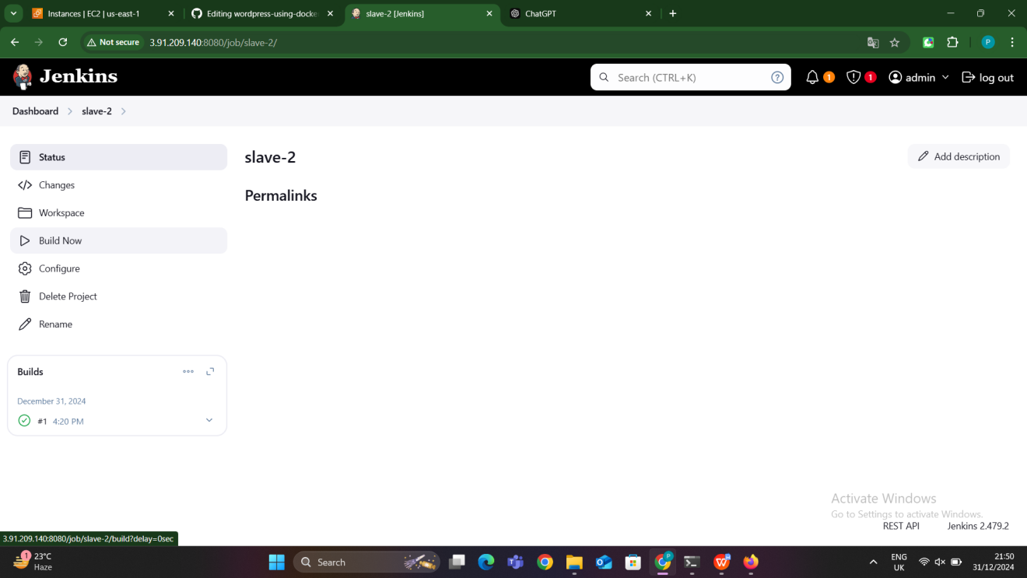

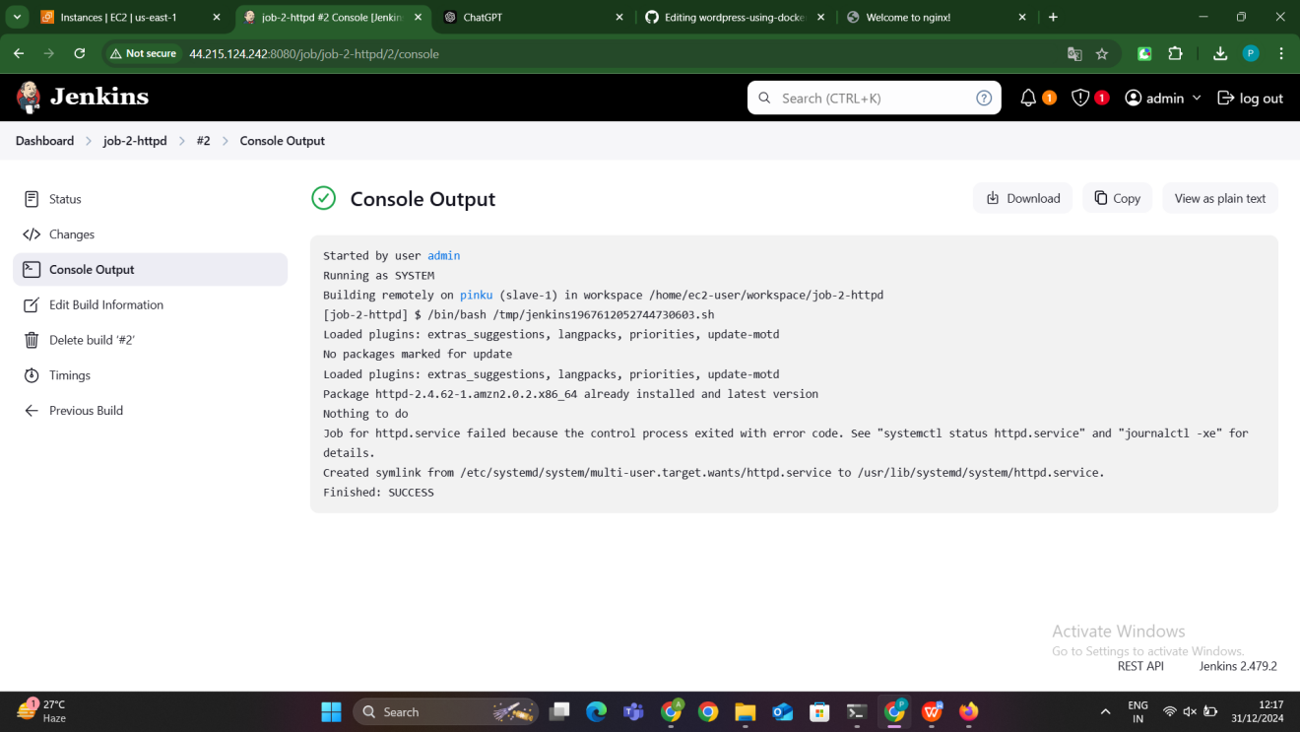

### ****Key Points****

* The **master node** orchestrates the job and delegates the execution to the **slave node** based on the label.
* The HTTPD installation commands are executed directly on the slave node by Jenkins.
* This approach ensures automation and consistency in software installation across nodes.

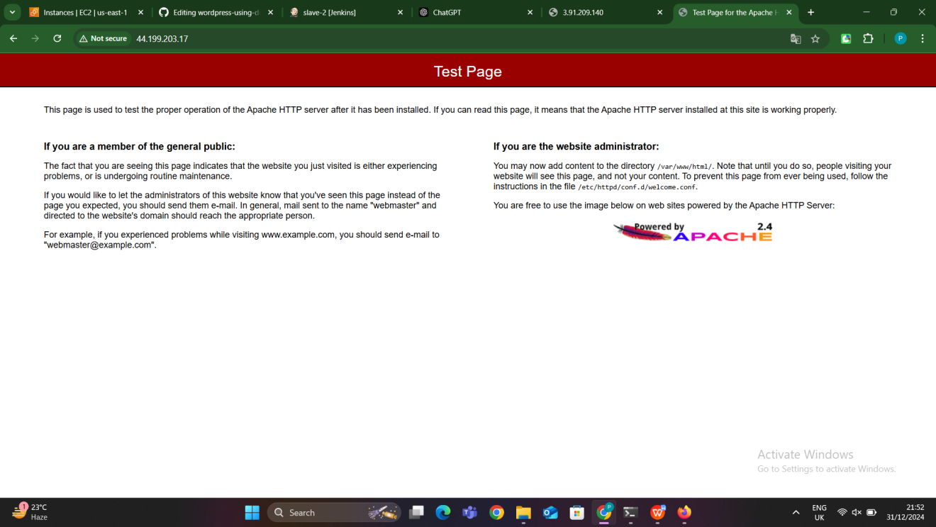

**SLAVE-3:Sonarqube installation**

· **Jenkins Master-Slave Setup**:

* · The Jenkins master and slave nodes should already be connected. Refer to the earlier steps for setting up Jenkins master-slave configuration.
* Ensure Java (OpenJDK 17 or later) is installed on both the master and slave nodes.

· **System Requirements for SonarQube**:

* · At least 2GB of RAM is recommended.
* PostgreSQL should be installed and configured for SonarQube.
* Ports like 9000 (default for SonarQube) must be open in the firewall/security groups.

· **Slave Node Labels**:

* · Add a label to the slave node for identification (e.g., slave-sonarqube).

#### **Step 1: Create a New Jenkins Job**

1. Go to Jenkins Dashboard > **New Item** > **Freestyle Project**.
2. Name the job (e.g., Install-SonarQube-Slave) and click **OK**.

#### **Step 2: Configure Job to Run on Slave Node**

1. Under the **General** section, check **Restrict where this project can be run**.
2. Enter the label for the slave node (e.g., slave-sonarqube).

#### **Step 3: Add Build Steps for SonarQube Installation**

In the **Build** section, add a build step:

* 1. Click **Add Build Step > Execute Shell**.

wget https://binaries.sonarsource.com/Distribution/sonarqube/sonarqube-8.9.6.50800.zip

unzip sonarqube-8.9.6.50800.zip

mv sonarqube-8.9.6.50800 sonar

cd sonar/bin/linux-x86-64

chmod +x sonar.sh

sh sonar.sh start

tail -f /home/ec2-user/workspace/slave3-job/sonar/logs/sonar.20250107.log

**Explaination of commands:**

wget https://binaries.sonarsource.com/Distribution/sonarqube/sonarqube-8.9.6.50800.zip

* 1. This command downloads the **SonarQube Community Edition version 8.9.6** from the official SonarSource distribution URL.
  2. wget is a command-line tool used to download files from the web.

**Purpose**: Fetch the required SonarQube software package for installation.

unzip sonarqube-8.9.6.50800.zip

* 1. This command extracts the contents of the downloaded SonarQube ZIP file.
  2. unzip is used to decompress .zip files.

**Output**: The extracted folder will be named sonarqube-8.9.6.50800, containing all the files required for SonarQube.

mv sonarqube-8.9.6.50800 sonar

* This command renames (or moves) the extracted folder from sonarqube-8.9.6.50800 to sonar for simplicity.
* mv is used to move or rename files and directories.

**Purpose**: Create a shorter, easier-to-use folder name for the SonarQube installation.

cd sonar/bin/linux-x86-64

* 1. This navigates into the bin/linux-x86-64 directory, which contains the scripts and binaries needed to manage SonarQube for Linux-based systems.
  2. cd stands for "change directory."

**Purpose**: Access the folder where the SonarQube startup script (sonar.sh) is located.

chmod +x sonar.sh

* This command makes the sonar.sh script executable.
* chmod +x changes the file permissions, allowing it to be run as a program.

**Purpose**: Ensure that the sonar.sh script can be executed without permission issues.

sh sonar.sh start

* This command starts the SonarQube application using the sonar.sh script.
* sh runs the script in a shell.

**Output**: Starts SonarQube as a background process. Logs and runtime files will be created in the sonar/logs directory.

**Purpose**: Launch the SonarQube server so it can be accessed via a web browser.

tail -f /home/ec2-user/workspace/slave3-job/sonar/logs/sonar.20250107.log

* This command continuously monitors and displays the log file sonar.20250107.log located in the SonarQube logs directory.
* tail -f is used to view the end of a file in real time as new lines are added.

**Purpose**:

* Verify the startup process of SonarQube.
* Check for any errors or warnings during initialization.
* Confirm that the application is running successfully.

### ****Why Each Step is Necessary****

1. **Downloading and Extracting**: Gets the required SonarQube software package.
2. **Renaming and Navigating**: Simplifies directory access and ensures we are in the right folder to start the application.
3. **Granting Permissions**: Prevents permission issues while running the startup script.
4. **Starting SonarQube**: Initializes the SonarQube server to process code quality analysis requests.
5. **Monitoring Logs**: Ensures that the application starts without issues and is ready for use.

#### **Step 4: Save and Build the Job**

1. Save the Jenkins job configuration.
2. Click **Build Now** to start the installation process.
3. Monitor the **Console Output** to ensure the commands are executed successfully.

#### **Step 5: Verify SonarQube Installation**

After the job completes successfully, check the SonarQube service on the slave node:

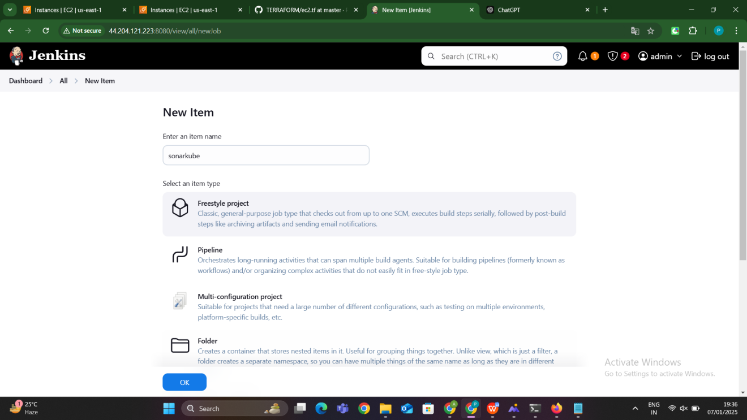

### ****Key Points****

* **Master-Slave Configuration**: The Jenkins master orchestrates the job, while the slave node handles the execution.
* **SonarQube Setup**: PostgreSQL must be properly configured to allow SonarQube to connect to the database.
* **Automation**: Using Jenkins ensures consistency in the installation process and saves time.

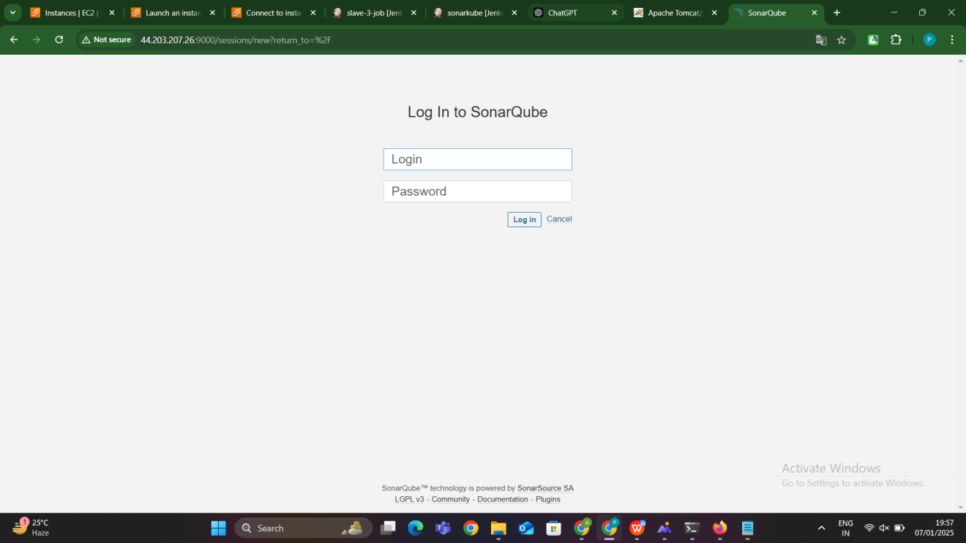

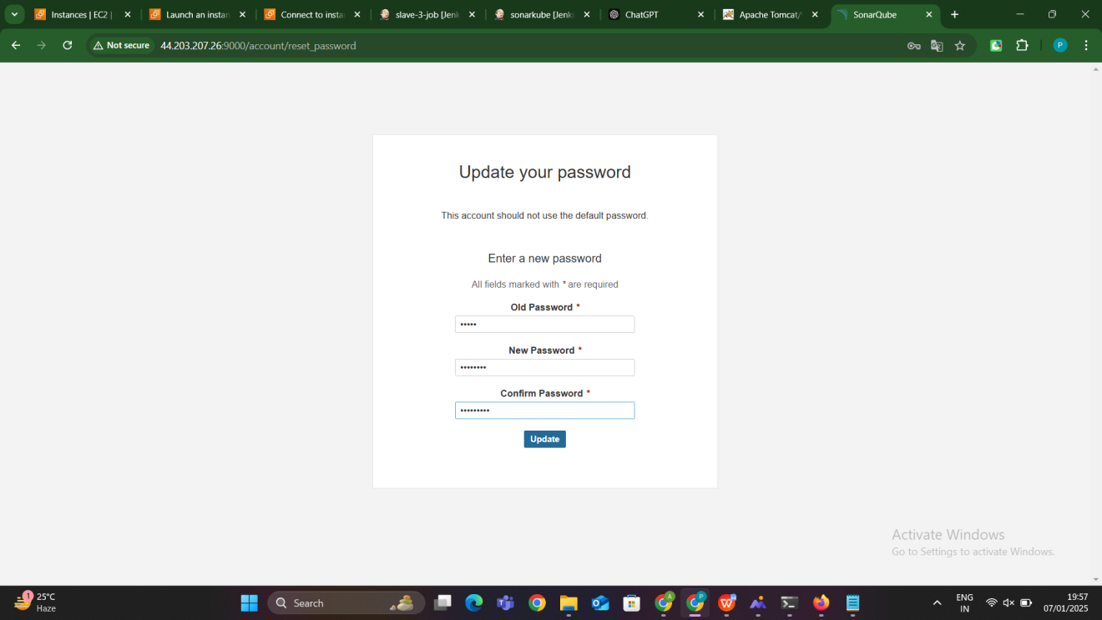

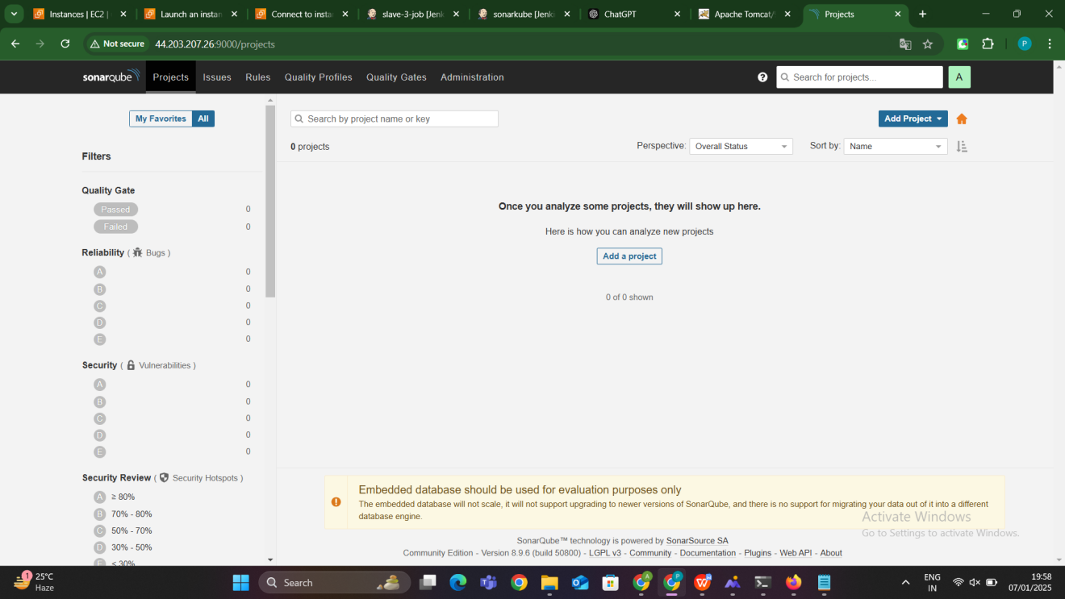

**SLAVE-4: Tomcat installation**

### ****Prerequisites****

**Jenkins Master-Slave Configuration**: Ensure that the Jenkins master and slave nodes are correctly configured and connected (refer to the earlier steps for setting this up).

**System Requirements for Tomcat**:

* 1. Java (JDK 8 or later) should be installed on the slave node.
  2. Proper internet access to download Tomcat packages.

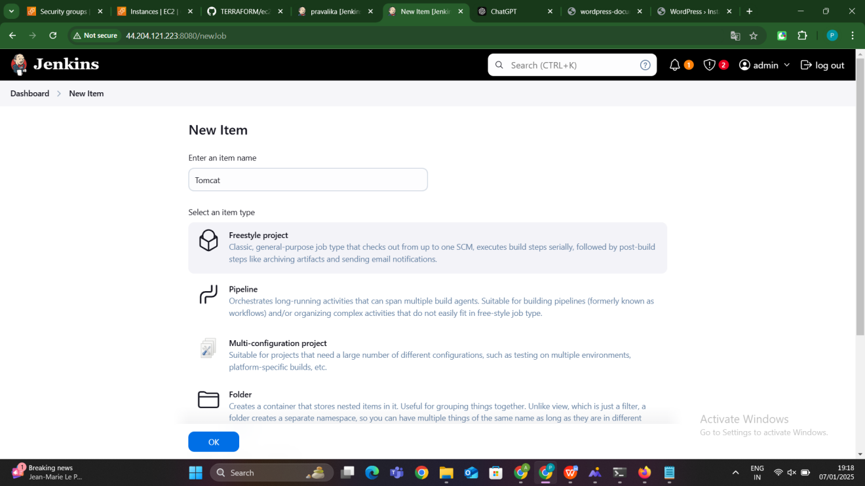

#### **Step 1: Create a New Jenkins Job**

1. Go to the Jenkins Dashboard.
2. Click on **New Item** > **Freestyle Project**.
3. Name the job (e.g., Install-Tomcat-Slave).
4. Click **OK**.

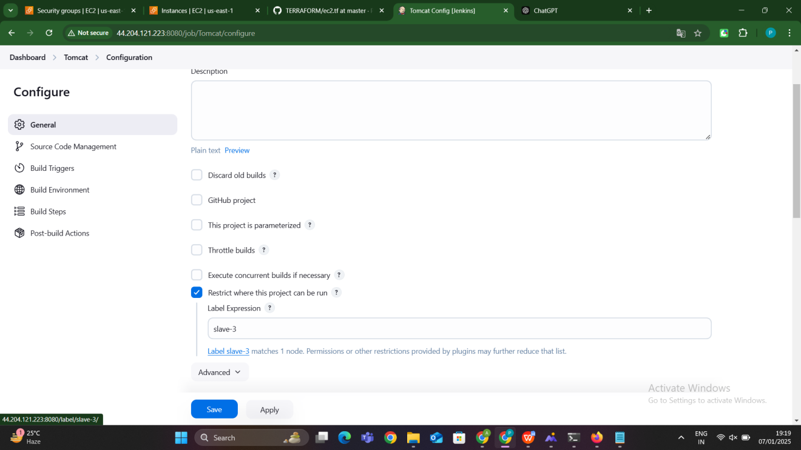

#### **Step 2: Configure Job to Run on Slave Node**

1. Under the **General** section, check **Restrict where this project can be run**.
2. In the **Label Expression**, enter the label of the slave node where you want Tomcat to be installed (e.g., slave-tomcat).
3. Click **Save**.

#### **Step 3: Add Build Steps to Install Tomcat**

In the **Build** section, add a **Build Step**:

* 1. Click **Add Build Step > Execute Shell**.

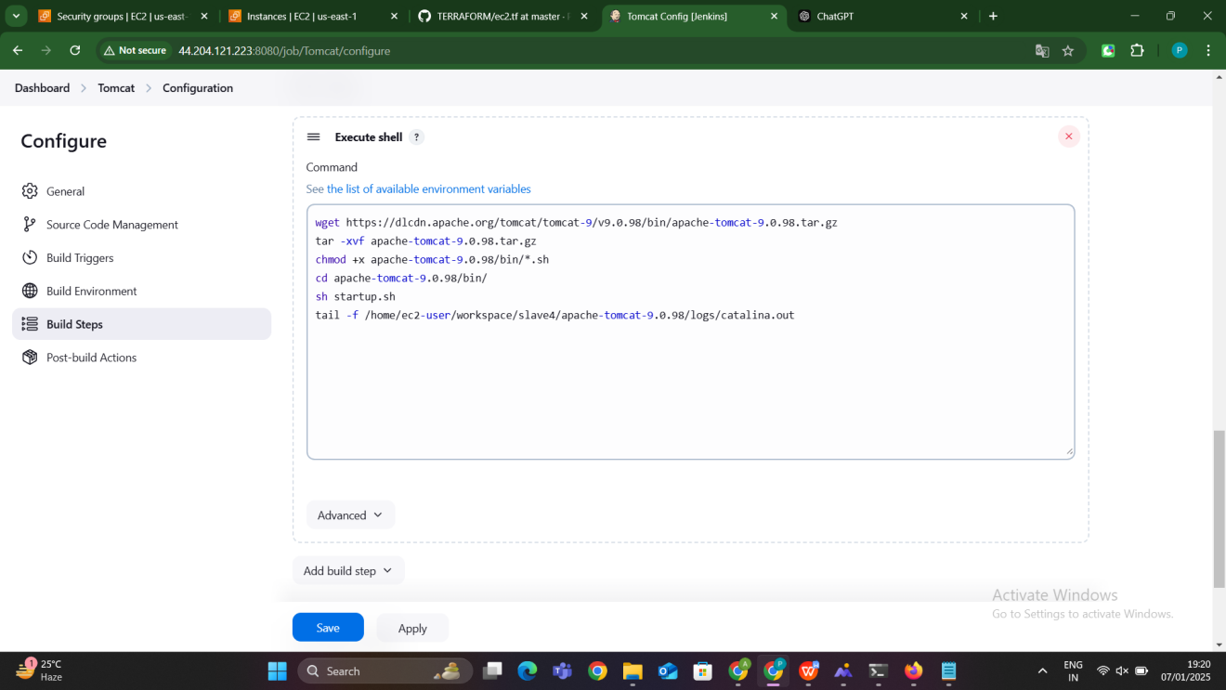

wget https://dlcdn.apache.org/tomcat/tomcat-9/v9.0.98/bin/apache-tomcat-9.0.98.tar.gz

tar -xvf apache-tomcat-9.0.98.tar.gz

chmod +x apache-tomcat-9.0.98/bin/*.sh

cd apache-tomcat-9.0.98/bin/

sh startup.sh

tail -f /home/ec2-user/workspace/slave4/apache-tomcat-9.0.98/logs/catalina.out

**Explaination:**

wget https://dlcdn.apache.org/tomcat/tomcat-9/v9.0.98/bin/apache-tomcat-9.0.98.tar.gz

* This command uses wget to download **Apache Tomcat 9.0.98** from the Apache mirror.
* wget is a command-line tool for downloading files over HTTP or HTTPS.
* https://dlcdn.apache.org/tomcat/tomcat-9/v9.0.98/bin/apache-tomcat-9.0.98.tar.gz is the official download URL for **Tomcat 9.0.98** in .tar.gz (gzip-compressed tarball) format.

**Purpose**: This step fetches the Tomcat binary archive, which contains all necessary files to run Tomcat.

tar -xvf apache-tomcat-9.0.98.tar.gz

* tar is used to extract files from compressed archives.
* The options:
  + -x: Extract the contents of the tarball.
  + -v: Verbose output (displays the files being extracted).
  + -f: Specifies the filename to extract (in this case, apache-tomcat-9.0.98.tar.gz).
* This command decompresses and extracts the files from the **Tomcat tarball** into the current directory.

**Purpose**: Unpack the downloaded Tomcat archive so that it can be used for installation and execution.

chmod +x apache-tomcat-9.0.98/bin/*.sh

* chmod is used to change the permissions of a file or directory.
* +x: Adds the **execute permission** to the specified files.
* apache-tomcat-9.0.98/bin/*.sh: This targets all .sh files in the bin directory of the extracted Tomcat folder, which are the startup and shutdown scripts for Tomcat (e.g., startup.sh, shutdown.sh).

**Purpose**: Grant execute permissions to the Tomcat startup script and other shell scripts, ensuring that they can be run.

cd apache-tomcat-9.0.98/bin/

* 1. cd stands for **change directory**.
  2. This command navigates to the bin **directory** inside the extracted Tomcat folder, where the executable scripts for starting and stopping Tomcat are located.

**Purpose**: Enter the directory where the startup script (startup.sh) is located, so you can execute it.

sh startup.sh

* sh is a shell command that executes a script.
* startup.sh is the Tomcat script that starts the Tomcat server.
* When you run this script, it launches Tomcat in the background as a process.

**Purpose**: Start the Tomcat server so it begins listening for incoming HTTP requests on the default port 8080.

tail -f /home/ec2-user/workspace/slave4/apache-tomcat-9.0.98/logs/catalina.out

* tail is a command used to display the last few lines of a file.
* -f makes tail follow the log file, meaning it will display new log entries in real-time as they are written to the file.
* /home/ec2-user/workspace/slave4/apache-tomcat-9.0.98/logs/catalina.out is the location of the **Tomcat log file**, which contains output messages from the Tomcat server, including startup messages, errors, and other important information.

**Purpose**: Monitor the Tomcat logs to check for any errors or to verify that the Tomcat server has started successfully. It helps in debugging issues during startup.

### ****What Happens During These Steps?****

**Download Tomcat**: First, you download the required version of **Tomcat 9.0.98** from Apache's servers.

**Extract the Tarball**: Then, the downloaded .tar.gz file is unpacked into a directory, making all Tomcat files available for use.

**Grant Execute Permissions**: Next, the script files (such as startup.sh) are given execute permissions to allow them to be run.

**Start Tomcat**: By executing startup.sh, you start the Tomcat server. Tomcat will now run and listen for incoming connections on port 8080 (default).

**Monitor Logs**: Finally, you use tail -f to continuously monitor the **Tomcat logs** (catalina.out) in real-time. This helps you to quickly spot any errors or warnings related to the Tomcat startup.

#### **Step 4: Save and Build the Job**

1. Save the Jenkins job configuration.
2. Click on **Build Now** to execute the job and install Tomcat on the slave node.

#### **Step 5: Verify Tomcat Installation**

Once the job completes, verify that Tomcat is running correctly by accessing the slave node’s public IP on port 8080:

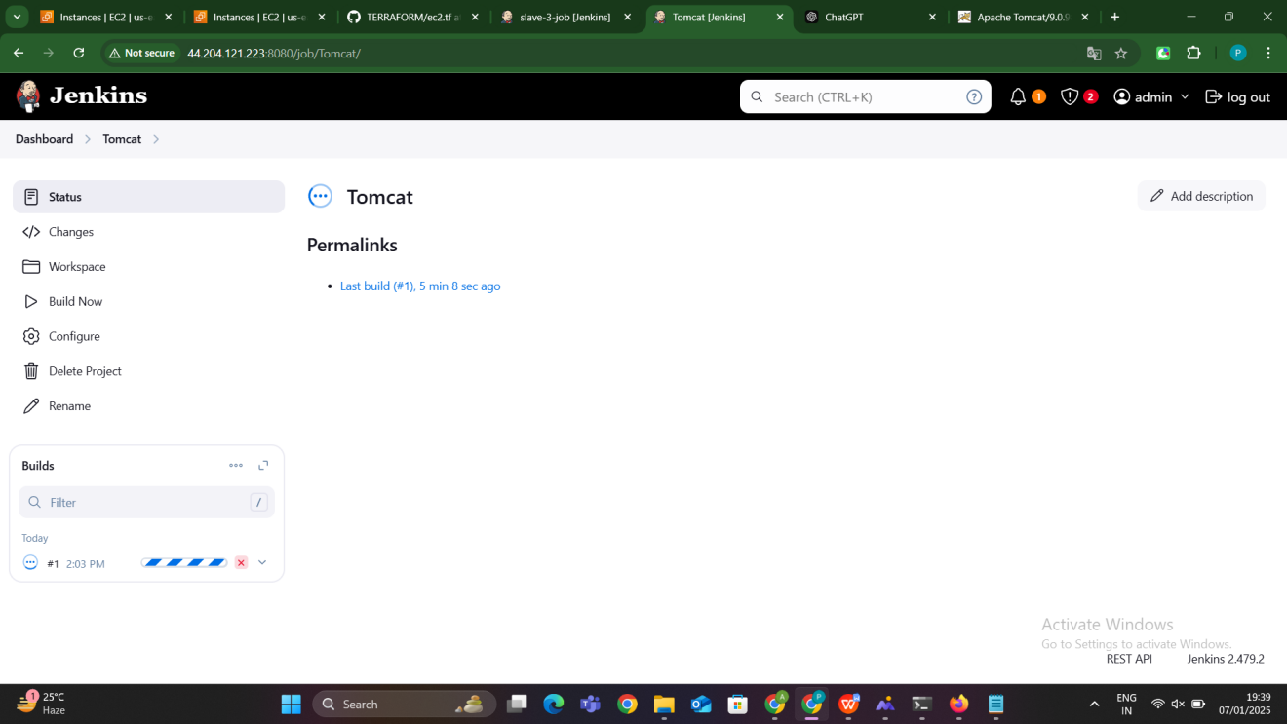

### ****Key Points****

* **Jenkins Master-Slave Setup**: The Jenkins master triggers the job, and the slave node executes the installation commands.
* **Automated Installation**: Jenkins automates the process of installing Tomcat, saving time and ensuring consistency across environments.
* **Tomcat Service**: By configuring Tomcat as a service, it is managed by systemd, ensuring it starts and stops properly.

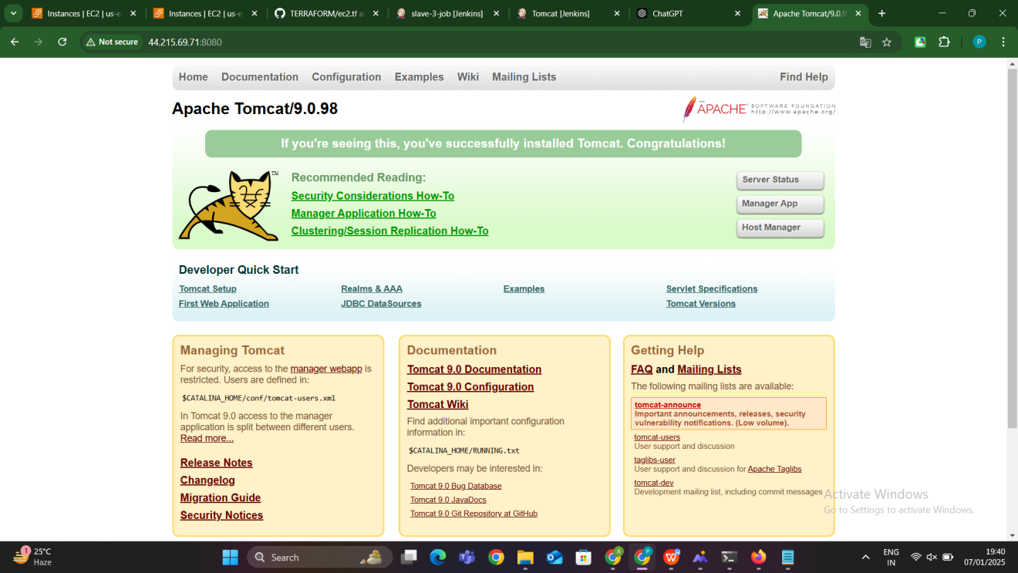

**Slave-5:Static application**

Below are the steps to **host a static web application** (e.g., an HTML website) on a **Jenkins Slave Node** using a **Jenkins Master-Slave setup**. This process will involve setting up the Jenkins environment, configuring the slave node, and running a job that deploys the static web application on a web server (e.g., Apache HTTP server or Nginx) on the slave node.

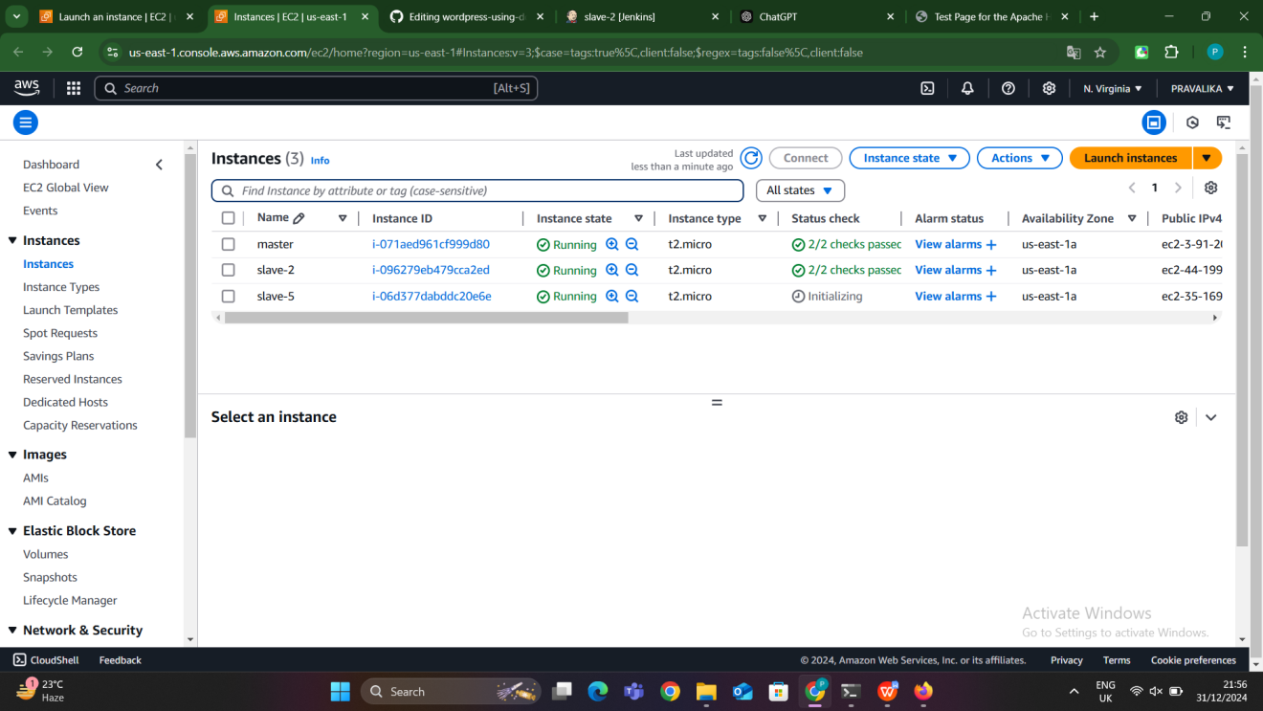

#### **1. Set Up the Jenkins Master and Slave Nodes**

Before proceeding with the deployment, make sure the **Jenkins Master-Slave setup** is already configured and the slave nodes are connected to the Jenkins master. If not, follow the steps to configure the master and slave nodes.

#### **Prepare the Static Application**

**Go to browser and search for free css templates copy url of any one of website**

Prepare your static web application (e.g., index.html, CSS, and JavaScript files).

Store this static application in a version control system like **Git** or keep it as a directory on the Jenkins master node.

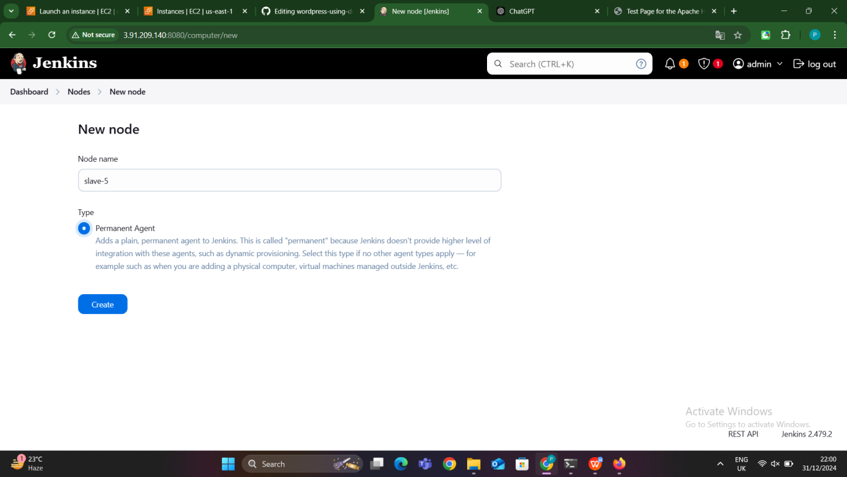

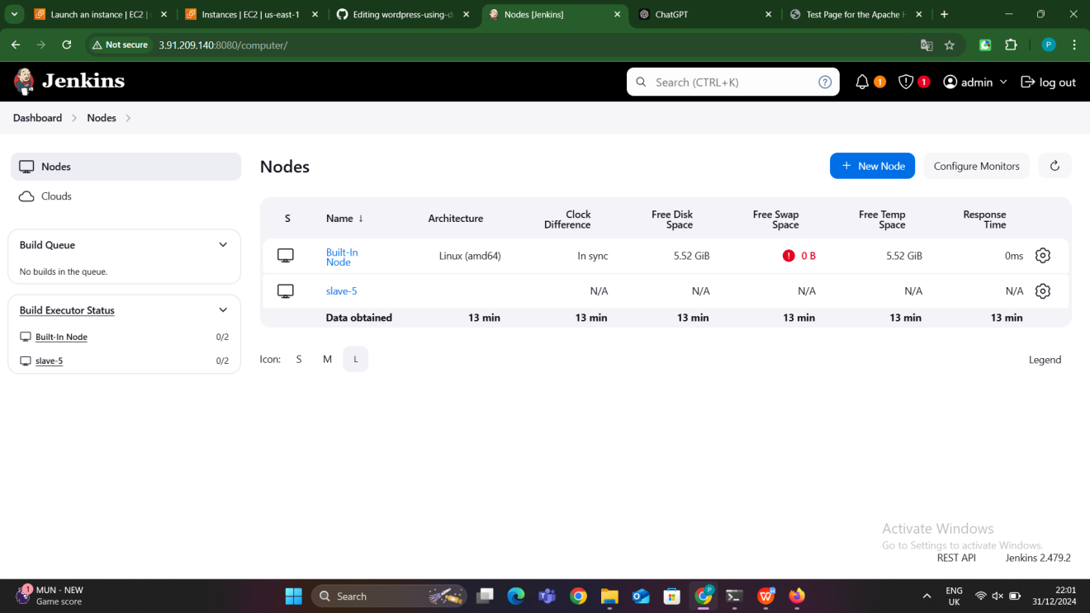

#### **3. Create a Jenkins Job**

1. Go to **Jenkins Dashboard**.
2. Click on **New Item** > **Freestyle Project**.
3. Name the job (e.g., Host-Static-App).
4. Select **Freestyle Project** and click **OK**.

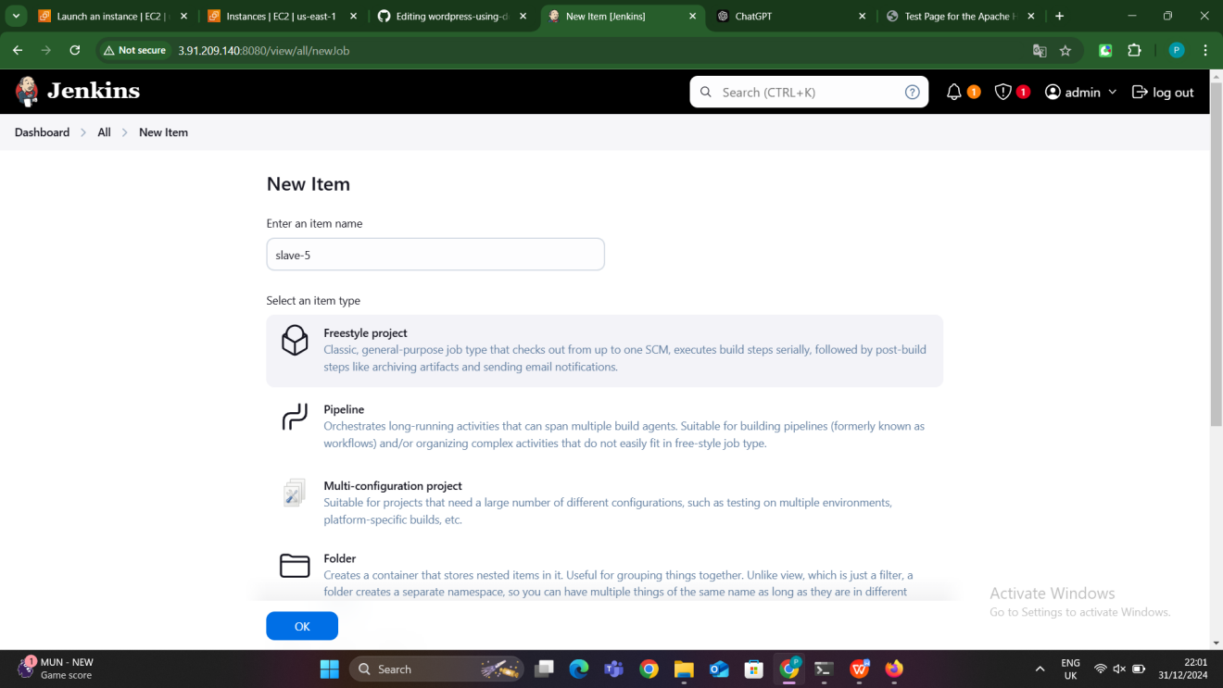

#### **4. Configure the Job to Run on a Slave Node**

1. In the **General** section, check the **Restrict where this project can be run** option.
2. In the **Label Expression** field, type the label of the slave node where you want the static app to be hosted (e.g., slave-static-app).
3. Click **Save**.

#### **5. Configure the Build Steps**

**Install a Web Server on Slave Node** (if not already installed):

* 1. Add a **Build Step** to install a web server (e.g., **Apache HTTP Server** or **Nginx**).

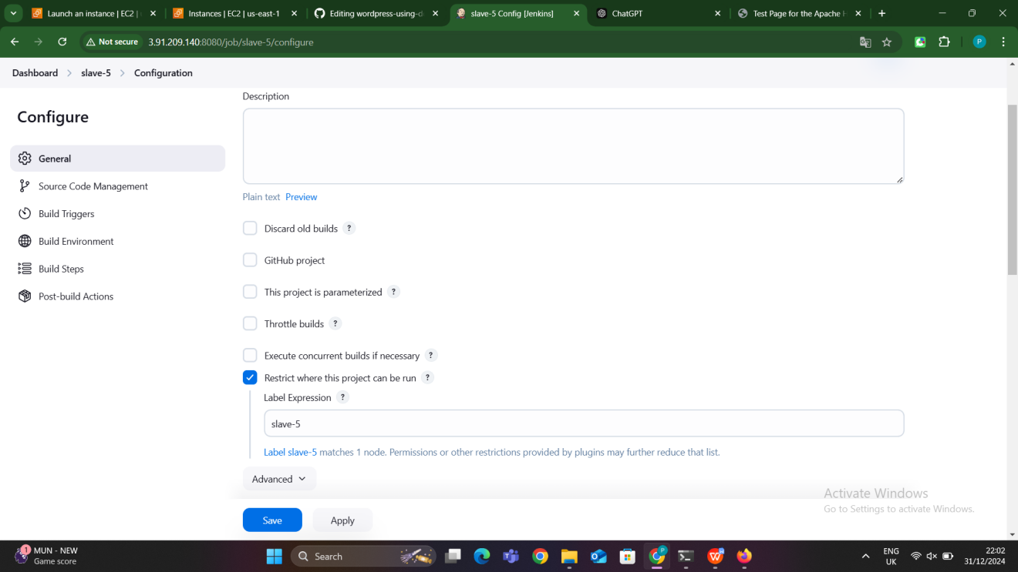

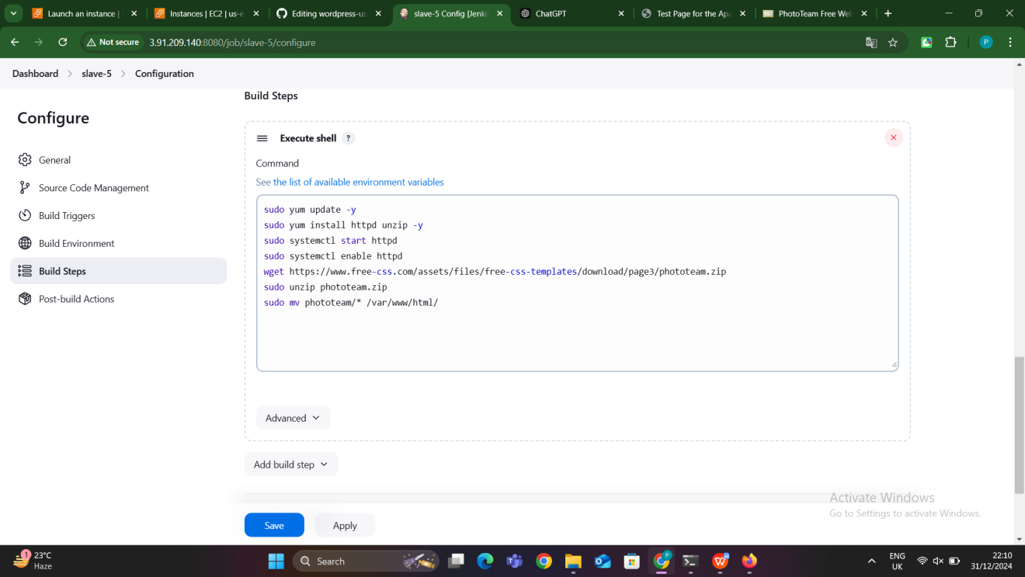

### ****1.**** sudo yum update -y

* sudo: Runs the command as a superuser (administrator), allowing elevated privileges.
* yum: The default package manager on **CentOS** or **RHEL** systems.
* update: This command updates all the installed packages to their latest available versions.
* -y: Automatically confirms the update without asking for user input.

**Explanation**: This command updates all installed packages on the system to their latest versions, ensuring that your system has the latest security patches and software updates.

### ****2.**** sudo yum install httpd unzip -y

* yum install: Installs the specified packages using the yum package manager.
* httpd: This is the package for **Apache HTTP Server**, a popular web server.
* unzip: Installs the unzip utility, which is used to extract .zip files.
* -y: Automatically confirms the installation of packages without asking for user input.

**Explanation**: This command installs **Apache HTTP Server** (httpd) and the **unzip** utility. Apache will be used to serve the static content, and unzip will help extract a .zip file.

### ****2.**** sudo yum install httpd unzip -y

* yum install: Installs the specified packages using the yum package manager.
* httpd: This is the package for **Apache HTTP Server**, a popular web server.
* unzip: Installs the unzip utility, which is used to extract .zip files.
* -y: Automatically confirms the installation of packages without asking for user input.

**Explanation**: This command installs **Apache HTTP Server** (httpd) and the **unzip** utility. Apache will be used to serve the static content, and unzip will help extract a .zip file.

### ****3.**** sudo systemctl start httpd

* systemctl: A systemd utility used to control system services (in this case, the Apache HTTP server).
* start: Tells systemctl to start the **Apache HTTP Server** service.
* httpd: This is the service name for Apache on CentOS/RHEL-based systems.

**Explanation**: This command starts the **Apache HTTP Server** service, allowing it to serve HTTP requests. After this, Apache will begin accepting requests on port 80 by default.

### ****4.**** sudo systemctl enable httpd

* systemctl: The systemd utility to manage system services.
* enable: Configures the system to start the specified service (httpd in this case) automatically at boot.
* httpd: The name of the service to be enabled.

**Explanation**: This command ensures that the **Apache HTTP Server** will start automatically whenever the system is rebooted, making the web server persistent across system restarts.

### ****5.**** wget https://www.free-css.com/assets/files/free-css-templates/download/page3/phototeam.zip

* wget: A command-line tool for downloading files from the internet.
* https://www.free-css.com/assets/files/free-css-templates/download/page3/phototeam.zip: The URL of the zip file (in this case, a free CSS template for a website called "Phototeam").

**Explanation**: This command uses wget to download the **Phototeam** template from the specified URL. It will save the file as phototeam.zip in the current working directory.

### ****6.**** sudo unzip phototeam.zip

* unzip: A utility to extract files from a .zip archive.
* phototeam.zip: The name of the zip file to be extracted.

**Explanation**: This command extracts the contents of the phototeam.zip archive. After running this command, the contents (e.g., HTML, CSS, and JavaScript files) will be available in the current directory.

### ****7.**** sudo mv phototeam/* /var/www/html/

* mv: The command to move or rename files.
* phototeam/*: This refers to all the files inside the extracted phototeam folder.
* /var/www/html/: The default directory where Apache serves web content on CentOS/RHEL systems.

**Explanation**: This command moves all the files from the phototeam folder to the Apache web server's root directory (/var/www/html/). By doing this, Apache will serve these files as the website content. After the files are moved, Apache will serve the **Phototeam** template as the default webpage.

#### **6. Save and Build the Job**

1. After configuring the build steps, **click Save**.
2. Go to the Jenkins dashboard, select the newly created job, and click **Build Now**.

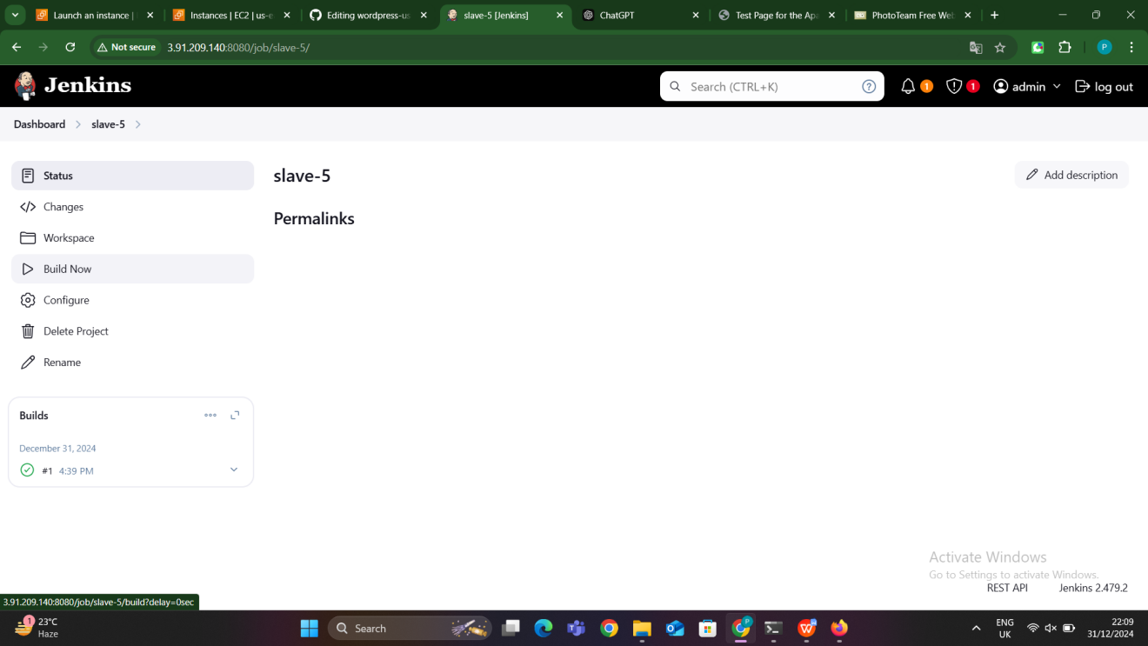

#### **7. Access the Static Application**

After the job is successfully executed, the static application should be available at:

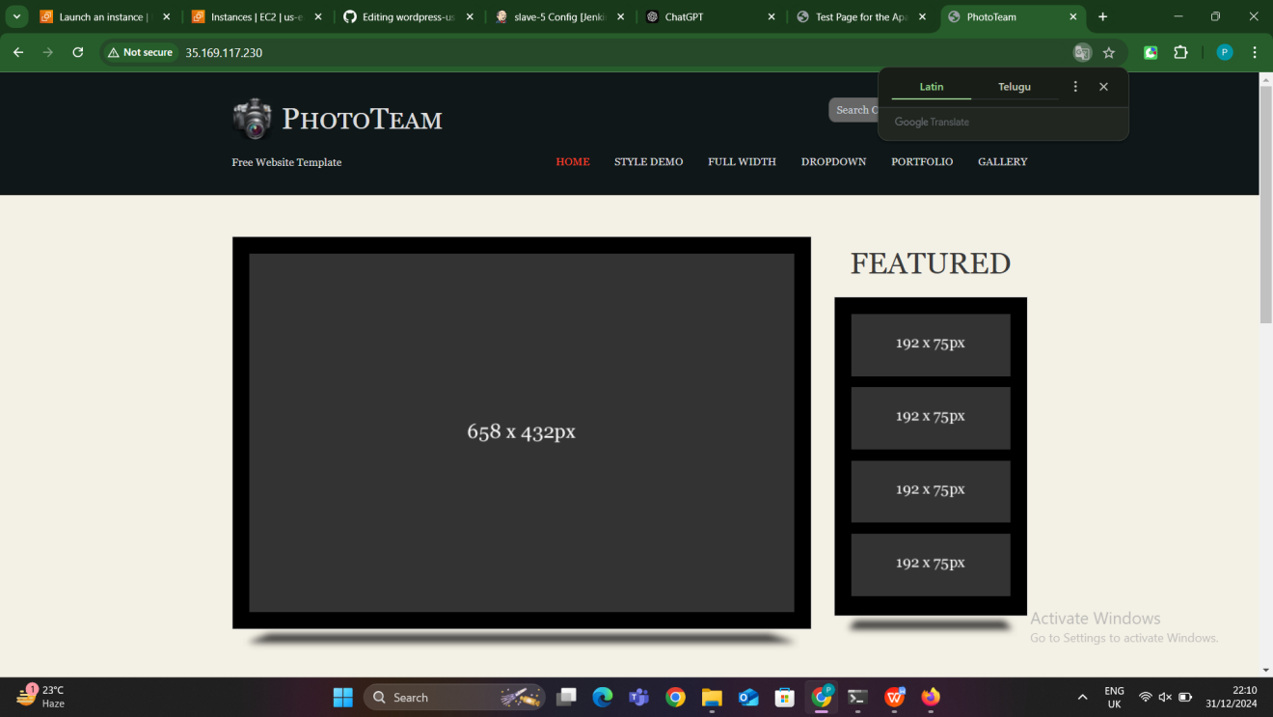

### ****Summary of Key Concepts:****

**Jenkins Master-Slave Concept**: The Jenkins master triggers the job, and the slave node executes the job to install the web server and deploy the static application.

**Web Server Installation**: In the job, a web server (Apache or Nginx) is installed and configured to serve the static web application.

**Static Application Deployment**: The static files (e.g., index.html, CSS, JS) are copied to the appropriate directory on the slave node’s web server and served to users.

**Automation**: Jenkins automates the entire deployment process, ensuring that the static application is consistently deployed every time the job runs.

**Method-2 Python project deployment**

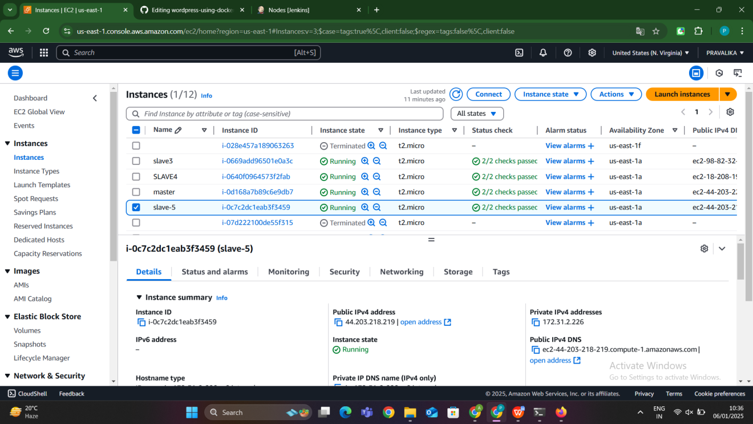

**METHOD-2**

### ****What is Python?****

**Python** is a high-level, general-purpose programming language known for its simplicity and readability. It was created by **Guido van Rossum** and first released in 1991. Python is widely used for various applications, including web development, data analysis, artificial intelligence, automation, and more.

#### Key Features of Python:

1. **Easy to Learn and Use**: Python has a simple syntax, making it beginner-friendly.
2. **Interpreted Language**: Python code is executed line-by-line by an interpreter, which makes debugging easier.
3. **Versatile**: Python supports multiple programming paradigms (e.g., procedural, object-oriented, functional).
4. **Extensive Libraries**: Python has a rich ecosystem of libraries and frameworks, such as NumPy, Pandas, Flask, Django, TensorFlow, etc.
5. **Platform Independent**: Python programs can run on multiple platforms like Windows, macOS, and Linux.

#### Why is Python Used?

* For **web development** (using Flask, Django).
* For **data science** and **machine learning** (using NumPy, Pandas, TensorFlow).
* For **automation** and scripting tasks.
* For **building APIs** and microservices.

### ****What is pip?****

**pip** stands for "Pip Installs Packages." It is the official package manager for Python, used to install, manage, and uninstall Python libraries and dependencies.

#### Key Features of pip:

1. **Ease of Use**: Simplifies the process of managing external libraries for Python projects.
2. **Repository Support**: Downloads packages from the **Python Package Index (PyPI)**, a vast repository of Python libraries.
3. **Dependency Management**: Automatically resolves and installs package dependencies.

### ****Why Do We Use Python and pip Together?****

* **Python** is the language in which you write your application or program.
* **pip** is the tool you use to install additional libraries or frameworks needed to extend Python's functionality.

**SLAVE-1:**

### ****Setup: Master-Slave Configuration****

**Install Jenkins (Master):**

* 1. Install Jenkins on the master server.
  2. Ensure Jenkins is up and running.

**Set Up Slave Node:**

* Install Java on the slave machine (required for Jenkins agent).
* In the Jenkins master dashboard:
  1. Go to **Manage Jenkins > Manage Nodes and Clouds**.
  2. Click on **New Node**, give it a name, and select **Permanent Agent**.
  3. Configure the node with the following details:
     + Remote root directory: Directory on the slave machine where Jenkins will run jobs (e.g., /home/jenkins/).
     + Labels: Add a label (e.g., python-slave).
     + Launch method: Select **Launch agent via SSH**, and provide the SSH credentials.
* Save the configuration and connect the slave to the master. Ensure the node shows as "online."

### ****Deploy Python Web Application****

#### **Step 1: Create a New Jenkins Job**

1. Navigate to Jenkins dashboard and click **New Item**.
2. Select **Freestyle Project**, provide a name (e.g., Deploy-Python-App), and click **OK**.

#### **Step 2: Configure the Job**

**Source Code Management:**

* 1. Select **Git**.
  2. Enter the repository URL containing the Python project.

**Restrict Job to Slave Node:**

* 1. Under the **General** section, check **Restrict where this project can be run**.
  2. Enter the slave label (e.g., python-slave).

**Build Steps:**

* 1. In the **Build** section, click **Add build step** and select **Execute shell**.

#### **Step 3: Save and Build**

1. Save the configuration.
2. Trigger the build manually by clicking **Build Now** .

### ****Step 4: Verify Deployment****

1. Check the build logs in Jenkins to ensure the application is deployed without errors.
2. Access the Python application by visiting the URL where the app is hosted (e.g., http://<slave-node-ip>:<port>)

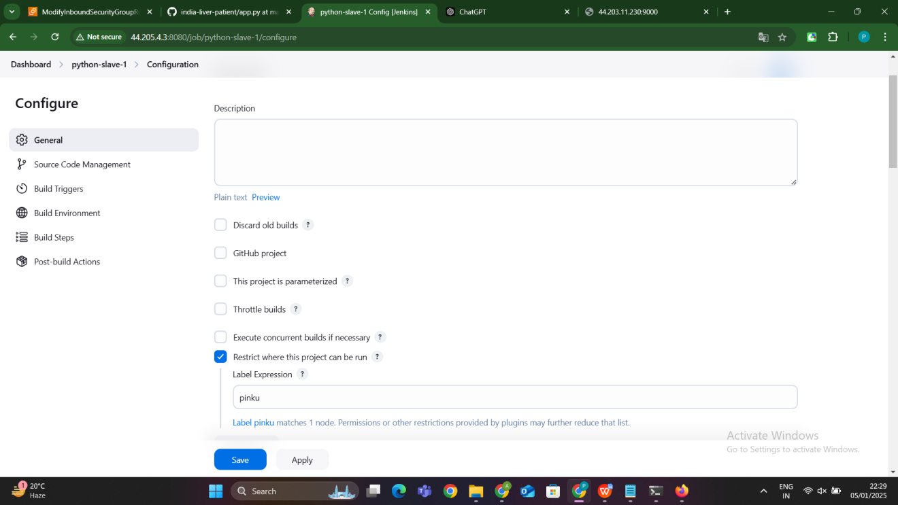

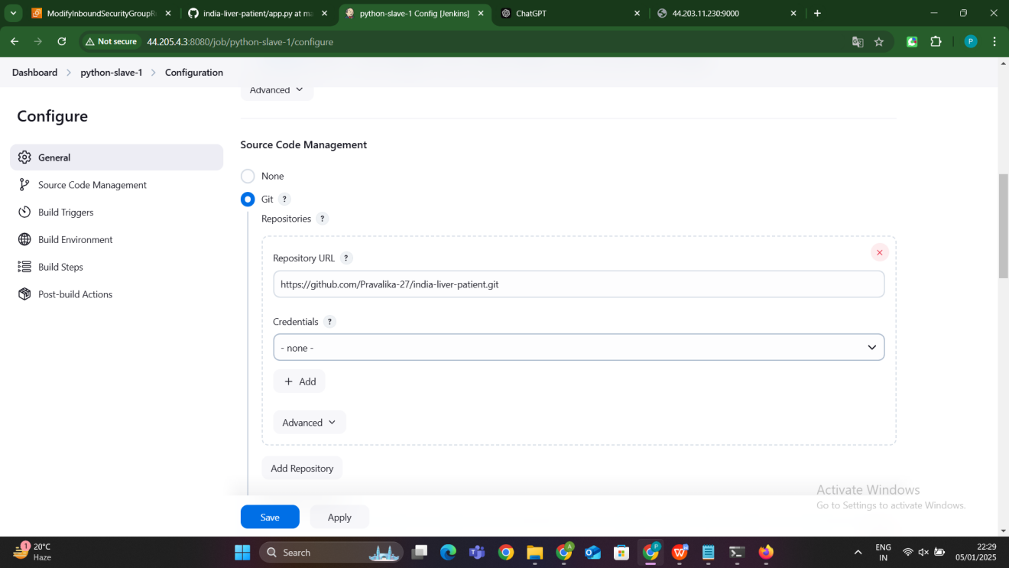

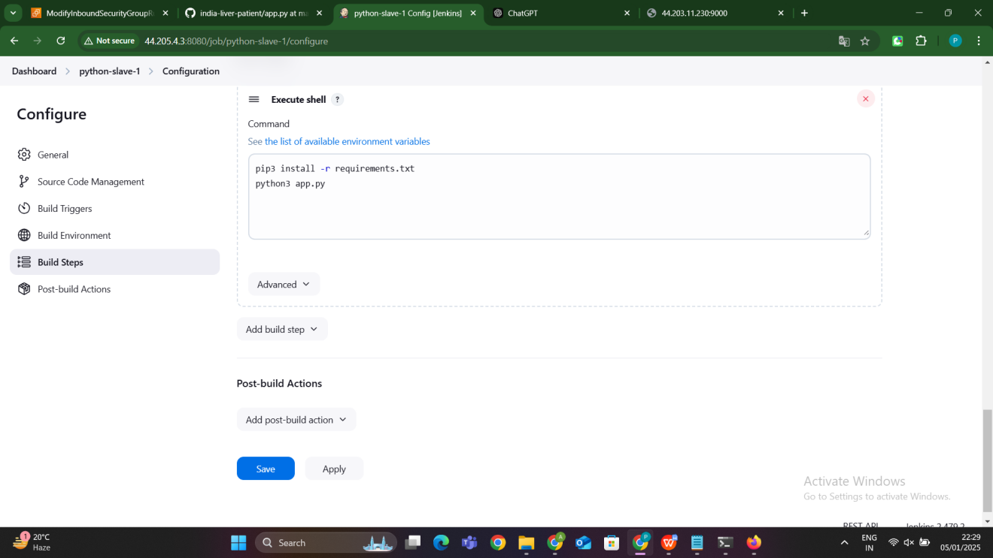

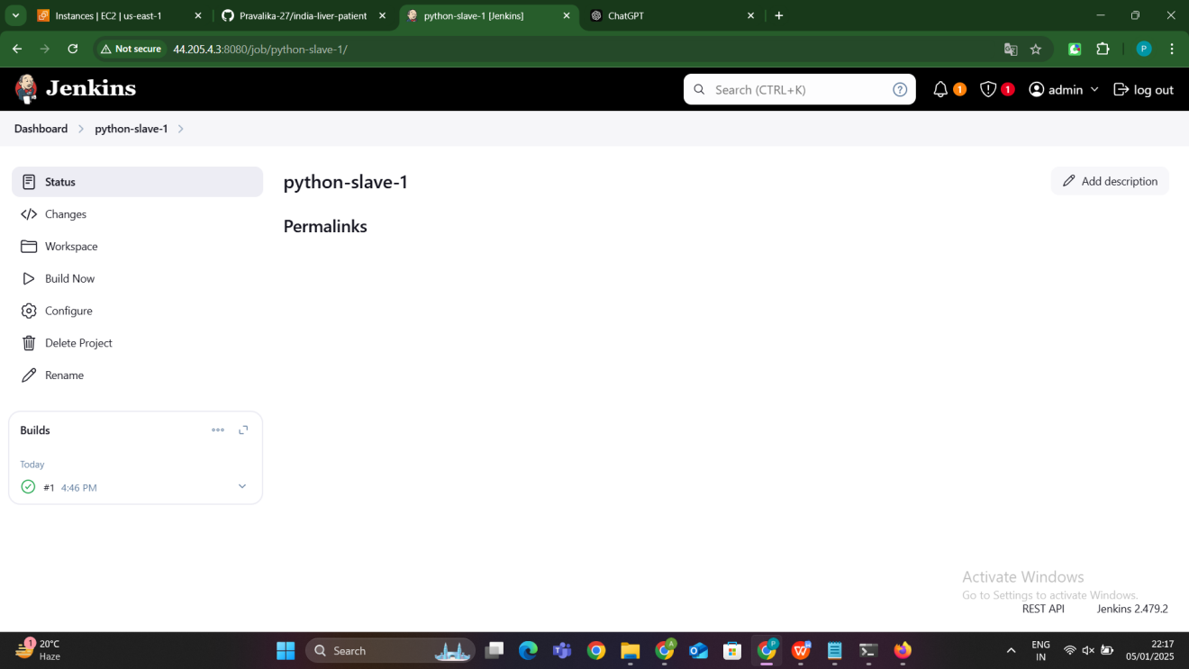

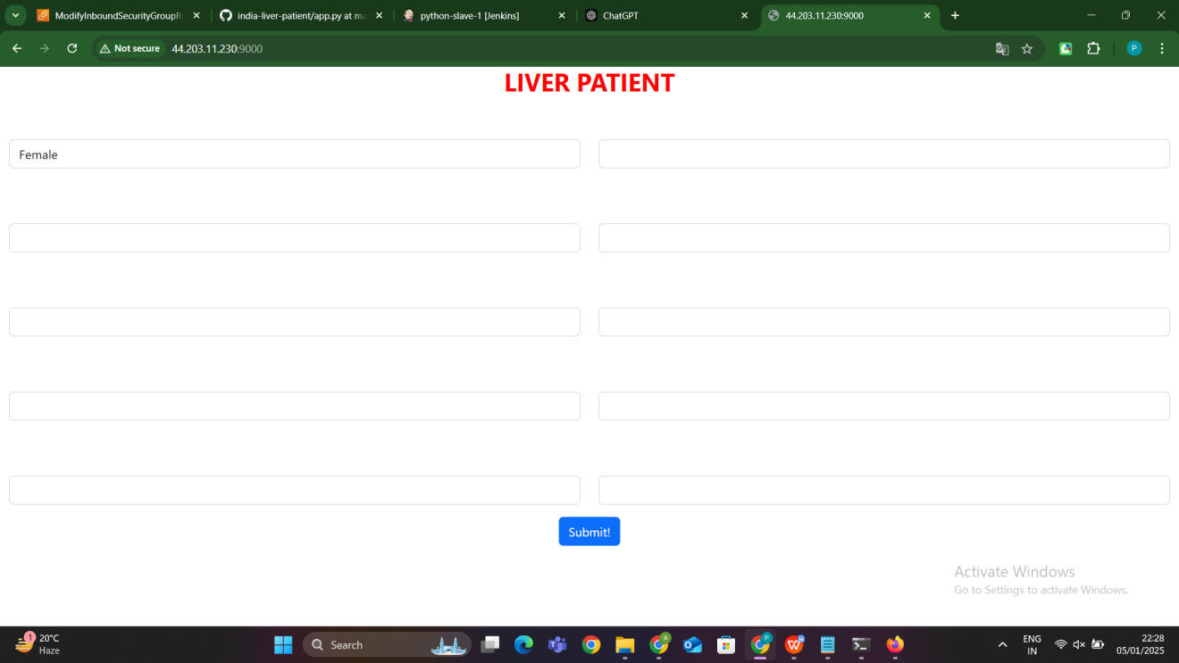

**SLAVE-2:Python application deployment using bashscript**

### ****Step 1: Master-Slave Setup****

**Install Jenkins on Master Node:**

* 1. Ensure Jenkins is installed and running on the master node.
  2. Add the slave node to the master (as explained in the earlier steps).

**Prepare the Slave Node:**

* 1. Install Python3, pip3, and Git on the slave machine if not already installed.
  2. Ensure the slave node can run Bash scripts from Jenkins.

### ****Step 3: Configure Jenkins Job****

**Create a New Job:**

* 1. Go to the Jenkins dashboard, click **New Item**, and create a **Freestyle Project**.

**Source Code Management:**

* 1. Choose **None** (as the Bash script will directly fetch and deploy the repository).

**Restrict Job to Slave Node:**

* 1. Under the **General** section, check **Restrict where this project can be run**.
  2. Add the label for the slave node (e.g., python-slave).

**Build Steps:**

* 1. Add a **Build Step** → **Execute shell**.

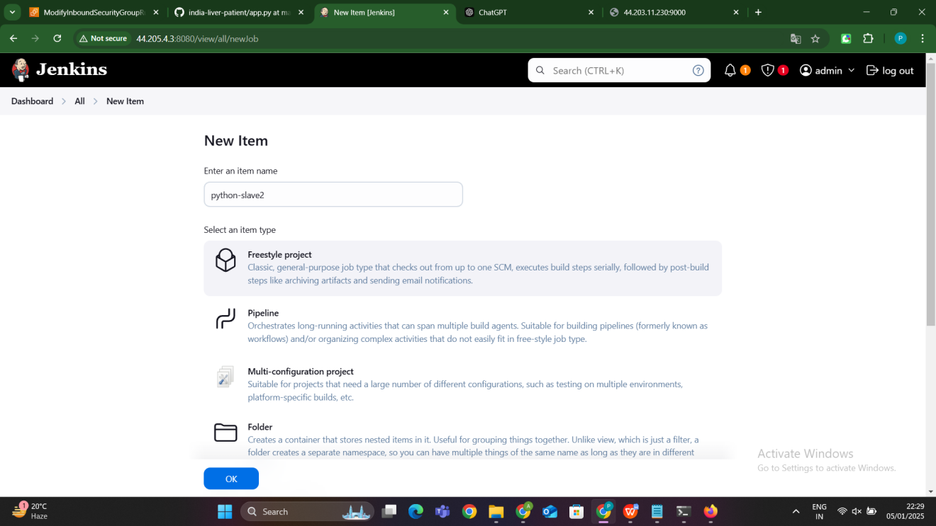

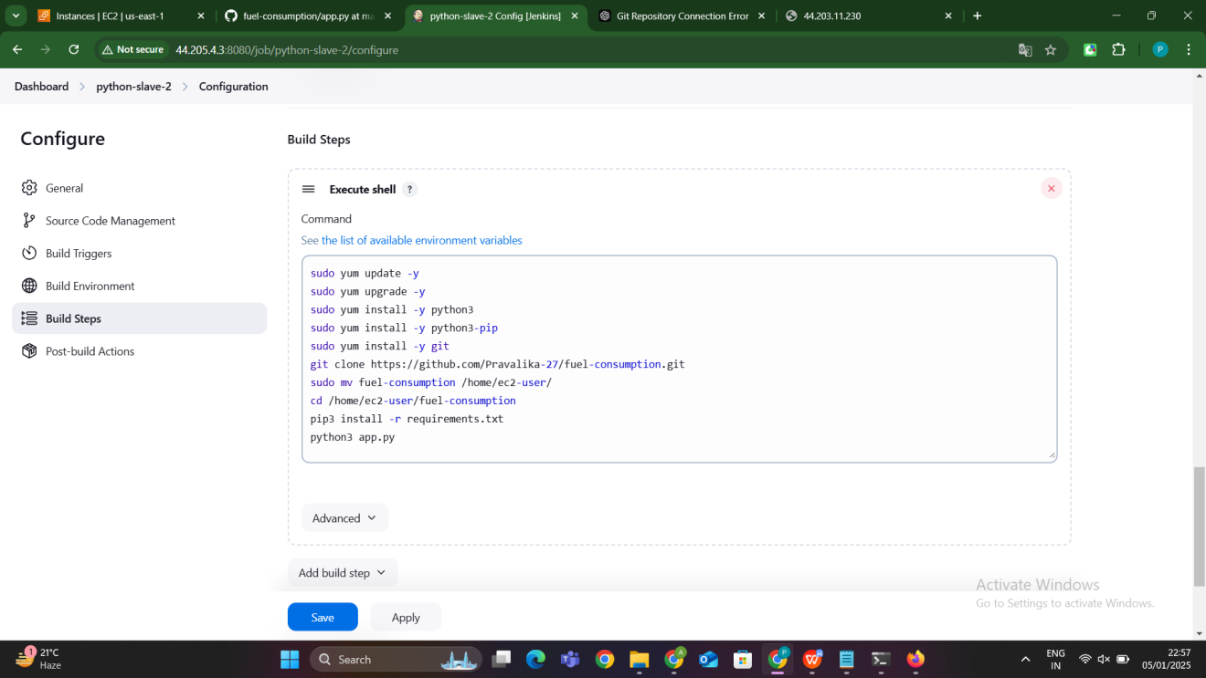

**Explaination:**

yum update: This command updates the package database of the system to ensure that the list of available software packages is current. It checks for any available updates for the installed software on the system and fetches the updated metadata from the configured software repositories.

yum upgrade: This command performs the actual upgrade of installed packages to their latest versions based on the updated package metadata. It ensures that the system is running the most recent and stable versions of all installed software, which may include important security updates, bug fixes, and performance improvements.

-y: This flag automatically answers "yes" to any prompts during the execution of the commands, allowing the commands to run without manual intervention.

**Purpose**: These commands ensure that the operating system is up-to-date before installing new software, which is important for security and compatibility.

sudo yum install -y python3

yum install: This command installs a specified package (in this case, Python 3) from the software repositories.

python3: This is the name of the package being installed, which refers to the Python 3 programming language. Python is a high-level programming language commonly used for web development, data analysis, automation, and much more.

**Purpose**: Installing Python 3 is necessary for running Python-based applications. This step ensures that Python is available on the system.

sudo yum install -y python3-pip

python3-pip: This is the package name for pip3, the package manager for Python 3. pip3 allows the user to easily install and manage Python libraries and dependencies from the Python Package Index (PyPI).

yum install: This command installs the specified package (pip3) on the system.

**Purpose**: pip3 is required to install any third-party Python packages, such as web frameworks (e.g., Flask, Django) or libraries (e.g., numpy, pandas). It ensures the application can access the necessary libraries specified in the requirements.txt file.

git: Git is a distributed version control system used to track changes in source code during software development. It allows multiple developers to collaborate on a project and track changes to the codebase.

yum install: This command installs Git on the system.

**Purpose**: Git is required to clone (download) a repository from platforms like GitHub, GitLab, or Bitbucket. This step ensures that the project code can be fetched from an online repository.

git clone: This command is used to create a copy of a remote Git repository. It downloads all the files from the specified repository (in this case, the fuel-consumption repository from GitHub) to the local machine.

https://github.com/Pravalika-27/fuel-consumption.git: The URL of the Git repository being cloned. This repository contains the source code for the Python project.

**Purpose**: The git clone command is used to retrieve the project files from a remote repository and store them locally on the machine. This step is necessary to get the project code onto the server.

mv: This command is used to move files or directories from one location to another. In this case, it moves the fuel-consumption directory to a new location.

fuel-consumption: The source directory containing the cloned Git repository.

/home/ec2-user/: The destination directory where the project will be moved.

**Purpose**: The mv command is used to organize the files by placing them in a specific directory on the system. It helps in structuring the application files for easier management.

cd: The cd (change directory) command is used to change the current working directory in the terminal.

/home/ec2-user/fuel-consumption: The path to the directory where the application files were moved.

**Purpose**: This command ensures that subsequent commands are executed within the project directory, where the application files and dependencies are located.

pip3 install: This command uses pip3, the Python package manager, to install Python libraries.

-r requirements.txt: This tells pip3 to read the requirements.txt file, which contains a list of all the required libraries (dependencies) for the project. Each line in this file specifies a package that should be installed.

**Purpose**: This step installs all the necessary Python libraries listed in the requirements.txt file. These libraries are essential for the application to run, such as web frameworks, database connectors, etc.

python3: This command is used to run a Python script using Python 3.

app.py: This is the Python script that starts the application. It typically contains the logic for initializing and running the web server or the core functionality of the application.

**Purpose**: Running the app.py script starts the Python application. If the application is a web server (e.g., Flask), this command will start it, allowing the application to accept requests from clients.

### ****Step 4: Trigger the Job****

1. Go to the Jenkins dashboard.
2. Click on the newly created job.
3. Trigger the build by clicking **Build Now**.

### ****Step 5: Access the Application****

1. Once the build is complete, check the console output in Jenkins to confirm the Python application has started successfully.

### Access the application using the slave instance's IP address and the port defined in your Python project (e.g., http://****Advantages of Using a Bash Script in Jenkins****

1. **Simplified Process**: The deployment logic is centralized in a single script.
2. **Reusability**: The same script can be used outside Jenkins or adapted for other projects.
3. **Customization**: Easily add or modify commands based on project requirements.
4. **Portability**: Works seamlessly across environments with similar configurations
5. <slave-node-ip>:<port>).

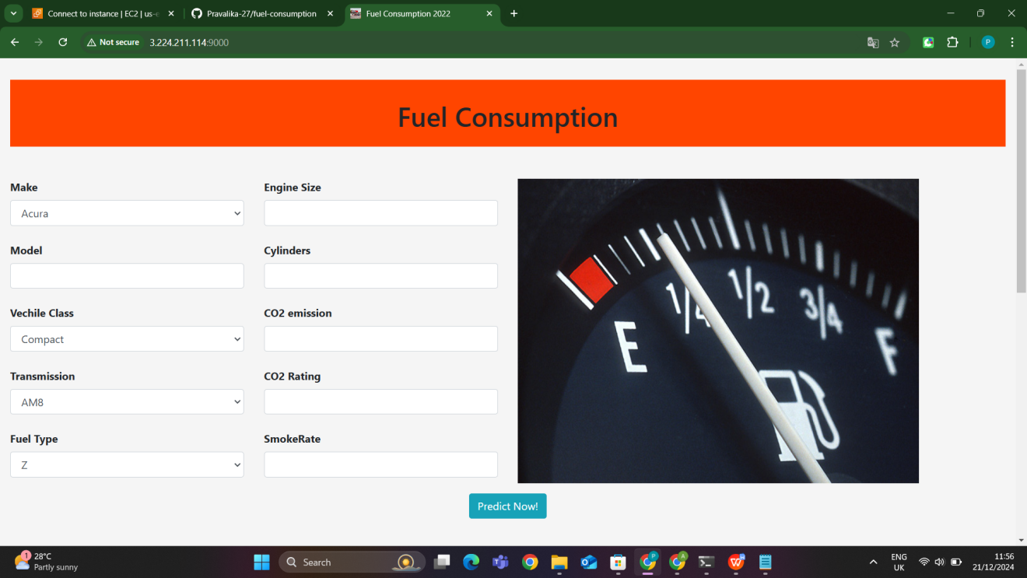

**SLAVE-3:Using Terraform :**

### ****1. Set Up Jenkins Master-Slave Architecture****

* **Jenkins Master**: Manages Jenkins tasks and jobs.
* **Jenkins Slave**: Executes the jobs assigned by the master. In this case, it's a system where you will deploy the Python project using Terraform.

**Step-by-Step:**

1. **Install Jenkins Master** on a server (if not already installed).
2. **Add Jenkins Slave** by configuring the Slave node in Jenkins:
   1. On the Jenkins Dashboard, go to **Manage Jenkins** → **Manage Nodes and Clouds** → **New Node**.
   2. Select **Permanent Agent** and give it a name (e.g., slave-3).
   3. Set the **Remote Root Directory** (this will be the directory on the slave node where Jenkins will work).
   4. Provide the necessary connection details like **Launch Method** (e.g., via SSH).
   5. **Save** the configuration.

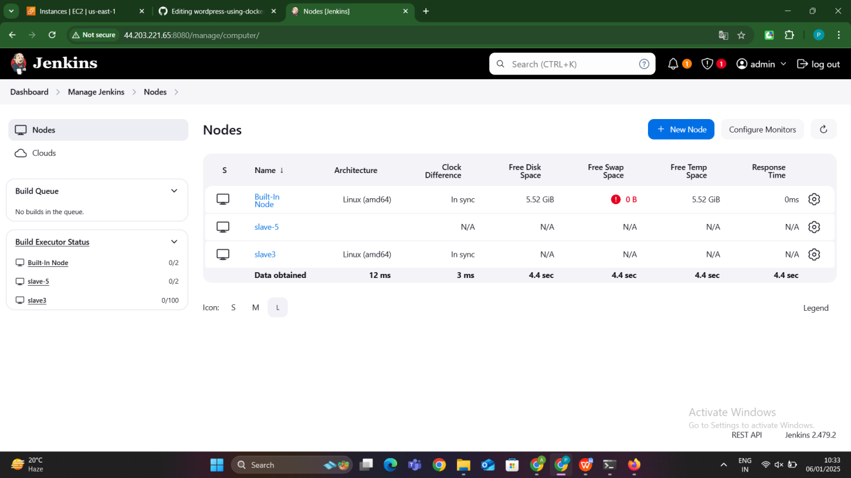

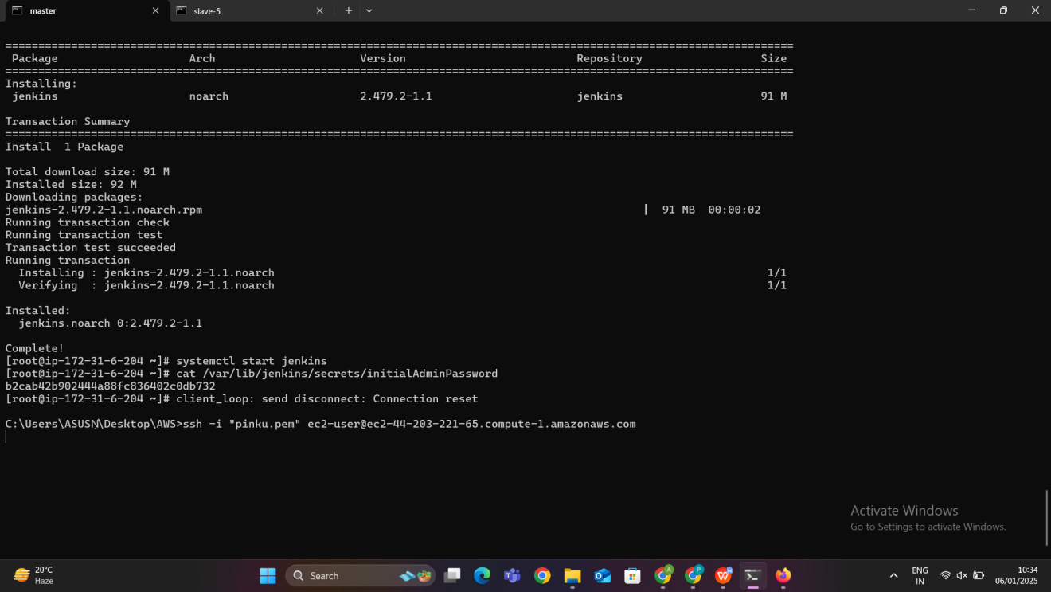

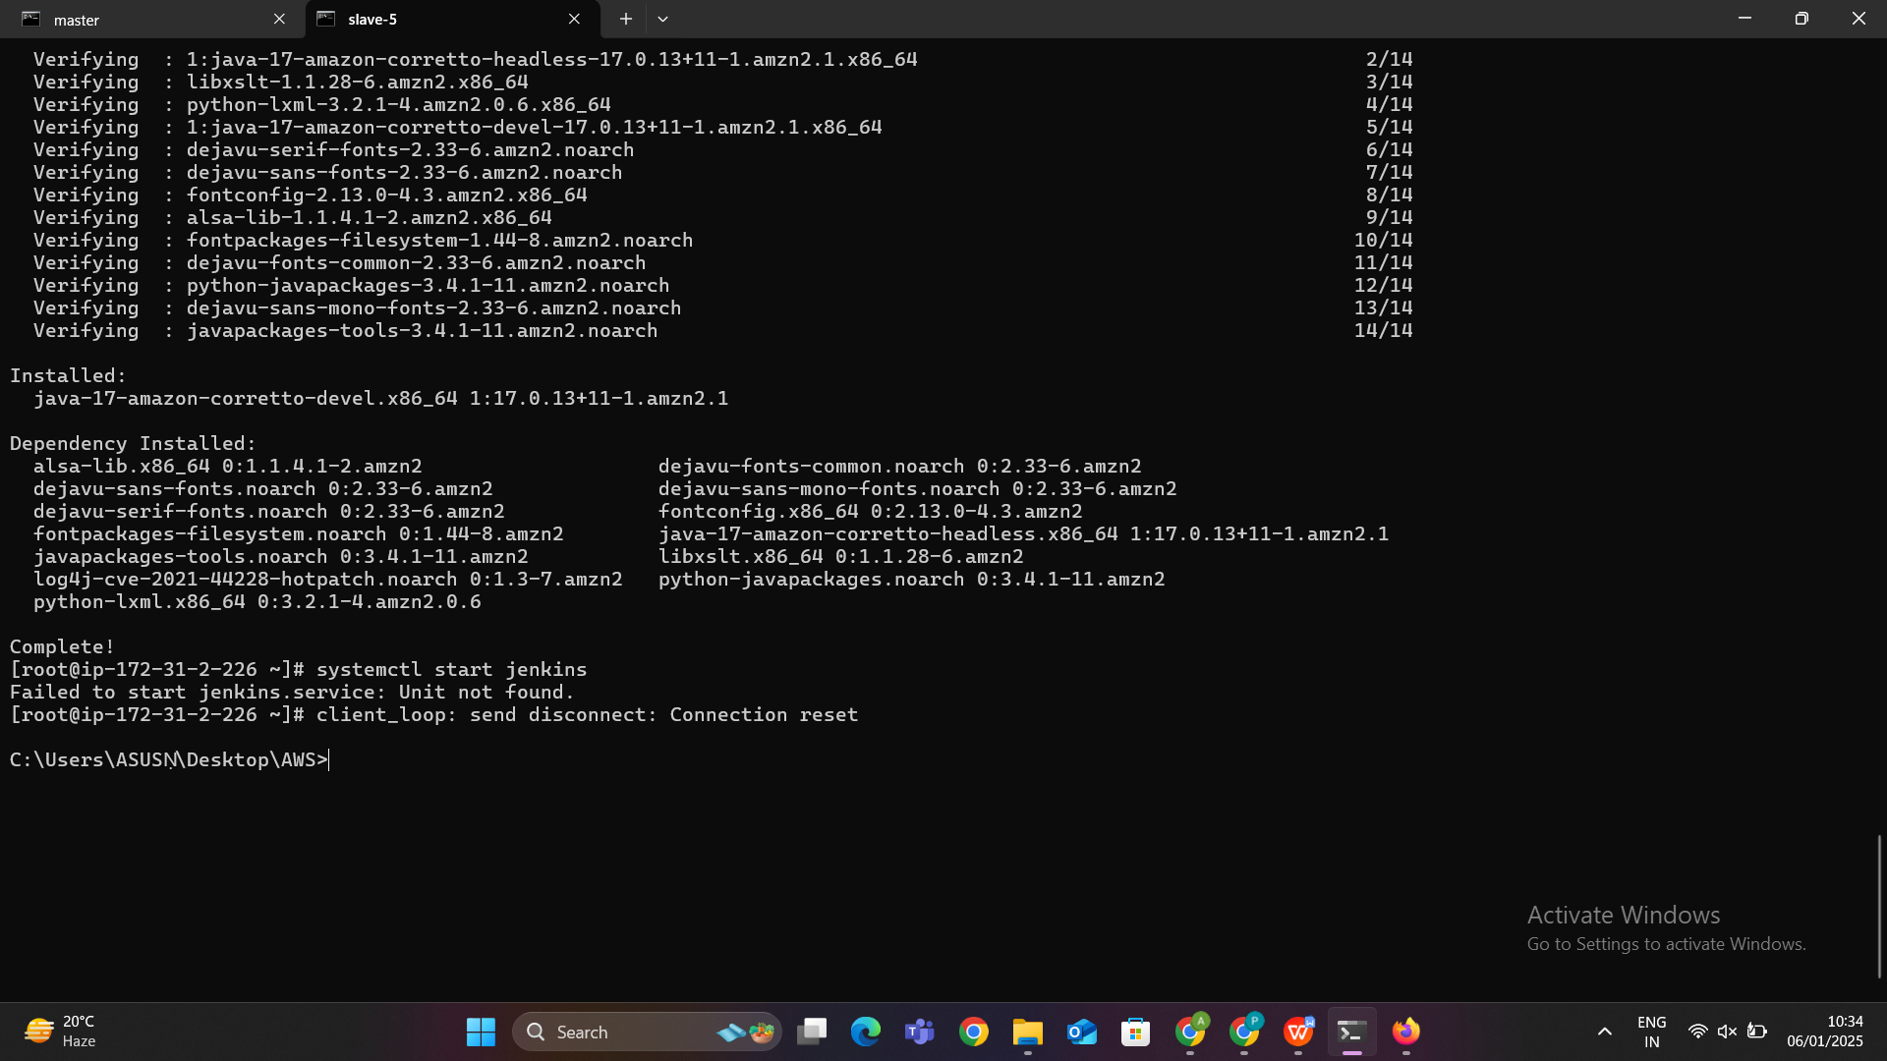

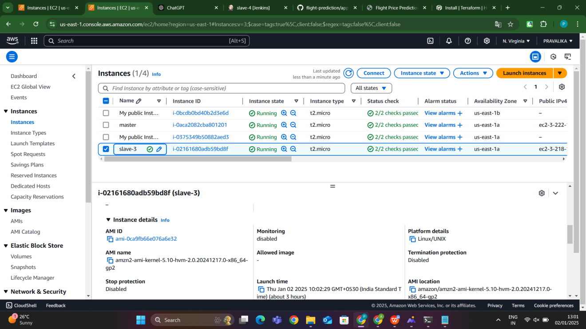

### ****2. Install Required Plugins in Jenkins****

* **AWS Credentials Plugin**: This plugin will allow Jenkins to interact with AWS services using your AWS credentials.
* **Terraform Plugin**: If you want to directly use the Terraform commands inside Jenkins.

**Install AWS Credentials Plugin**:

1. Go to **Manage Jenkins** → **Manage Plugins** → **Available** tab.
2. Search for **AWS Credentials Plugin** and install it.
3. After installation, restart Jenkins.

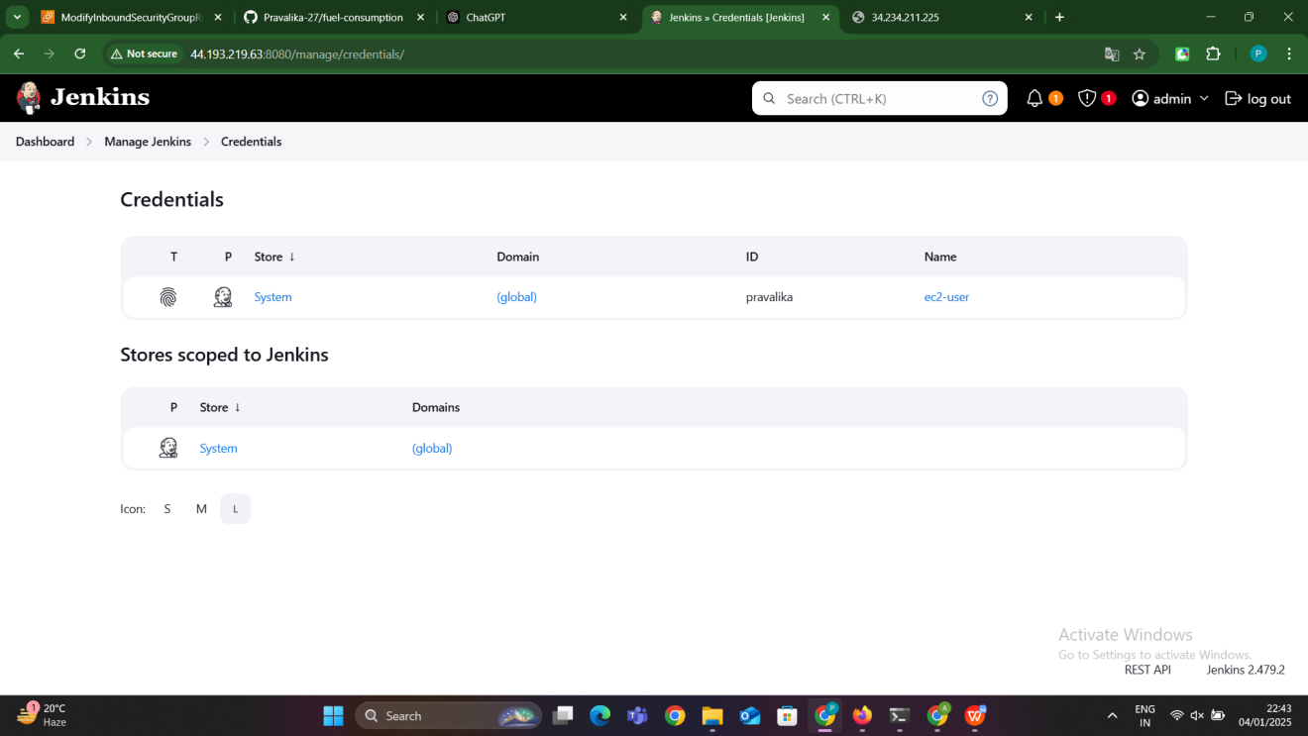

### ****3. Configure AWS Credentials in Jenkins****

1. Go to **Manage Jenkins** → **Configure System**.
2. Scroll down to **AWS Credentials**.
3. Add a new **AWS Access Key** by providing:
   1. **Access Key ID**
   2. **Secret Access Key**
4. Save the configuration.

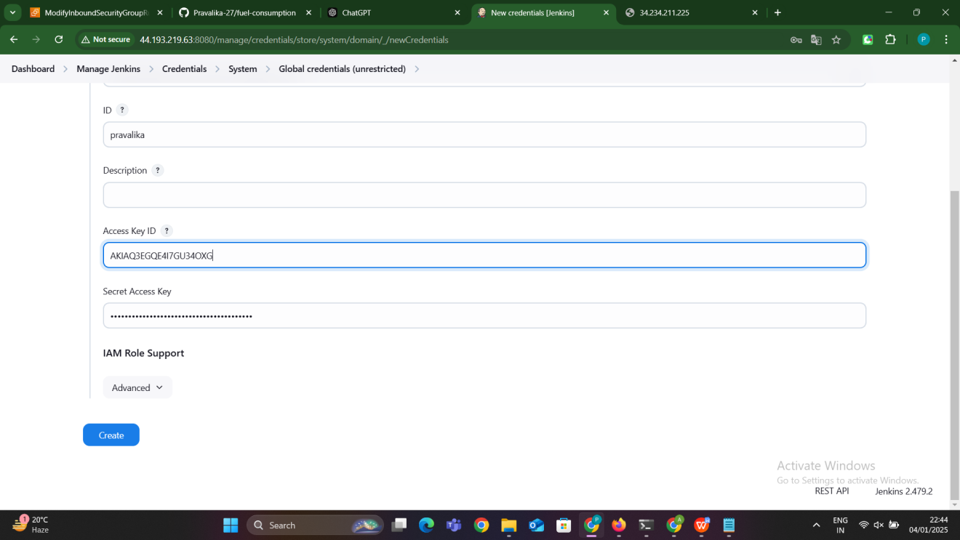

### ****5. Configure the Job for Terraform Execution****

**Configure Source Code Management**:

* 1. Under **Source Code Management**, select **Git**.
  2. Add your repository URL, e.g., https://github.com/Pravalika-27/python-project-deployment.git.
  3. Provide the necessary credentials if required.

**Configure Build Triggers** (optional):

* 1. You can set up triggers, like **Poll SCM** or **Build periodically**, if you want the job to run automatically based on changes to the repository or on a schedule.

**Configure Build Environment**:

* 1. Ensure that the Slave node (slave-3) is selected in the **Restrict where this project can be run** section.

**Configure Build**:

* 1. In the **Build** section, add an **Execute Shell** build step.
  2. Copy and paste the following script:

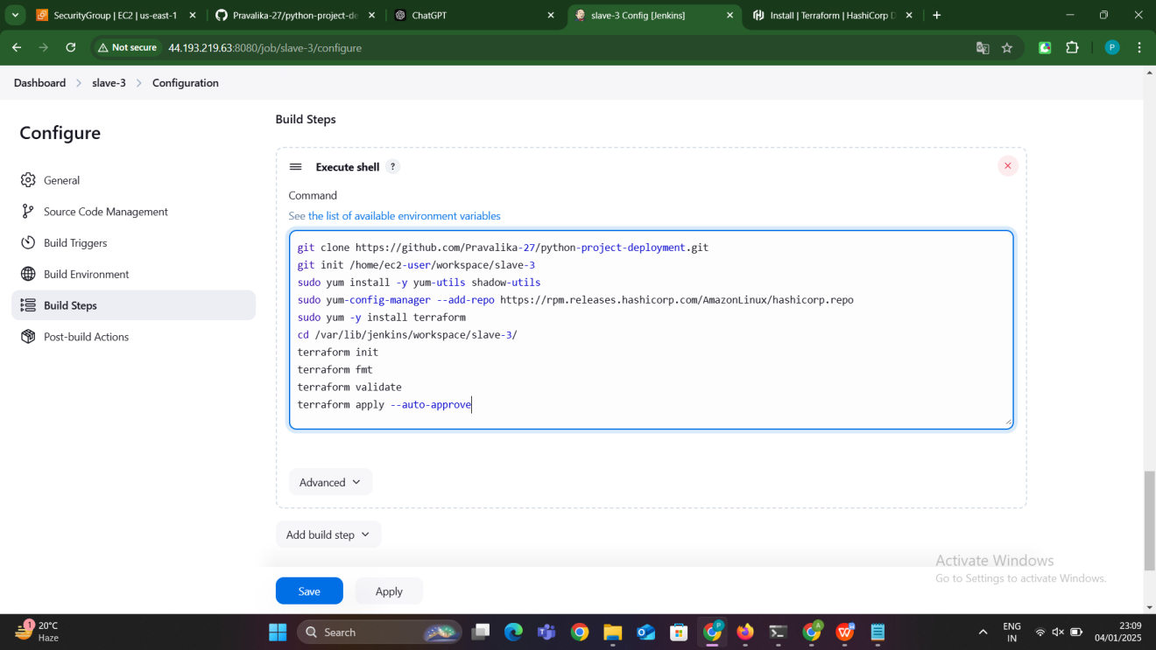

**Explanation**:

* git clone: Fetches the Python project repository from GitHub.
* git init: Initializes a Git repository in the specified directory (not strictly necessary if you've already cloned the repo).
* yum install: Installs necessary utilities to manage packages and install Terraform.
* yum-config-manager: Adds HashiCorp's repository for installing Terraform.
* terraform init: Initializes the Terraform environment by downloading necessary provider plugins and dependencies.
* terraform fmt: Formats the Terraform configuration files to make the code clean and consistent.
* terraform validate: Validates the Terraform configuration files to check for any errors.
* terraform apply --auto-approve: Deploys the infrastructure defined in the Terraform configuration and automatically approves the actions without requiring manual confirmation.

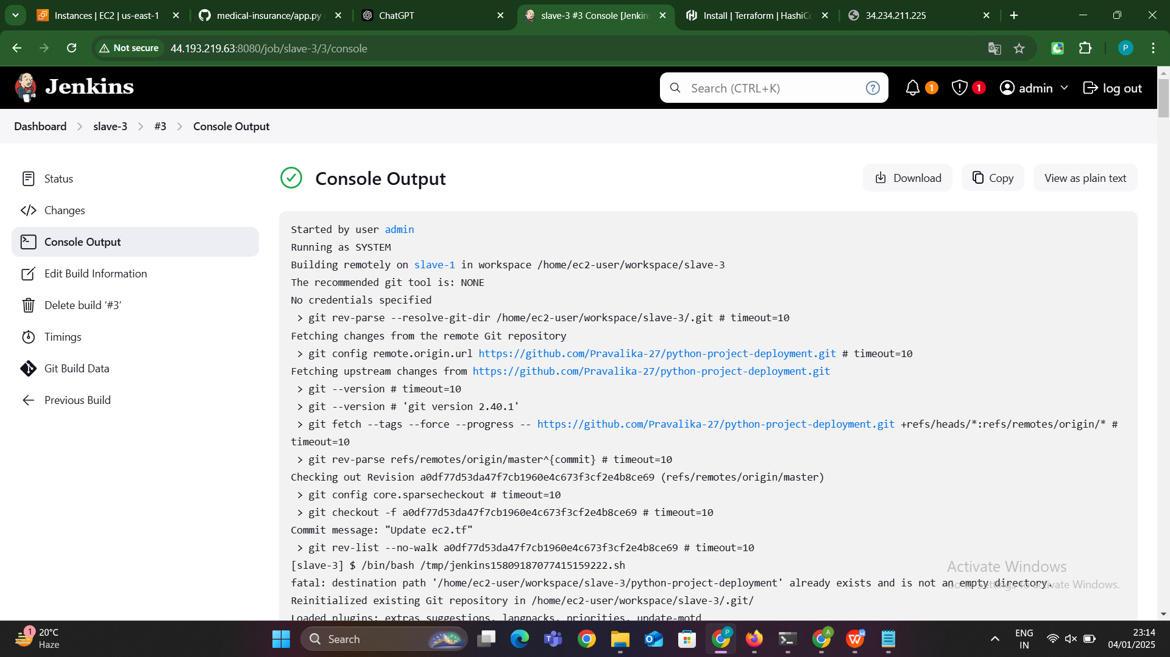

### ****Run the Job and Access the Application****

**Build the Job**: Click **Build Now** to start the job. Jenkins will:

* 1. Clone the repository.
  2. Install Terraform and other dependencies.
  3. Initialize, validate, and apply the Terraform configuration.
  4. Deploy the infrastructure (e.g., creating an EC2 instance, security groups, etc.).

**Check Build Logs**: Monitor the console output to see the progress of the job and any issues that may arise during the Terraform execution.

**Access the Application**:

* 1. Once the job is successful and Terraform finishes deploying, the EC2 instance will be created.
  2. Check the **public IP address** of the instance.
  3. If the application is running on a specific port (as defined in the app.py or Terraform configurations), access the application by entering http://<public-ip>:<port> in your browser.

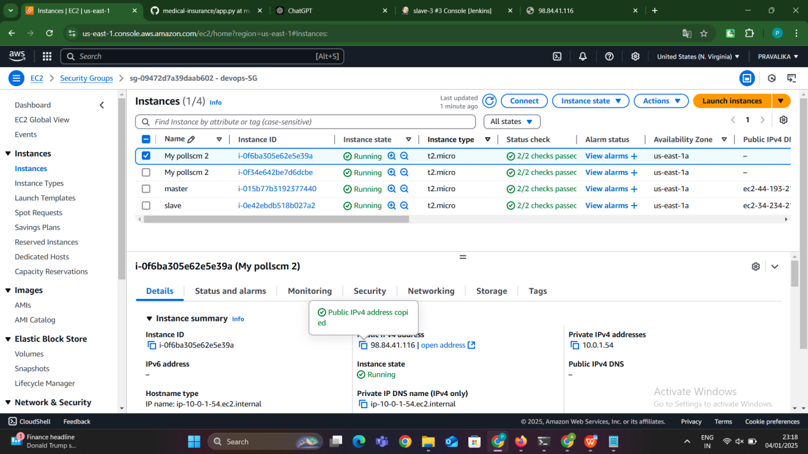

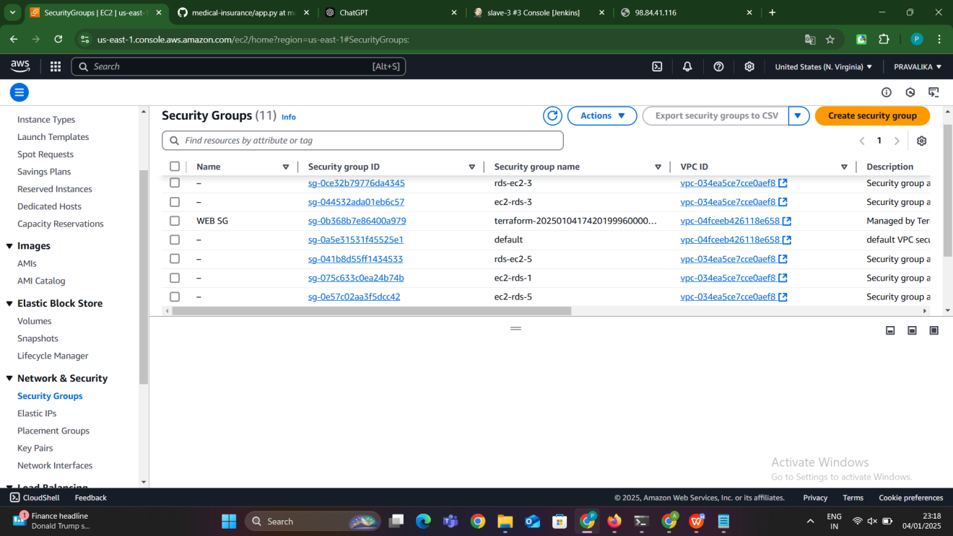

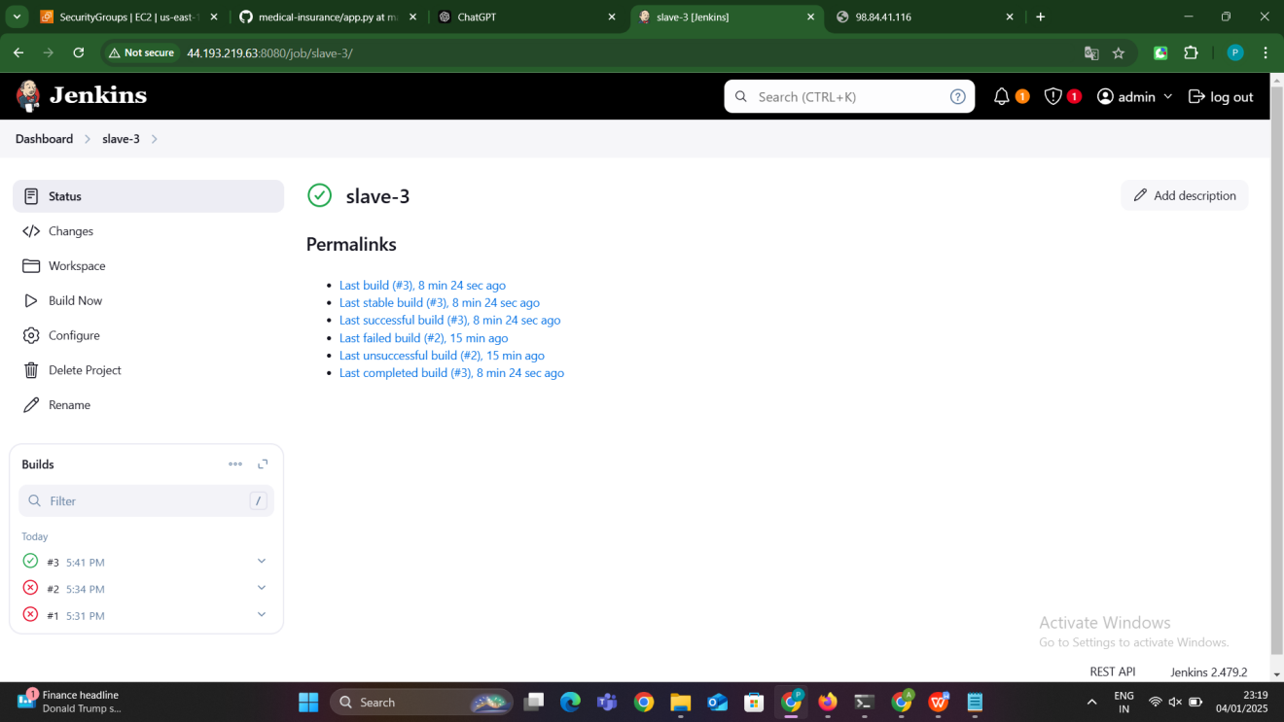

By following these steps, you use Jenkins Master-Slave architecture to automate the deployment of a Python application with Terraform. The key actions include:

* Configuring Jenkins to clone your repository, run Terraform commands, and deploy infrastructure.
* Using AWS credentials to authenticate Terraform with AWS.
* Deploying the infrastructure (e.g., EC2 instance) and running the Python application.

This automation process helps streamline deployments, reduce human error, and ensure consistency across environments.



**Slave-4:Java application**

#### **1. Set Up Jenkins Master and Slave Nodes**

**Jenkins Master Node Setup**:

* **Purpose**: The Jenkins Master node acts as the central hub where the Jenkins service is installed and managed. It coordinates all the builds and deployments, and also stores the configuration and build logs.
* **Installation Steps**:
  1. **Install Java**: Jenkins requires Java to run. Ensure that Java 17 or higher is installed on the master node.
  2. **Install Jenkins**: The Jenkins service is installed and started on the master node. It is typically accessed through a web browser where the Jenkins interface is hosted.

**Jenkins Slave Node Setup**:

* **Purpose**: The Jenkins Slave node is responsible for carrying out specific tasks assigned by the master node, like executing build jobs or deploying applications. It can be a remote machine.
* **Steps**:
  1. **Generate SSH Keys on Master**: An SSH key pair is generated on the master node to allow secure communication between the master and slave nodes.
  2. **Copy Public Key to Slave**: The public SSH key generated on the master is copied to the slave's authorized keys to enable passwordless SSH access.
  3. **Install Java on Slave**: As the slave node will be handling deployment tasks (like running a Java application), it should also have Java installed.

#### **2. Install Maven on Jenkins Master Node**

* **Purpose**: Maven is a build automation tool for Java projects. It handles the compilation, packaging, and testing of Java applications. Jenkins uses Maven to build Java applications during the deployment process.
* **Installation**: Maven is installed on the Jenkins master node, and it is used to build Java projects via Jenkins jobs.
* **Verification**: Once Maven is installed, the version can be verified by running mvn -version on the master node.

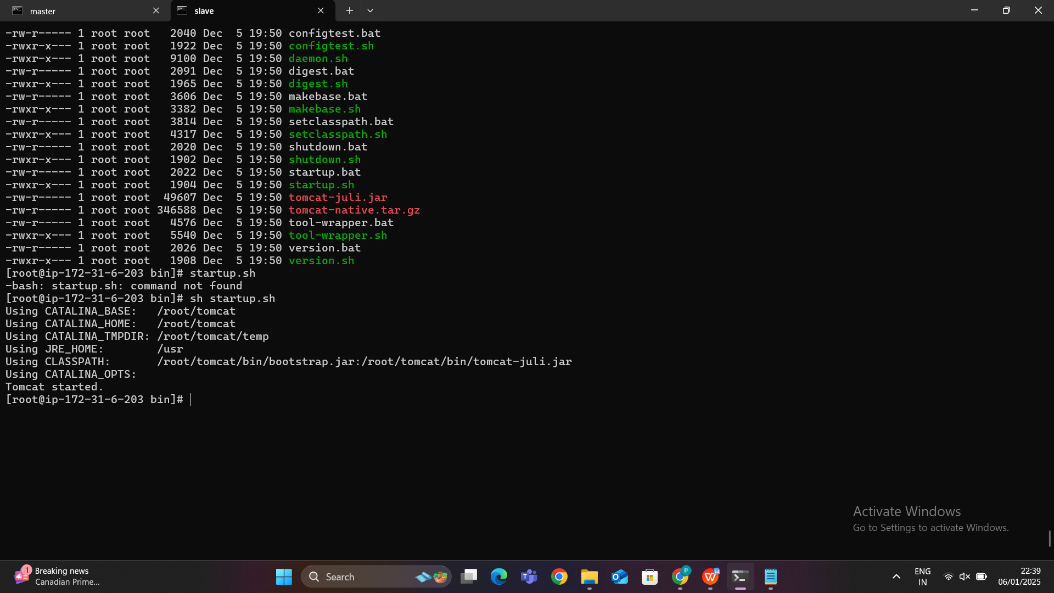

#### **3. Install and Configure Tomcat on Jenkins Slave Node**

* **Purpose**: Tomcat is a widely-used open-source application server for running Java web applications. The slave node will host the Tomcat server to run the deployed Java web application.
* **Installation**:
  1. **Download Tomcat**: The appropriate version of Tomcat is downloaded from the official Apache website.
  2. **Extract Tomcat**: After downloading, Tomcat is extracted to a directory on the slave node (e.g., /opt/tomcat).
  3. **Start Tomcat**: Tomcat is started using the startup.sh script located in the bin directory of the extracted Tomcat folder.
  4. **Configure Tomcat Manager**: To allow Jenkins to deploy applications to Tomcat, we need to edit the context.xml and tomcat-users.xml files in the conf folder. These configurations allow remote access to the Tomcat manager and provide credentials for Jenkins to deploy WAR files.

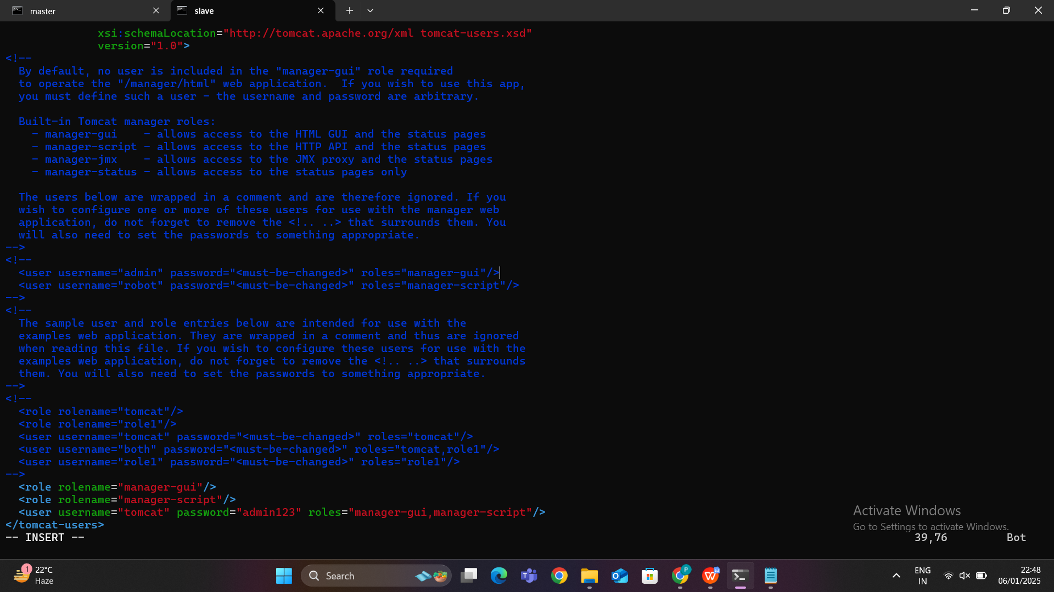

#### **4. Create a Jenkins Job to Deploy Java Application**

* **Purpose**: The Jenkins job defines the process for building and deploying the Java application to the Tomcat server running on the slave node. The job will be triggered automatically or manually from the Jenkins interface.
* **Steps**:
  1. **Create a New Jenkins Job**: A new Jenkins job is created, and the job type is selected (typically "Freestyle Project").
  2. **Source Code Management**: In the job configuration, the Git repository URL containing the Java application is provided so Jenkins can fetch the project files.
  3. **Build Step (Maven)**: A build step is added to run Maven commands (mvn clean package) to compile and package the Java application into a WAR file.
  4. **Install Deploy to Container Plugin**: The "Deploy to Container" plugin is installed on Jenkins. This plugin allows Jenkins to deploy WAR files to application servers like Tomcat.
  5. **Post-Build Action**: After the build step, a post-build action is added to deploy the WAR file to the Tomcat server. The path to the WAR file (target/*.war) is specified, along with the Tomcat credentials and the Tomcat URL.
  6. **Save and Build the Job**: The job is saved, and a build is triggered. The build process will compile the Java application, package it as a WAR file, and deploy it to Tomcat running on the slave node.

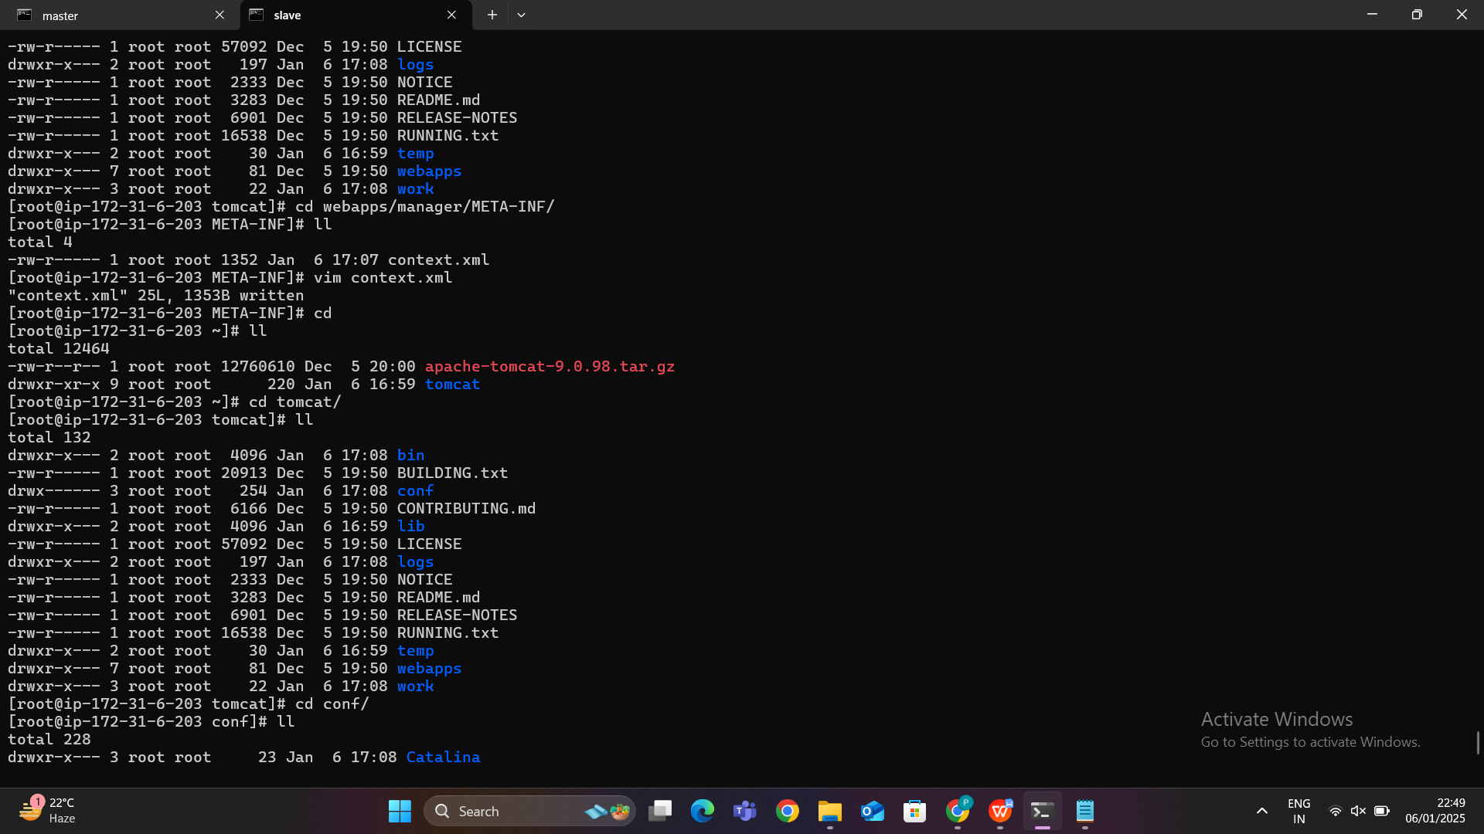

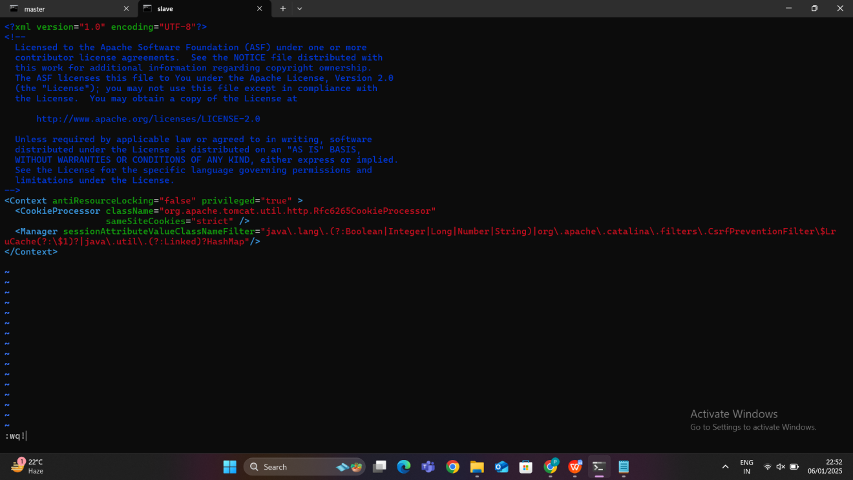

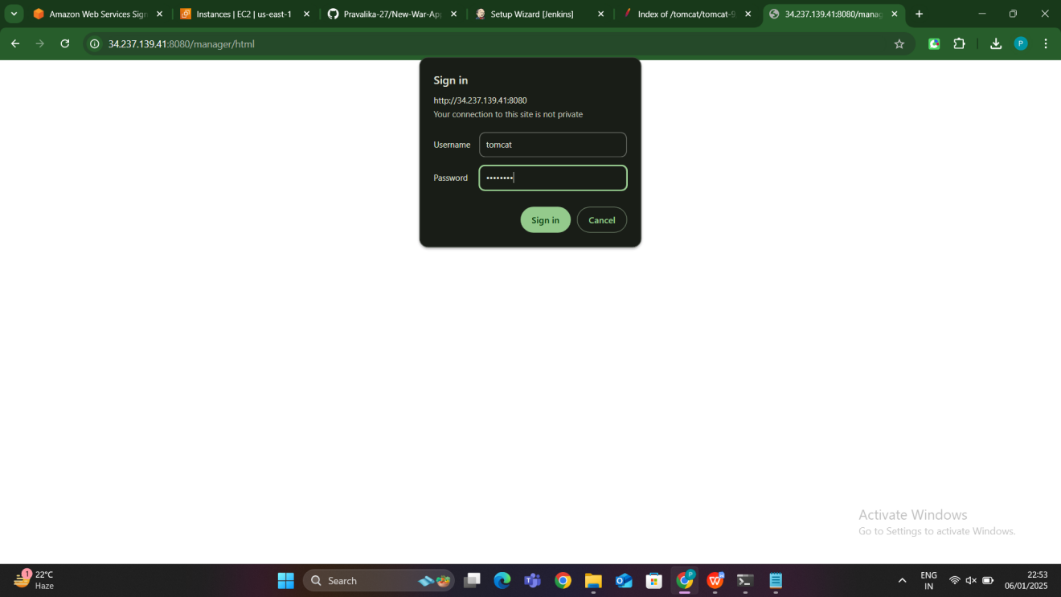

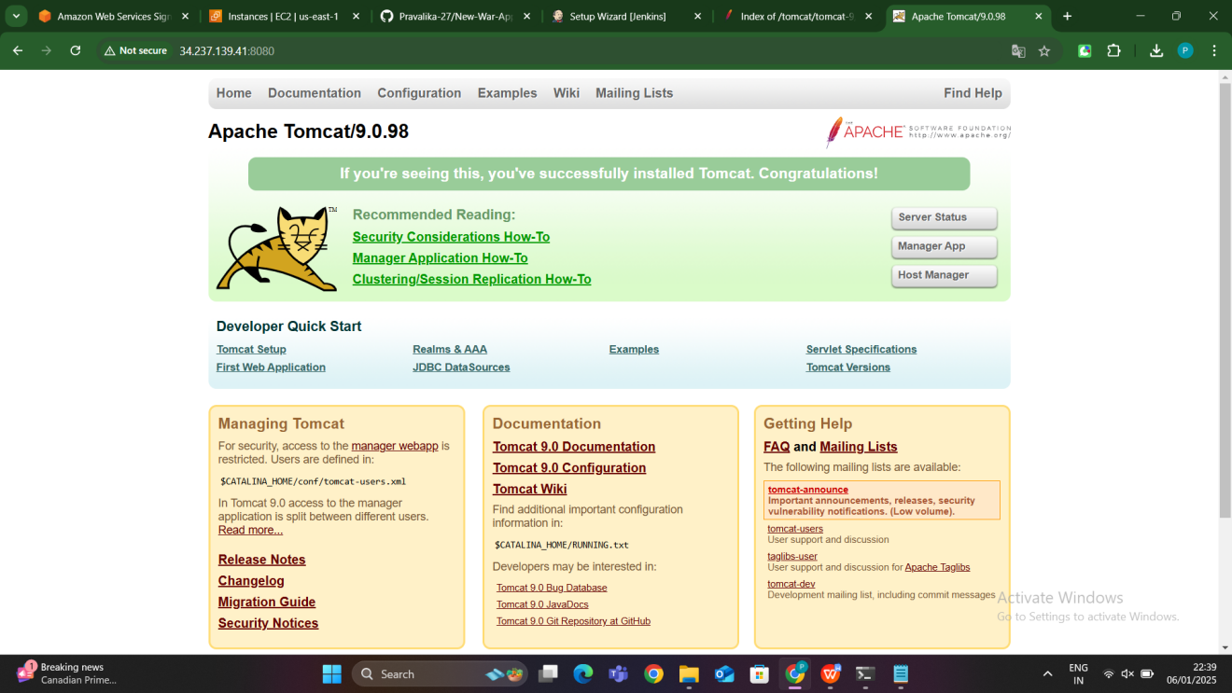

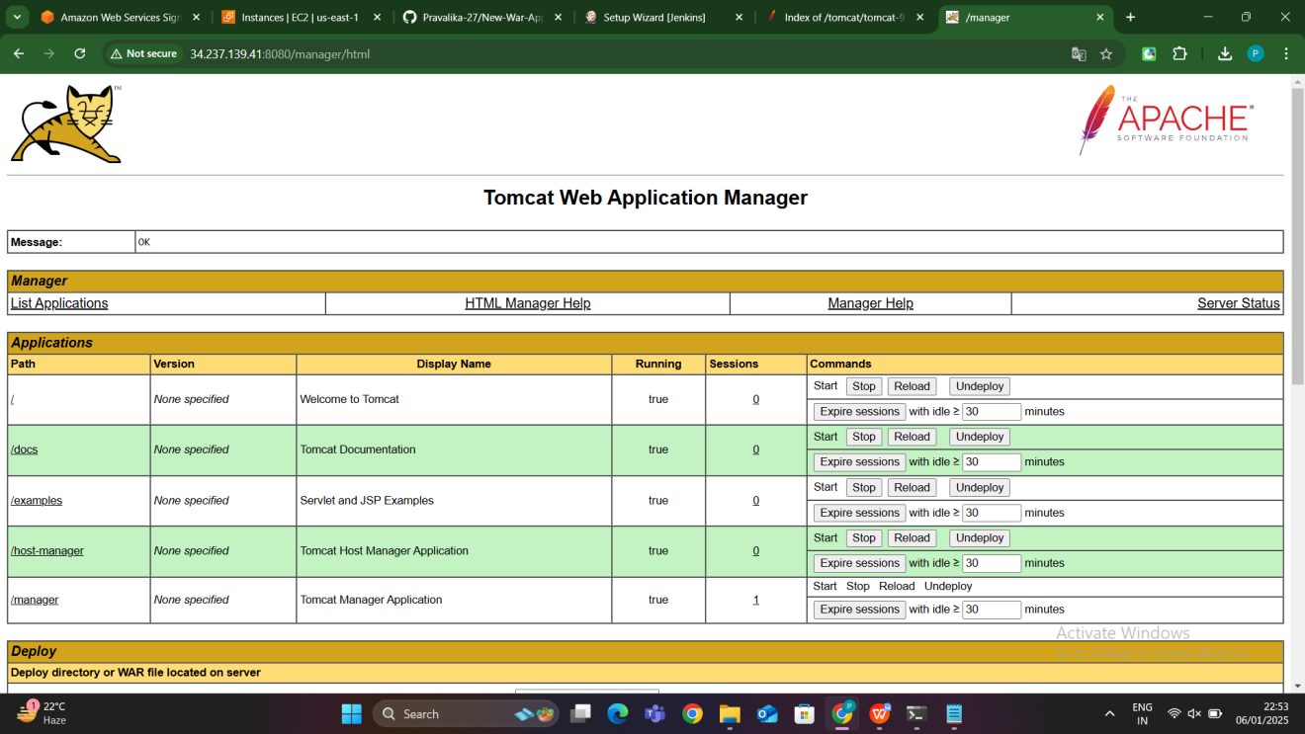

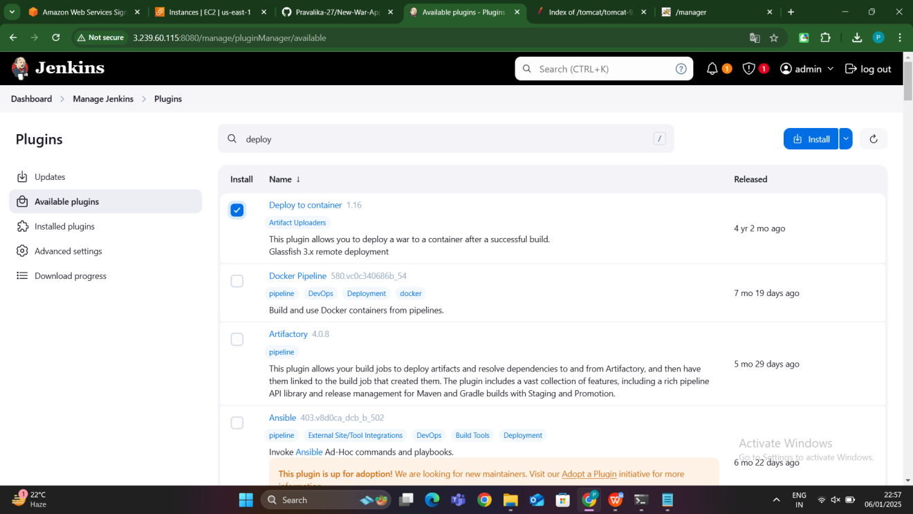

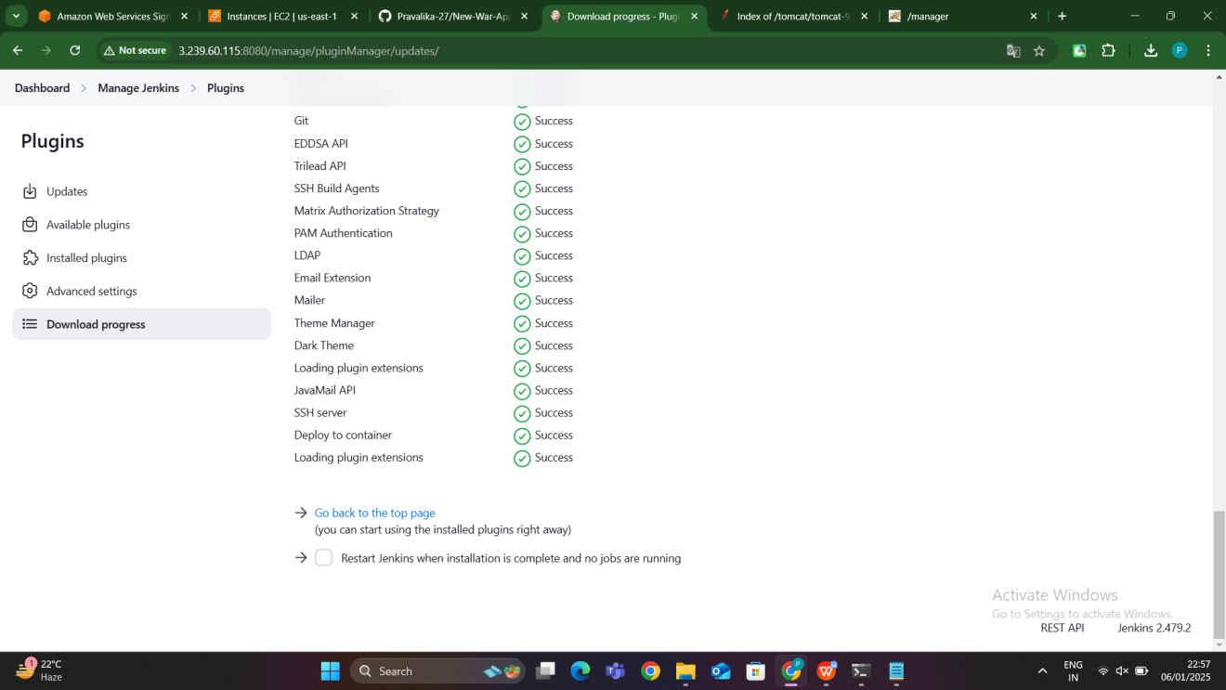

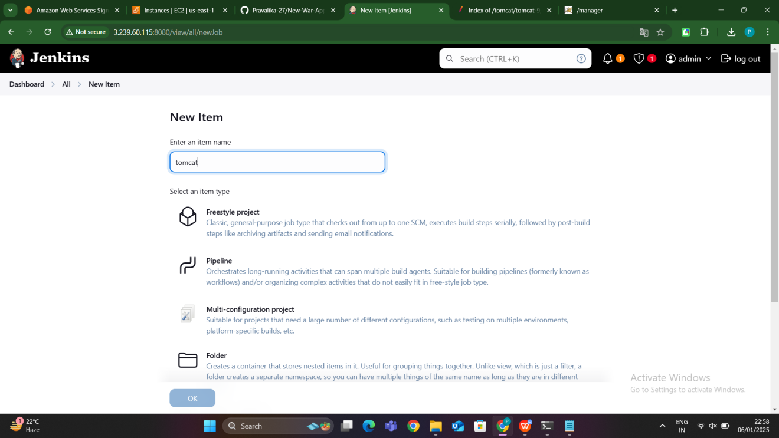

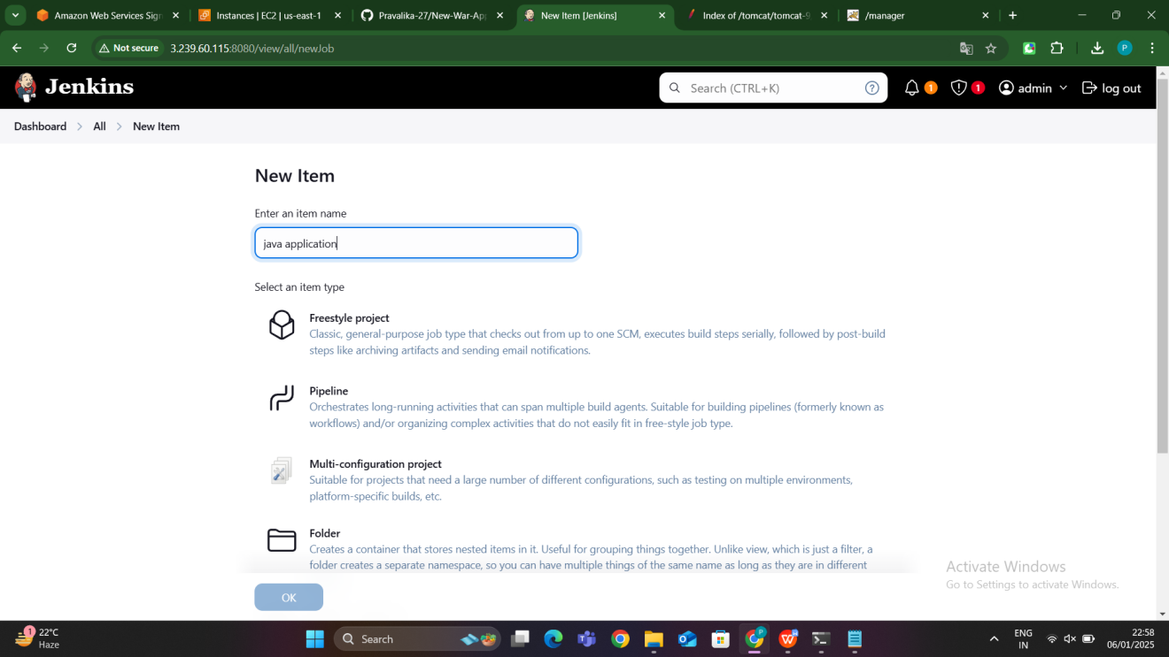

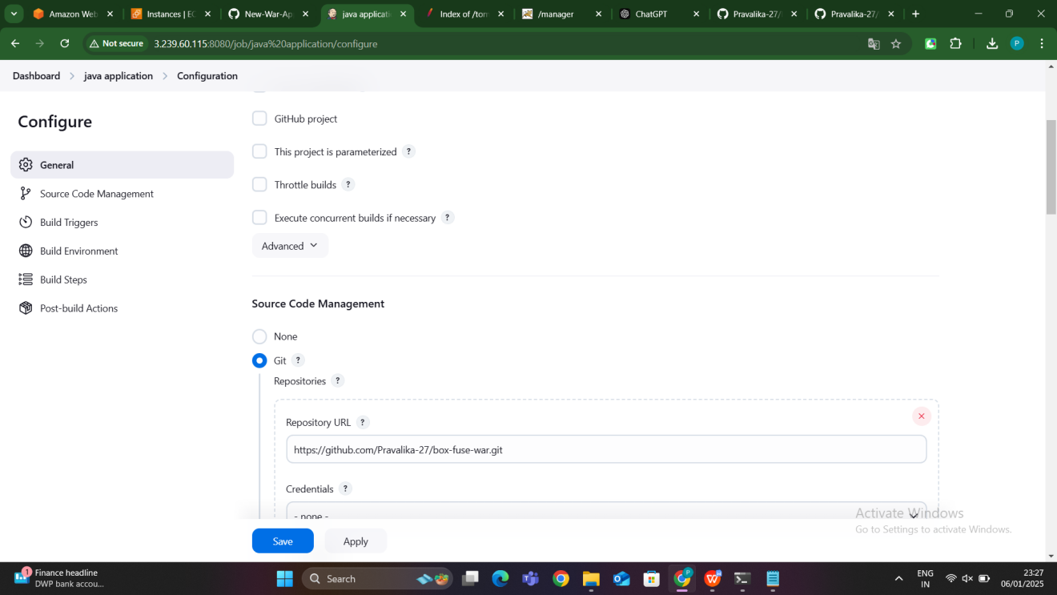

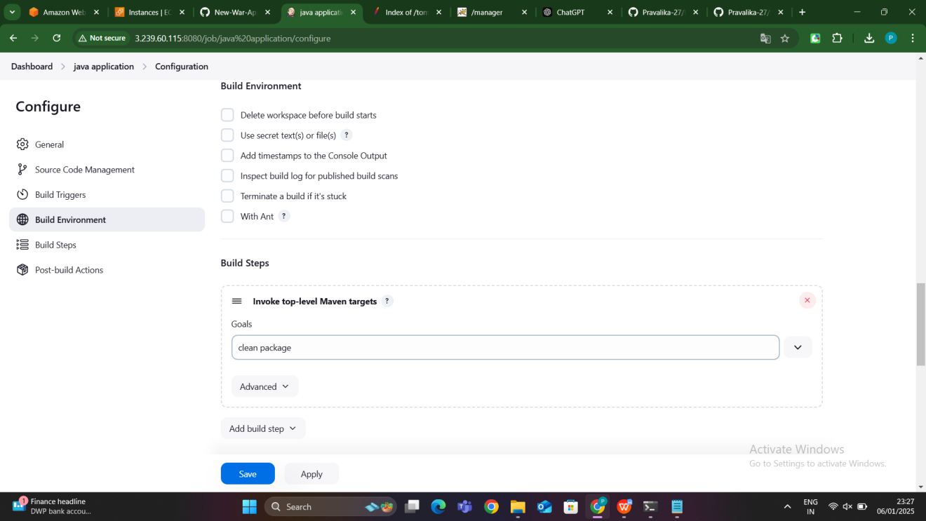

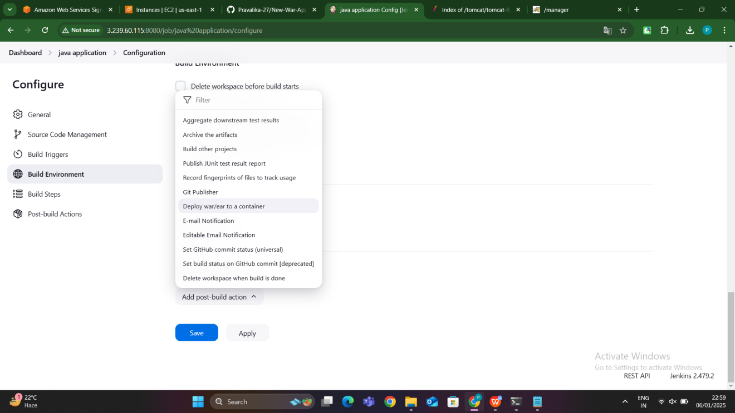

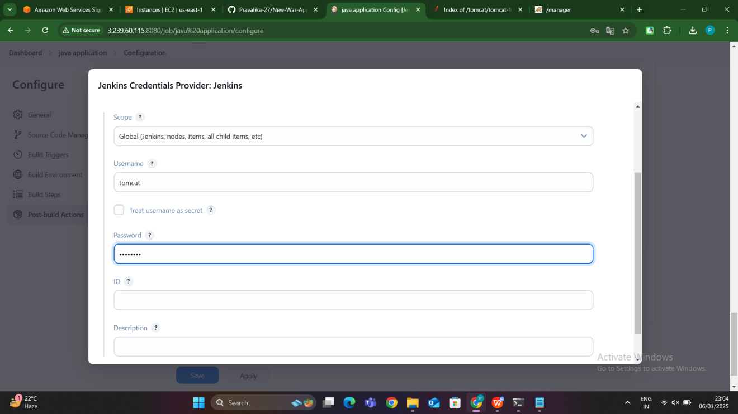

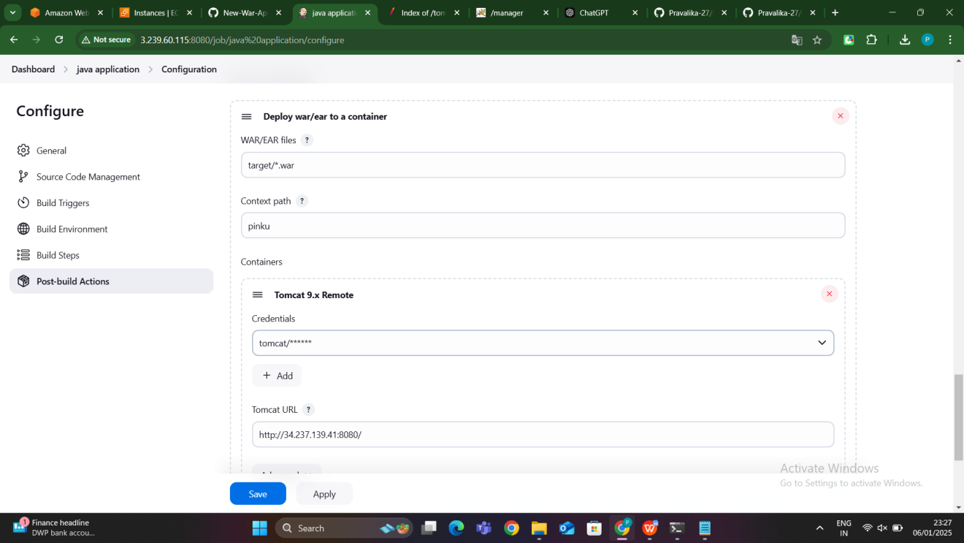

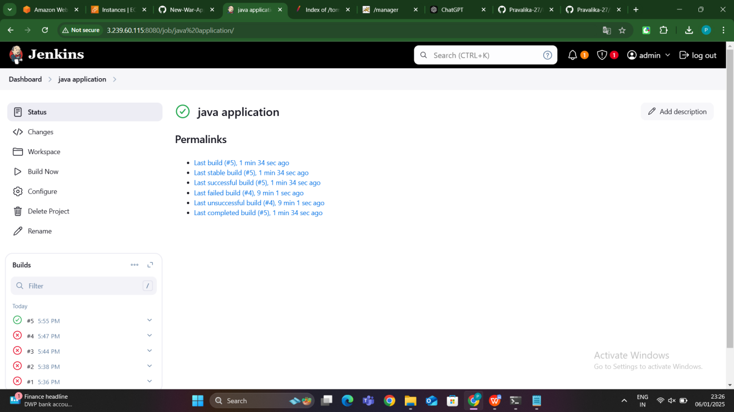

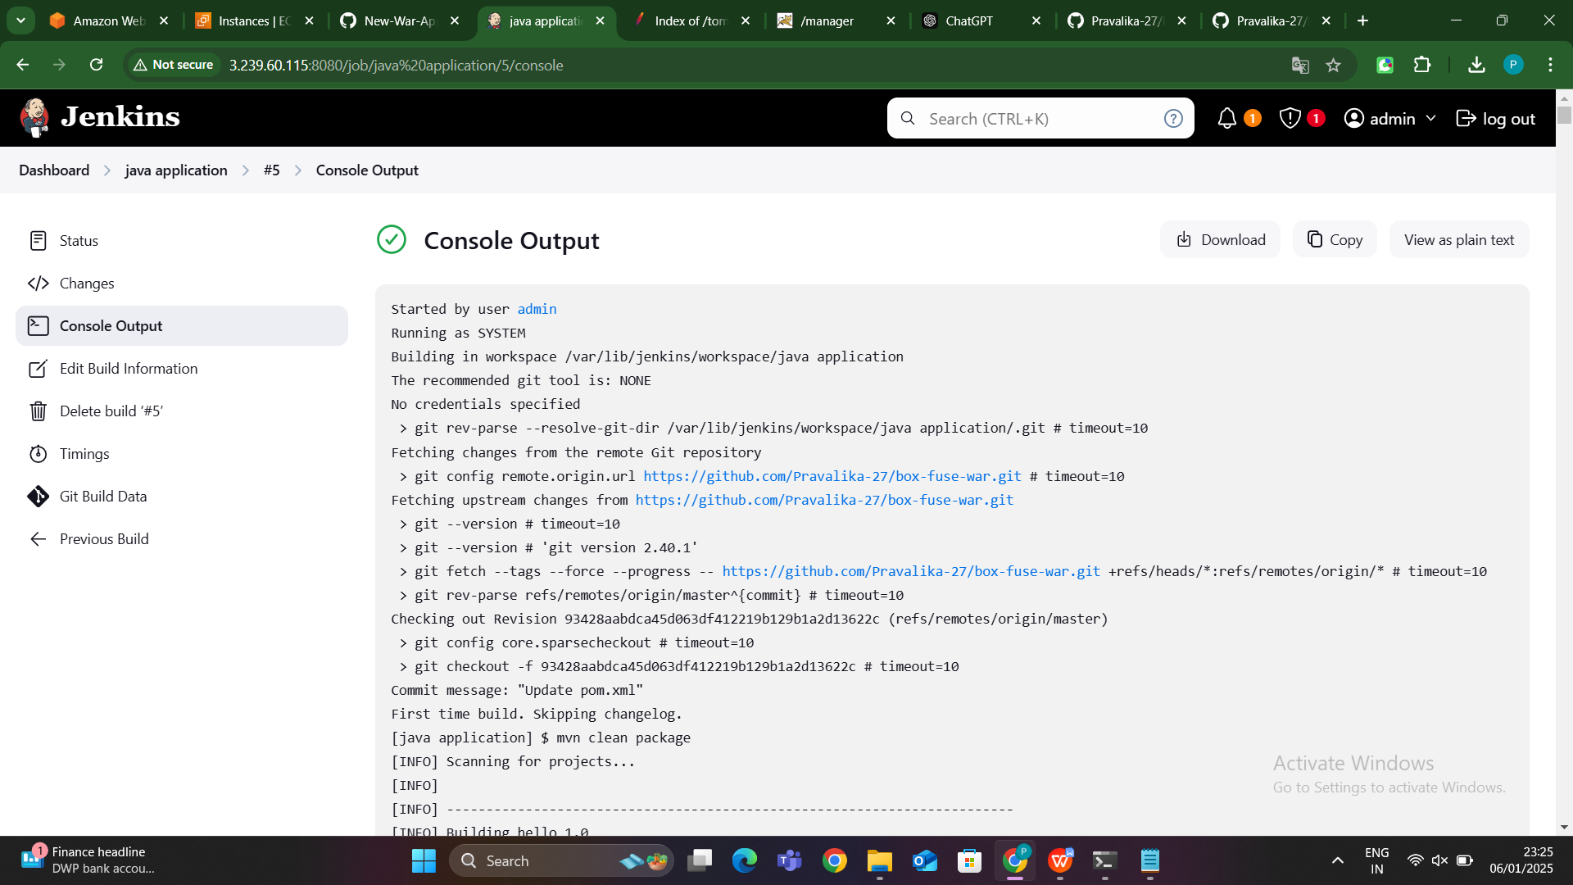

#### **5. Access the Deployed Application**

* **Purpose**: After the Jenkins job completes successfully, the Java application is deployed to the Tomcat server running on the slave node. The application should now be accessible via a web browser.
* **Steps**:
  1. **Verify Deployment in Tomcat**: The deployed application can be accessed by going to http://<slave_node_ip>:8080/<application_name>.
  2. **Monitor the Application**: The application is now live, and users can interact with it through the Tomcat web interface.

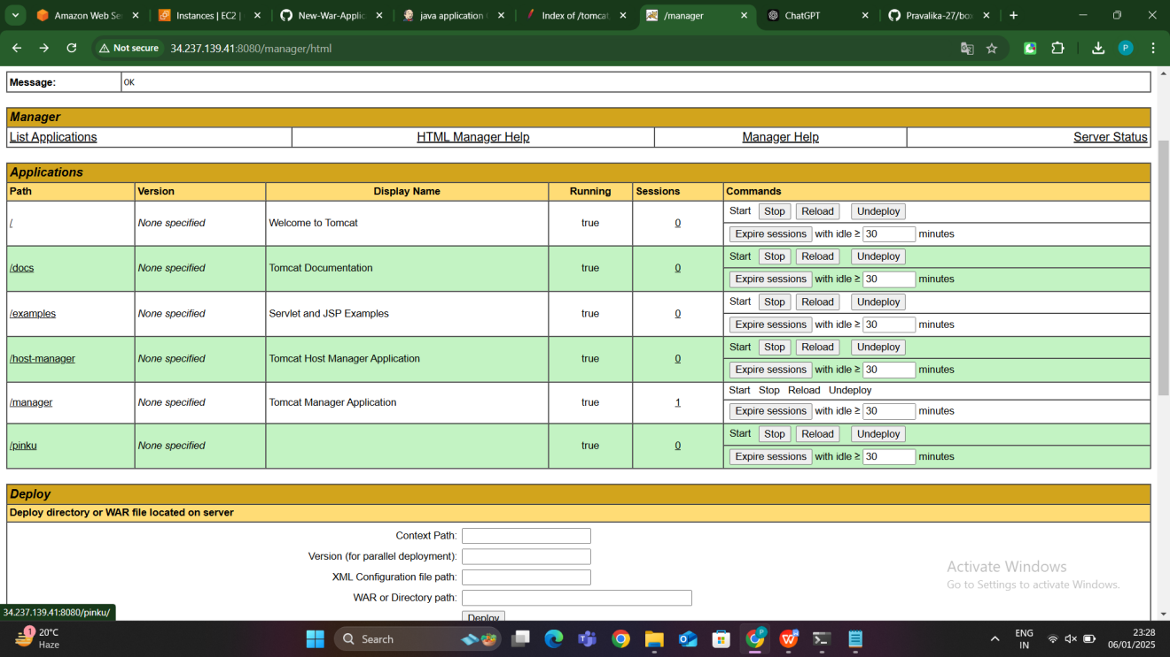

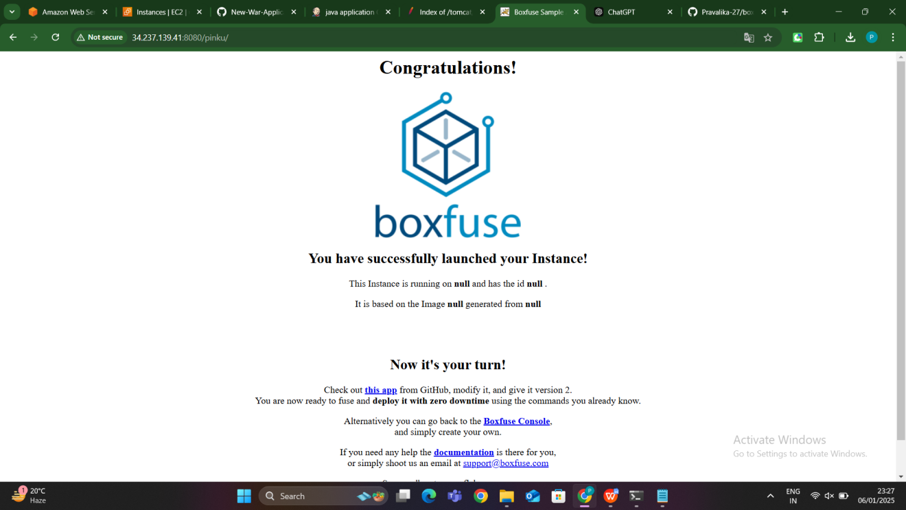

**SLAVE-5:Java application Deployment using bash script**

### ****1. Install and Configure Jenkins Master and Slave Nodes:****

* **Jenkins Master Node**:
  + Install Jenkins on the **Master** node (typically the server where Jenkins runs).
  + Ensure that the **Master** node is connected to the internet for downloading dependencies, tools, and repositories.
* **Jenkins Slave Node**:
  + Set up a **Slave** node (a machine where the actual deployment will happen).
  + The **Slave** node should be connected to the **Master** node using SSH or through other communication methods.
  + The Slave will be responsible for building and deploying the Java application.
* **SSH Connection Setup**:
  + Use SSH to connect the **Master** and **Slave** nodes.
  + Set up SSH keys (via ssh-keygen on the Master) for passwordless communication between the nodes.

### ****2. Install Java on Slave Node****:

**Java 17 Installation**:

* + Install the appropriate version of Java (e.g., Java 17) on the **Slave** node.
  + This is necessary for running and building the Java application.

### ****3. Install Maven on the Master Node****:

**Maven Installation**:

* + Maven is required for building Java applications and packaging them as .war or .jar files.
  + Install Maven on the **Master** node to enable it to execute Maven commands.

### ****4. Install Tomcat on the Slave Node****:

**Tomcat Installation**:

* + Tomcat is required to run Java web applications.
  + Install Tomcat on the **Slave** node for hosting the .war files.

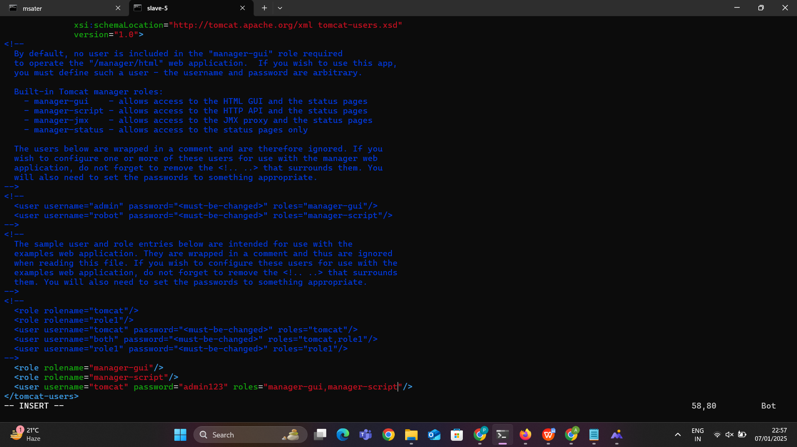

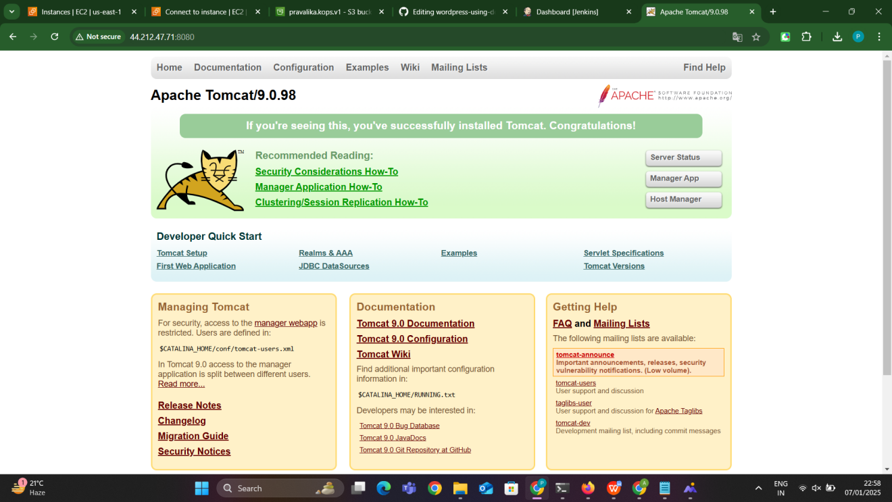

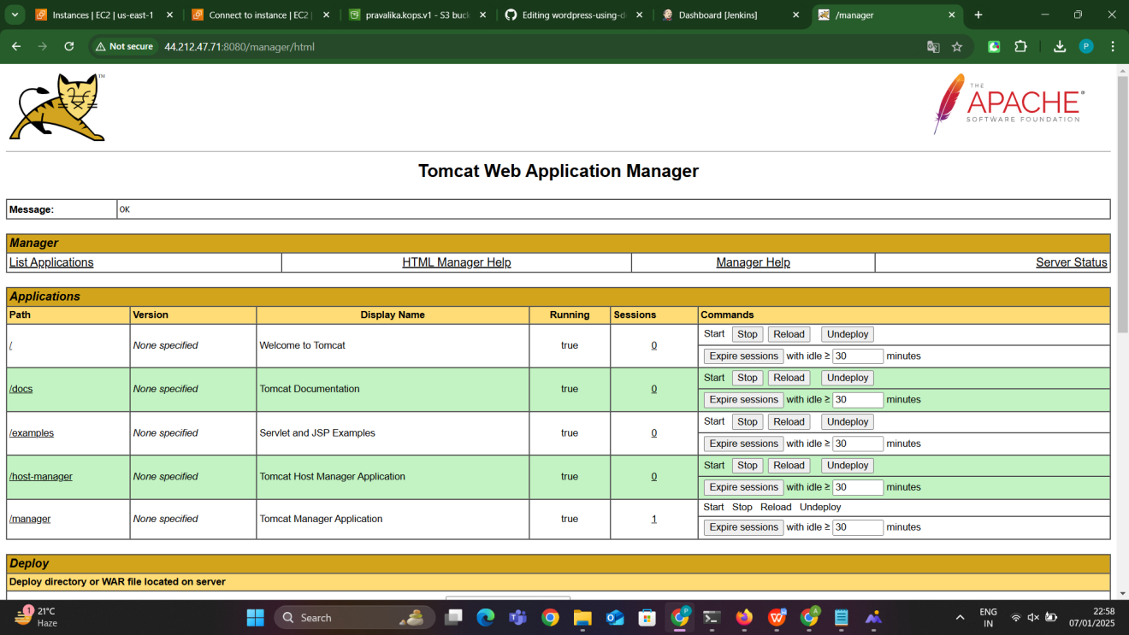

### ****5. Create a Jenkins Job for Deployment****:

* **Create a New Job**:
  + On Jenkins **Master**, create a new job (e.g., “Deploy Java Application”).
* **Configure the Job**:
  + In the **Build Environment** section, select **"Restrict where this project can be run"** and choose the label of your **Slave** node.
  + This ensures the job will be executed on the **Slave** node.
* **Source Code Management**:
  + Under the **Source Code Management** section, configure the Git repository URL where your Java application is hosted (e.g., GitHub).

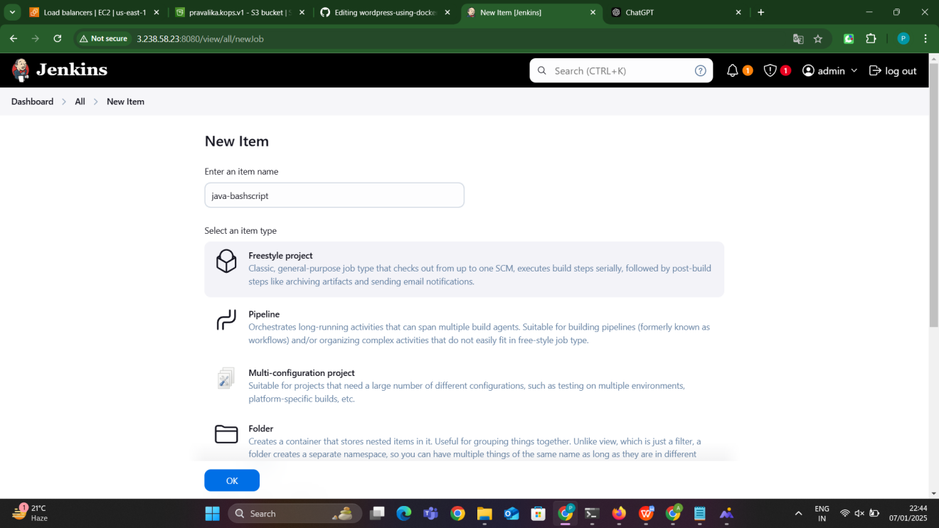

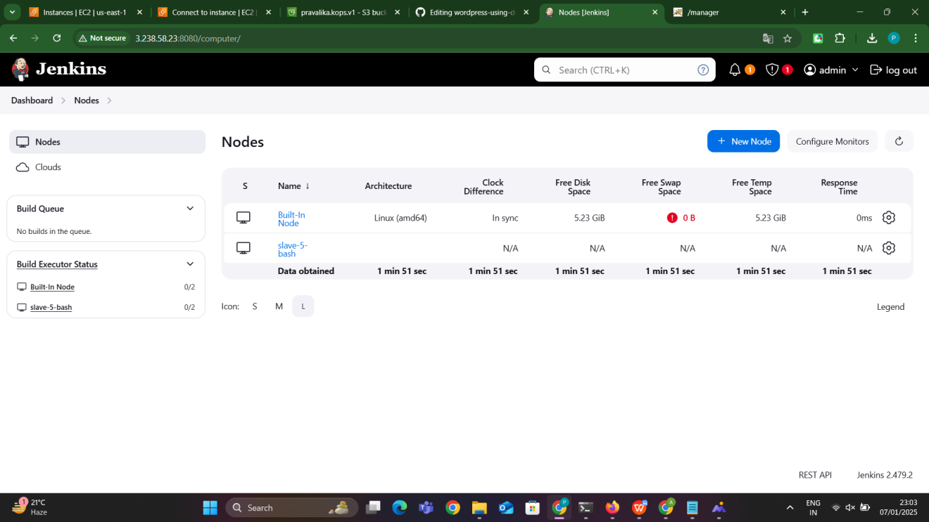

### ****6. Write the Bash Script for Deployment****:

**Bash Script**

* + In the **Build Steps** section, add **“Execute Shell”**.
  + The Bash script will perform the following tasks:
    - Clone the Git repository with the Java project.
    - Build the Java application using Maven.
    - Copy the resulting .war file to the Tomcat **webapps** directory on the **Slave** node.
    - Restart Tomcat to deploy the new application.

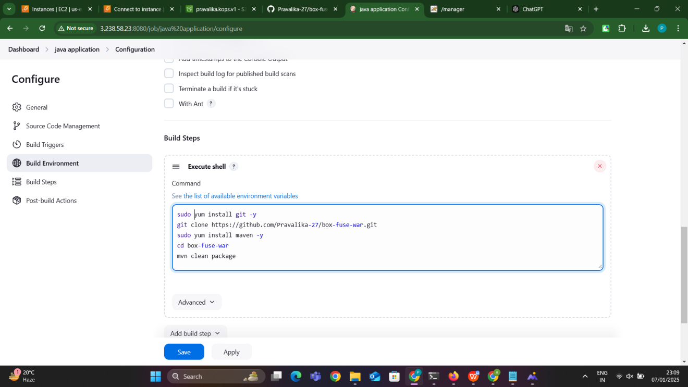

### 1. sudo yum install git -y

* **Purpose**: This command installs **Git** on the system using the **YUM package manager**, which is commonly used on CentOS, Red Hat, and Amazon Linux.
* **Explanation**:
  + sudo: Runs the command with elevated (root) privileges.
  + yum: The default package manager for RPM-based Linux distributions.
  + install: Installs the specified package.
  + git: The name of the package to install, which is a version control system that allows you to clone, pull, and manage repositories.
  + -y: Automatically answers "yes" to any prompts (e.g., confirmation to install the package).

**Outcome**: Git is installed on the system, enabling you to manage and interact with repositories

### 2. git clone https://github.com/Pravalika-27/box-fuse-war.git

* **Purpose**: This command clones the Git repository hosted on GitHub to your local system.
* **Explanation**:
  + git: Invokes the Git command-line tool.
  + clone: A Git command that copies an entire repository (including all its history and branches) to your local machine.
  + https://github.com/Pravalika-27/box-fuse-war.git: The URL of the GitHub repository. This is where the source code of the application resides.

**Outcome**: The project repository box-fuse-war is copied to your local machine, creating a directory called box-fuse-war with all the files and folders from the GitHub repository.

### 3. sudo yum install maven -y

* **Purpose**: This command installs **Apache Maven**, a build automation tool for Java projects, on the system using the YUM package manager.
* **Explanation**:
  + sudo: Runs the command with elevated (root) privileges.
  + yum: The package manager used on RPM-based Linux distributions.
  + install: Installs the specified package.
  + maven: The name of the package to install. Apache Maven is used for managing dependencies and building Java-based projects.
  + -y: Automatically confirms the installation.

**Outcome**: Apache Maven is installed on the system, allowing you to build Java projects and manage dependencies.

### 4. cd box-fuse-war

* **Purpose**: This command changes the current directory to the box-fuse-war directory, which was created after cloning the repository in step 2.
* **Explanation**:
  + cd: Stands for "change directory." It is used to navigate between directories in a Linux environment.
  + box-fuse-war: The directory that was created when you cloned the GitHub repository. This is the directory containing the source code and configuration files for your project.

**Outcome**: The current working directory is changed to box-fuse-war, where the project files are located.

### 5. mvn clean package

* **Purpose**: This Maven command is used to clean the previous builds and package the application into a deployable artifact (e.g., .jar, .war, or .ear).
* **Explanation**:
  + mvn: The command-line interface for **Apache Maven**.
  + clean: This goal removes the target directory from the previous build, ensuring no leftover files affect the new build.
  + package: This goal compiles the source code, runs tests, and packages the compiled code into a deployable format (such as a .war file for web applications).

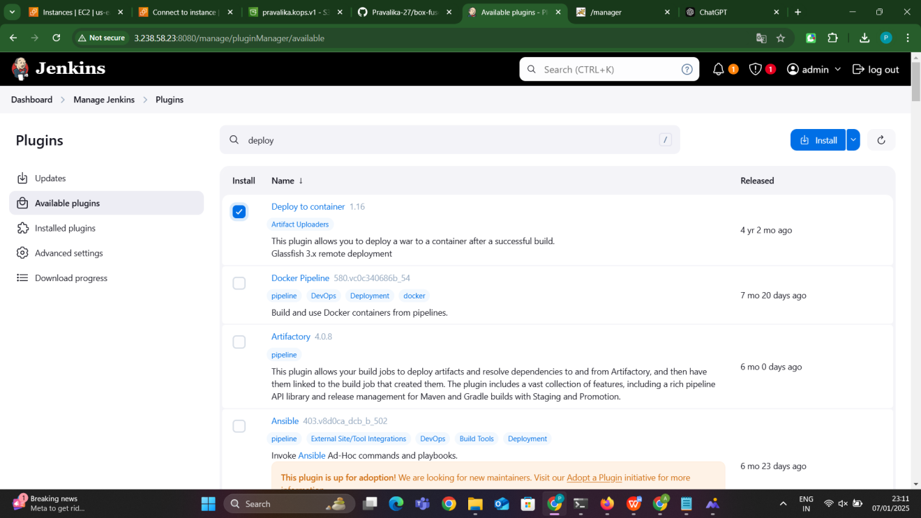

The **Deploy to Container plugin** in Jenkins automates the deployment of Java web applications (e.g., .war or .ear files) to application servers like **Tomcat**, **Jetty**, or **GlassFish**. It integrates seamlessly into Jenkins pipelines, allowing automatic deployment after a successful build. Key benefits include:

* **Automation**: Deploy applications without manual intervention.
* **Flexibility**: Supports multiple application servers.
* **Continuous Deployment**: Automates deployments to different environments (e.g., staging, production).
* **Error Reduction**: Minimizes human error in the deployment process.
* **Efficiency**: Speeds up the deployment process, improving CI/CD workflows.

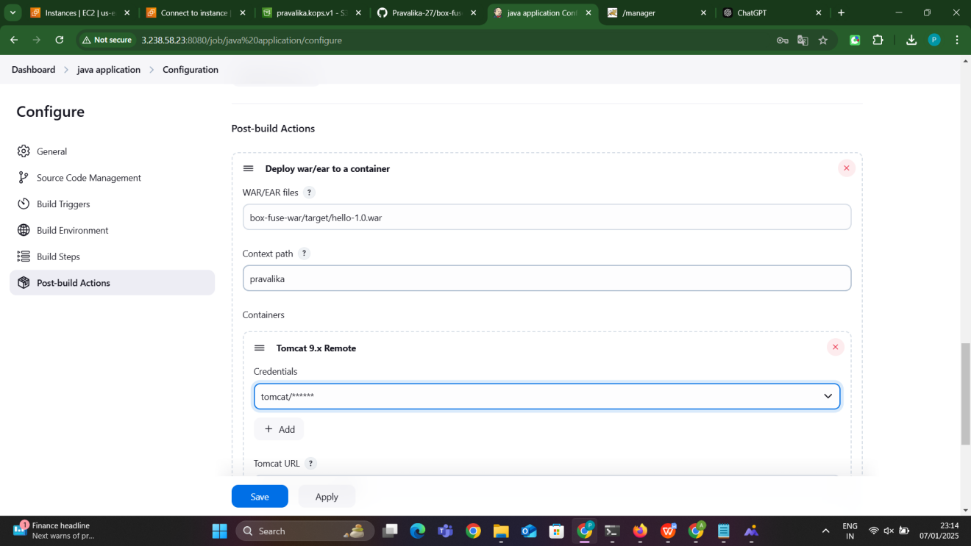

### ****Run the Jenkins Job****:

* **Trigger the Job**:
  + You can manually trigger the Jenkins job, or set it to trigger on code changes (using GitHub webhooks).
* **Jenkins Actions**:
  + Jenkins will perform the following actions upon job execution:
    - Clone the Git repository.
    - Build the Java application using Maven.
    - Deploy the .war file to Tomcat on the **Slave** node.
    - Restart Tomcat to apply the changes.

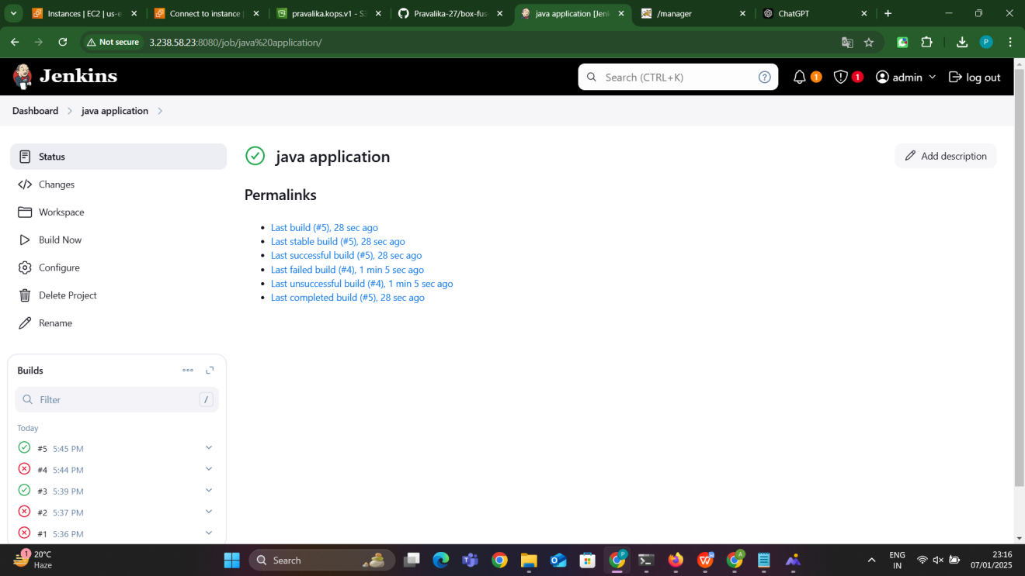

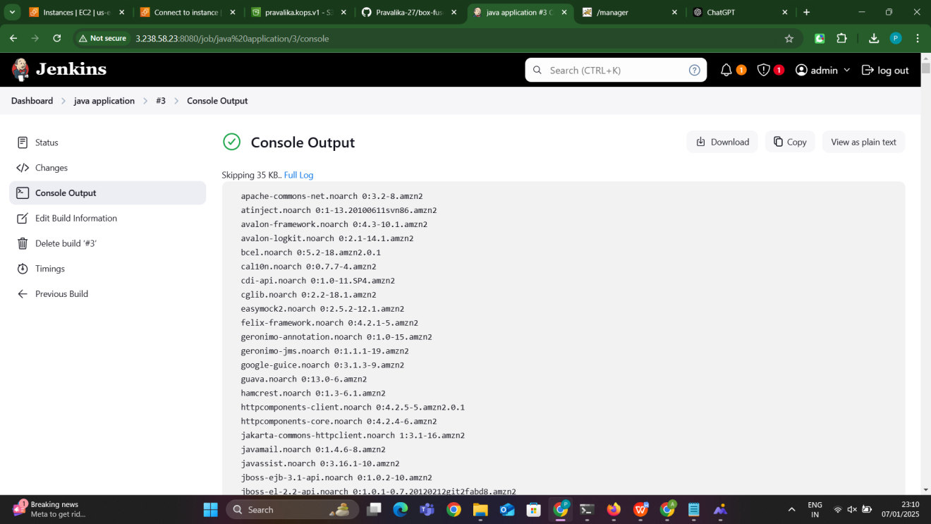

### ****9. Verify Deployment****:

* **Access the Application**:after successful build of the job our application can be seen in the tomcat move to the tomcat and access the application

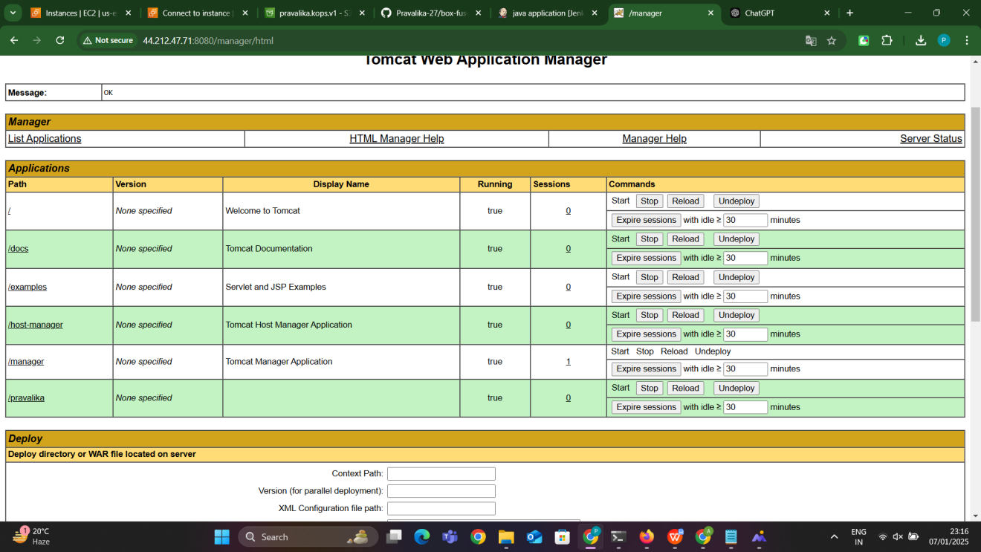

Click on pravalika which is present in the tomcat the output will be seen

